|  |
| --- |
| **Concordia University**  **Department of Computer Science**  **and Software Engineering** |

|  |
| --- |
| **Touch For Food** |

|  |
| --- |
| **Management** |

|  |
| --- |
| **SOEN 490**  **Capstone Project**  **Fall 2012 – Winter 2013** |

|  |  |
| --- | --- |
| **CloudNine** |  |
| Josh Hum (Team Leader) | 9583157 |
| Katrina Anderson | 9106251 |
| Cristian Asenjo | 9280014 |
| Christian Daher | 9599673 |
| Cynthia Donato | 9353852 |
| Mikhail Levkovsky | 9583165 |
| Patrick Modafferi | 9401377 |
| Ryan Nasr | 9605614 |
| Matthew Tam | 9675701 |

**Table of Contents**

1 List of User Stories 10

2 AHP 11

3 Code Quality Goals 11

4 Iteration 0 Report 12

4.1 Person-Hour Work Log 12

5 Iteration 1 Plan 13

5.1 Planned Activities 13

5.2 Person-Hour Estimation 13

6 Iteration 1 Report 14

6.1 Person-Hour Work Log 14

6.2 Cumulative Velocities vs. Time 15

6.3 Cumulative Flow Diagram 15

6.4 Measurement Report 16

6.5 Retrospective 17

7 Iteration 2 Plan 18

7.1 Planned Activities 18

7.2 Person-Hour Estimation 18

8 Iteration 2 Report 19

8.1 Person-Hour Work Log 19

8.2 Hour Burndown Chart 20

8.3 Issue Burndown Chart 22

8.4 Cumulative Velocities vs. Time 23

8.5 Cumulative Flow Diagram 23

8.6 Measurement Report 24

8.7 Retrospective 27

9 Iteration 3 Plan 29

9.1 Planned Activities 29

9.2 Person-Hour Estimation 29

10 Iteration 3 Report 30

10.1 Person-Hour Work Log 30

10.2 Hour Burndown Chart 31

10.3 Issue Burndown Chart 32

10.4 Cumulative Flow Diagram 33

10.5 Measurement Report 34

10.6 Retrospective 36

11 Iteration 4 Plan 37

11.1 Planned Activities 37

11.2 Person-Hour Estimation 37

12 Iteration 4 Report 38

12.1 Person-Hour Work Log 38

12.2 Hour Burndown Chart 39

12.3 Issue Burndown Chart 40

12.4 Cumulative Flow Diagram 41

12.5 Measurement Report 42

12.6 Retrospective 45

13 Iteration 5 Plan 46

13.1 Planned Activities 46

13.2 Person-Hour Estimation 48

14 Iteration 5 Report 49

14.1 Person-Hour Work Log 49

14.2 Hour Burndown Chart 50

14.3 Issue Burndown Chart 51

14.4 Cumulative Flow Diagram 52

14.5 Measurement Report 53

14.6 Retrospective 56

15 Iteration 6 Plan 57

15.1 Planned Activities 57

15.2 Person-Hour Estimation 59

16 Iteration 6 Report 60

16.1 Person-Hour Work Log 60

16.2 Hour Burndown Chart 62

16.3 Issue Burndown Chart 63

16.4 Cumulative Flow Diagram 64

16.5 Measurement Report 65

16.6 Retrospective 69

17 Iteration 7 Plan 70

17.1 Planned Activities 70

17.2 Person-Hour Estimation 72

17.3 Activity-on-Node Planning 73

18 Iteration 7 Report 74

18.1 Person-Hour Work Log 74

18.2 Hour Burndown Chart 76

18.3 Issue Burndown Chart 77

18.4 Cumulative Flow Diagram 78

18.5 Measurement Report 79

18.6 Retrospective 83

19 Iteration 8 Plan 85

19.1 Planned Activities 85

19.2 Person-Hour Estimation 87

19.3 Activity-on-Node Planning 88

20 Iteration 8 Report 89

20.1 Person-Hour Work Log 89

20.2 Hour Burndown Chart 91

20.3 Issue Burndown Chart 92

20.4 Cumulative Flow Diagram 93

20.5 Measurement Report 94

20.6 Retrospective 98

21 Iteration 9 Plan 100

21.1 Planned Activities 100

21.2 Person-Hour Estimation 103

21.3 Activity-on-Node Planning 104

22 Iteration 9 Report 105

22.1 Person-Hour Work Log 105

22.2 Hour Burndown Chart 108

22.3 Issue Burndown Chart 109

22.4 Cumulative Flow Diagram 110

22.5 Measurement Report 111

22.6 Retrospective 117

23 Iteration 10 Plan 119

23.1 Planned Activities 119

23.2 Person-Hour Estimation 122

23.3 Activity-on-Node Planning 123

24 Iteration 10 Report 124

24.1 Person-Hour Work Log 124

24.2 Hour Burndown Chart 126

24.3 Issue Burndown Chart 127

24.4 Cumulative Flow Diagram 128

24.5 Measurement Report 129

24.6 Retrospective 136

25 Iteration 11 Plan 138

25.1 Planned Activities 138

25.2 Sprint Schedule 138

26 Iteration 11 Report 139

26.1 Person-Hour Work Log 139

26.2 Hour Burndown Chart 141

26.3 Issue Burndown Chart 142

26.4 Cumulative Flow Diagram 143

26.5 Measurement Report 144

26.6 Retrospective 144

27 Final Project Report 146

27.1 Summary 146

27.2 Stakeholder 146

27.3 Risk Management 146

27.4 Budget 146

27.5 Conclusion 147

Appendix A References 148

Appendix B Glossary 149

List of Figures

Figure 1‑1 Backlog Stories 10

Figure 2‑1 AHP Graph 11

Figure 4‑1 Person-Hour Work Log 12

Figure 6‑1 Person-Hour Work Log 14

Figure 6‑2 Cumulative Velocities vs. Time 15

Figure 6‑3 Cumulative Flow Diagram 15

Figure 6‑4 Code Analysis report 16

Figure 8‑1 Person-Hour Work Log 19

Figure 8‑2 Hour Burndown Chart 20

Figure 8‑3 Overestimation of CAP-73 and Underestimation of CAP-48 21

Figure 8‑4 Issue Burndown Chart 22

Figure 8‑5 Cumulative Velocities vs. Time 23

Figure 8‑6 Cumulative Flow Diagram 24

Figure 10‑1 Person-Hour Work Log 30

Figure 10‑2 Hour Burndown Chart 31

Figure 10‑3 Issue Burndown Chart 32

Figure 10‑4 Cumulative Flow Diagram 33

Figure 10‑5 Code Quality Report 35

Figure 12‑1 Person-Hour Work Log 38

Figure 12‑2 Hour Burndown Chart 39

Figure 12‑3 Issue Burndown Chart 40

Figure 12‑4 Cumulative Flow Diagram 41

Figure 12‑5 Code Quality Report 44

Figure 14‑1 Person-Hour Work Log 49

Figure 14‑2 Hour Burndown Chart 50

Figure 14‑3 Issue Burndown Chart 51

Figure 14‑4 Cumulative Flow Diagram 52

Figure 14‑5 Code Quality Report 55

Figure 16‑1 Person-Hour Work Log 61

Figure 16‑2 Hour Burndown Chart 62

Figure 16‑3 Issue Burndown Chart 63

Figure 16‑4 Cumulative Flow Diagram 64

Figure 16‑5 Code Quality Report 68

Figure 17‑1 Activity-on-Node Diagram 73

Figure 18‑1 Person-Hour Work Log 74

Figure 18‑2 Hour Burndown Chart 76

Figure 18‑3 Issue Burndown Chart 77

Figure 18‑4 Cumulative Flow Diagram 78

Figure 18‑5 Code Quality Report 82

Figure 19‑1 Activity-On-Node Diagram 88

Figure 20‑1 Person-Hour Work Log 89

Figure 20‑2 Hour Burndown Chart 91

Figure 20‑3 Issue Burndown Chart 92

Figure 20‑4 Cumulative Flow Diagram 93

Figure 20‑5 Code Quality Report 97

Figure 21‑1 Activity on Node Diagram 104

Figure 22‑1 Person-Hour Work Log 107

Figure 22‑2 Hour Burndown Chart 108

Figure 22‑3 Issue Burndown Chart 109

Figure 22‑4 Cumulative Flow Diagram 110

Figure 22‑5 Code Quality Report 116

Figure 23‑1 Activity on Node Diagram 123

Figure 24‑1 Person-Hour Work Log 125

Figure 24‑2 Hour Burndown Chart 126

Figure 24‑3 Issue Burndown Chart 127

Figure 24‑4 Cumulative Flow Diagram 128

Figure 24‑5 Code Quality Report 135

Figure 26‑1 Person-Hour Work Log 140

Figure 26‑2 Hour Burndown Chart 141

Figure 26‑3 Issue Burndown Chart 142

Figure 26‑4 Cumulative Flow Diagram 143

List of Tables

Table 3‑1 Code Quality Goals 11

Table 5‑1 Planned Activities 13

Table 5‑2 Person-Hour Estimation 13

Table 6‑1 Completed User Stories 17

Table 5‑7‑1 Planned Activities 18

Table 5‑7‑2 Person-Hour Estimation 18

Table 9‑1 Planned Stories 29

Table 9‑2 Planned Defects 29

Table 9‑3 Person-Hour Estimation 29

Table 11‑1 Planned Stories 37

Table 11‑2 Planned Defects 37

Table 11‑3 Person-Hour Estimation 37

Table 13‑1 Iteration 5 Planned Tasks 46

Table 13‑2 Iteration 5 Planned Stories 47

Table 13‑3 Iteration 5 Planned Defects 48

Table 13‑4 Iteration 5 Person-Hour Estimation 48

Table 15‑1 Planned Activities 57

Table 17‑1 Planned Activities 70

Table 17‑2 Person-Hour Estimation 72

Table 19‑1 Planned Activities 85

Table 19‑2 Person-Hour Estimation 87

Table 21‑1 Planned Activities 100

Table 21‑2 Person-Hour Estimation 103

Table 23‑1 Planned Activities 119

Table 23‑2 Person-Hour Estimation 122

Table 25‑1 Sprint Tasklist 138

|  |
| --- |
| **Touch For Food** |

|  |
| --- |
| **Management** |

|  |
| --- |
| **Version 11.23** |

**Revision History**

|  |  |  |  |
| --- | --- | --- | --- |
| **Date** | **Rev.** | **Description** | **Author(s)** |
| 2012-11-03 | 1.0 | Document Creation | Josh Hum |
| 2012-11-04 | 1.1 | Update doc | Josh Hum |
| 2012-12-03 | 2.2 | Added Iteration 2 retrospective | Josh Hum |
| 2012-12-17 | 3.3 | Made correction to Section 3.3 | Josh Hum |
| 2012-12-30 | 4.4 | Reducing redundancy | Katrina Anderson |
| 2013-01-08 | 5.5 | Iteration 3 Plan and Report | Josh Hum |
| 2013-01-10 | 5.6 | Iteration 4 Plan and Report | Josh Hum |
| 2013-01-11 | 5.7 | Iteration 5 Plan added and formatting fixing | Katrina Anderson |
| 2013-01-15 | 5.8 | Fixed user story number error | Josh Hum |
| 2013-01-15 | 5.9 | Iteration 0 Report | Josh Hum |
| 2013-01-18 | 6.10 | Iteration 6 Plan | Josh Hum |
| 2013-02-01 | 6.11 | Iteration 6 Report, Analysis, and Retrospective | Josh Hum |
| 2013-02-01 | 7.12 | Iteration 7 Plan | Josh Hum |
| 2013-02-12 | 7.13 | Reviewed Document for submission | Cynthia Donato |
| 2013-02-12 | 7.14 | Iteration 7 Report, Analysis, and Retrospective | Josh Hum |
| 2013-02-18 | 8.15 | Iteration 8 Plan | Josh Hum |
| 2013-02-26 | 8.16 | Iteration 8 Report, Analysis, and Retrospective | Josh Hum |
| 2013-03-01 | 9.17 | Iteration 9 Plan | Josh Hum |
| 2013-03-17 | 9.18 | Iteration 9 Report, Analysis, and Retrospective | Josh Hum |
| 2013-03-18 | 9.19 | Iteration 10 Plan | Josh Hum |
| 2013-03-30 | 10.20 | Iteration 10 Report, Analysis, and Retrospective | Josh Hum |
| 2013-03-31 | 10.21 | Reviewed document | Cristian Asenjo |
| 2013-04-05 | 11.22 | Iteration 11 Plan, Report, Analysis, and Retrospective | Josh Hum |
| 2013-04-05 | 11.23 | Final Project Report | Josh Hum |

# List of User Stories

The following is the list of user stories in the backlog. Stories will be chosen to work on at the beginning of each sprint based on the results of the AHP graph as well as if they are blockers or not.

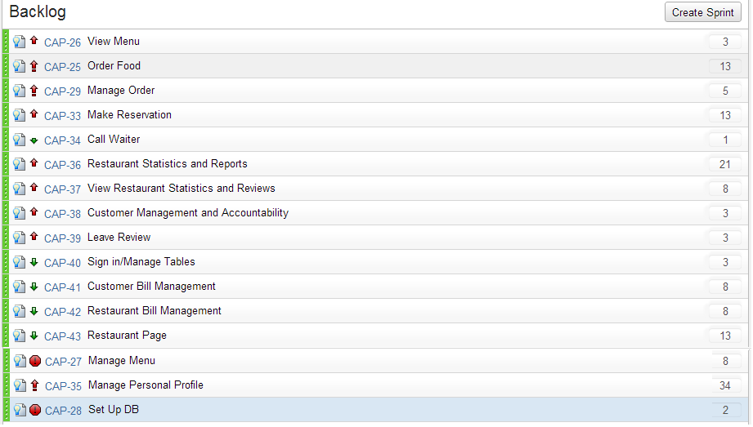

Figure 1‑1 Backlog Stories

# AHP

The AHP method was used to determine priority of user stories. The following graph shows the results of building AHP cost-value matrices. High priority stories are between the y-axis and the first diagonal line. Medium priority stories fall between the two diagonal lines and low priority stories come between the second diagonal line and the x-axis.

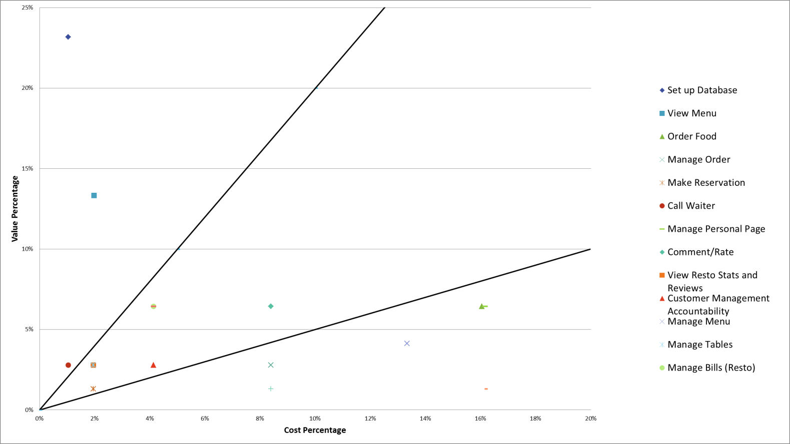

Figure 2‑1 AHP Graph

# Code Quality Goals

We will attempt to meet the following goals with the combination of our code and the Code Metrics Viewer Visual Studio plugin [1]. The plugin outputs a report with the following metrics displayed. Average is defined on the report with a yellow background, while an optimal result is shown with a green background. Below average is shown with a red background. Our goals are shown in the table below.

Table 3‑1 Code Quality Goals

| **Metric** | **Level** |
| --- | --- |
| Cyclomatic Complexity (CC) | Average (or lower) |
| Maintainability Index (MI) | Average (or higher) |
| Class Coupling (CCP) | Average (or lower) |
| Lines of Code (LOC) | Average (or lower) |
| Depth of Inheritance (DOI) | Average (or lower) |

# Iteration 0 Report

Iteration 0 was spent doing research, setup, and preparation for development. Research was conducted for configuration management, code hosting and versioning, server and client side technologies, mobile technologies, and databases. We also made decisions on local machine standards for both documenting and code development. Time was also spent setting up our local machines.

## Person-Hour Work Log

The following work log shows hours worked during Iteration 0.

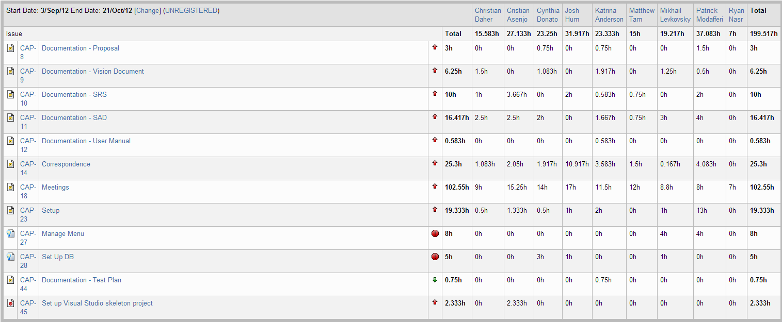

Figure 4‑1 Person-Hour Work Log

# Iteration 1 Plan

Iteration 1 is the first iteration where coding development began. The period of time before Iteration 1 was used for planning, meetings, setup and configuration of each team member’s development environment.

## Planned Activities

The two stories planned for Iteration 1 are CAP-35 – Manage Personal Profile and CAP-27 – Manage Menu. We chose to start with them because they provide a foundation for other user stories to be developed.

Table 5‑1 Planned Activities

| **User Story ID** | **Total Story Points** | **Related Use Cases** |
| --- | --- | --- |
| CAP-35, CAP-27, CAP-28 | 44.00 | UC1.1, UC2.5 |

## Person-Hour Estimation

The Expert Judgement Method was used to calculate person-hour estimations. Estimations were made for the worst case, most likely case, and best case. The worst case and best case are +30% and -30%. The expected case was then calculated with the formula:

Expected case = 1/6([worst case] + 4[most likely case] + [best case])

Table 5‑2 Person-Hour Estimation

| **User Story ID** | **Worst Case** | **Most Likely Case** | **Best Case** | **Expected Case** |
| --- | --- | --- | --- | --- |
| US35 | 110 | 90 | 75 | 90.8 |
| US27 | 30 | 20 | 15 | 20.8 |
| US28 | 10 | 7 | 3 | 6.8 |
| Total (ph) | 150 | 117 | 93 | 118.4 |
| Velocity (ph/day) | 10.7 | 8.4 | 6.6 | 8.5 |
| Velocity (ph/team member/day) | 1.2 | 0.9 | 0.7 | 0.9 |

# Iteration 1 Report

## Person-Hour Work Log

The following table shows the person-hour work log for each team member and activity during this iteration. This table was generated from the JIRA management system.

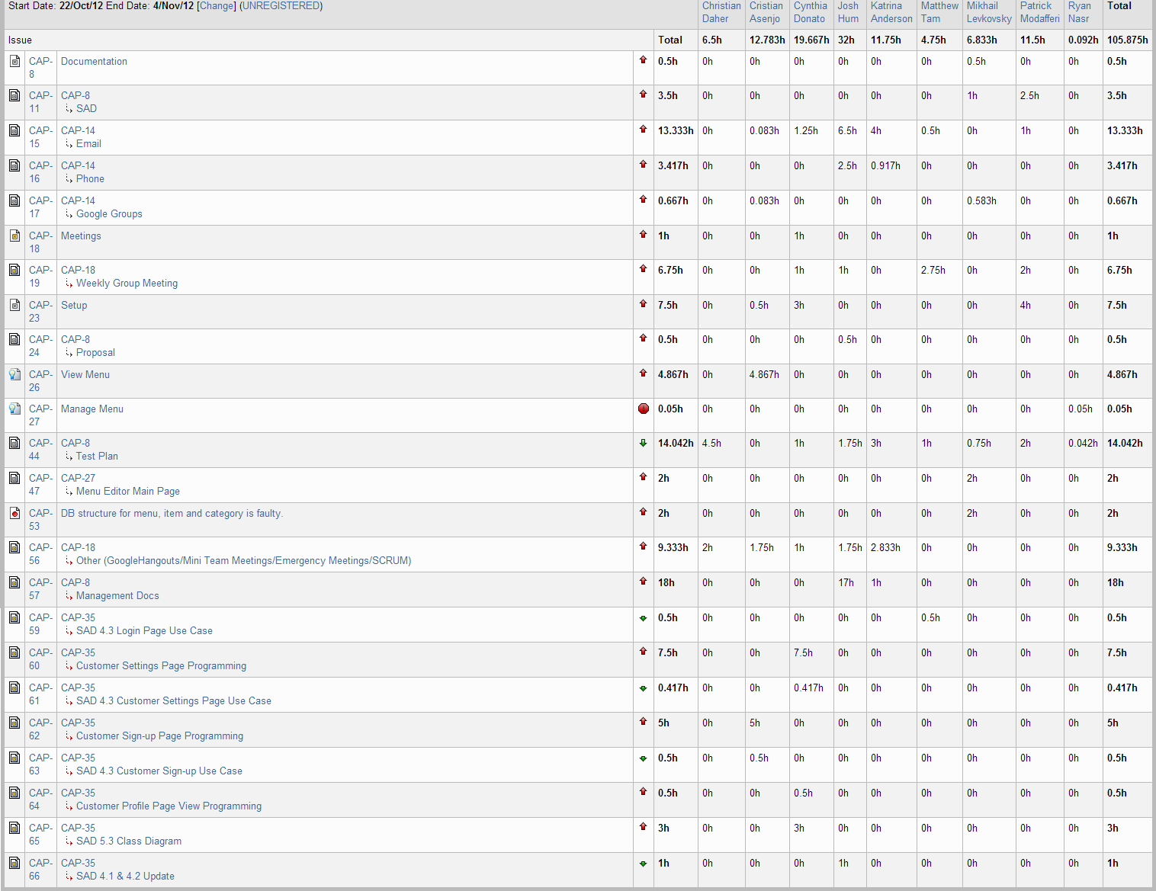

Figure 6‑1 Person-Hour Work Log

## Cumulative Velocities vs. Time

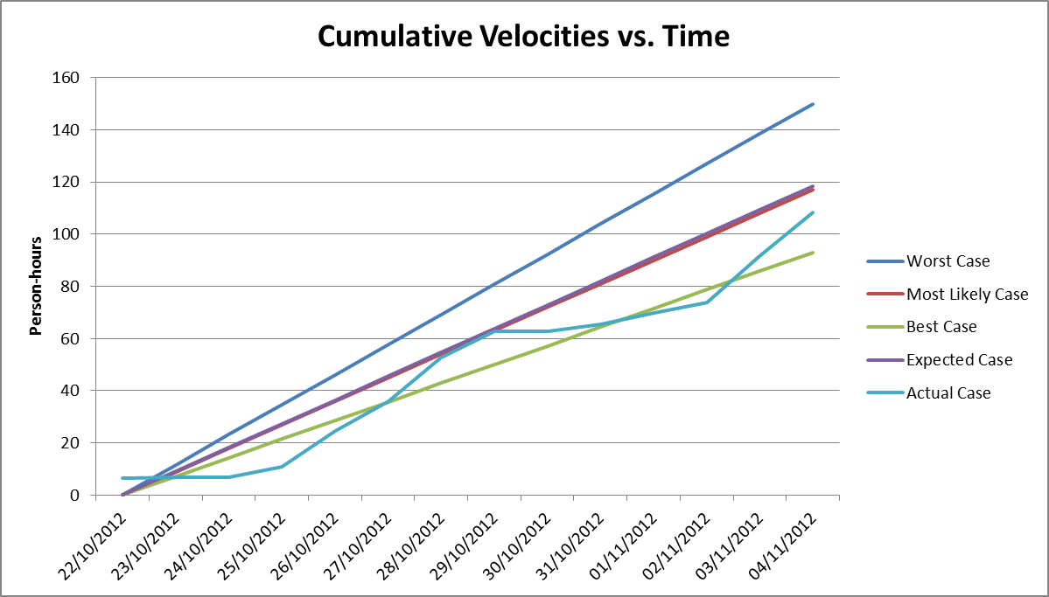

Figure 6‑2 Cumulative Velocities vs. Time

## Cumulative Flow Diagram

The following diagram shows the three stories and how the work progressed. Blue tasks have not been started, purple tasks are in progress and green represents a completed story. This diagram was generated in JIRA.

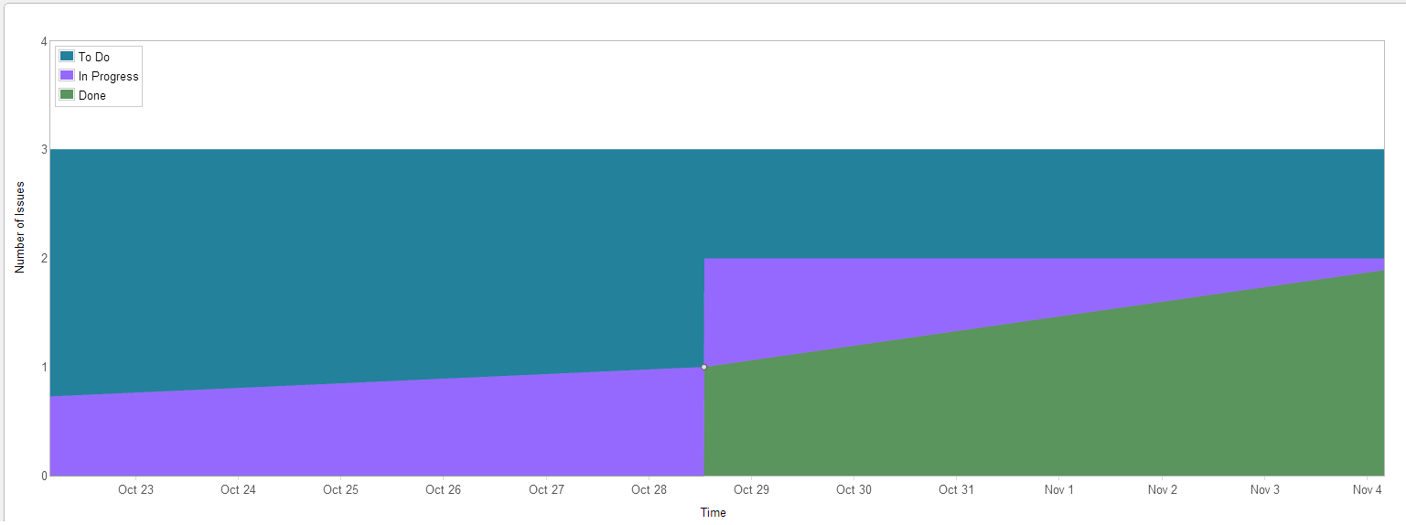

Figure 6‑3 Cumulative Flow Diagram

## Measurement Report

### Code Quality Analysis

The following report was generated after analyzing the code. All our minimum goals were met while some were exceeded.

Analysis tool used: Code Metrics Viewer

Found at: <http://visualstudiogallery.msdn.microsoft.com/9f35524b-a784-4dbc-bd7b-6babd7a5a3b3>

Version: 1.5.3

Last updated: 2/5/2012

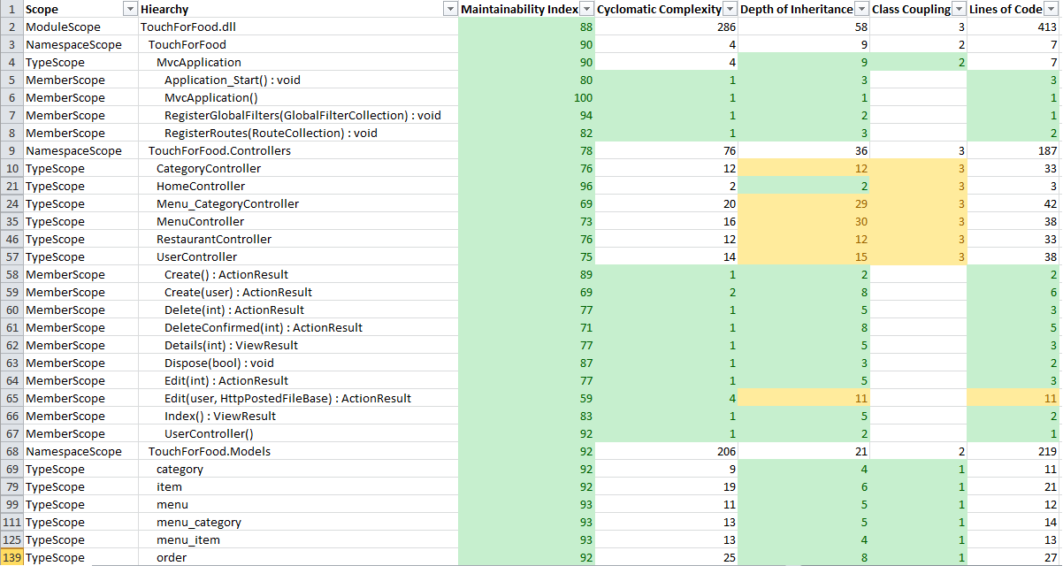

Figure 6‑4 Code Analysis report

## Retrospective

In Iteration 1, we completed US27 and US28. This amounts to 10 out of the planned 44 story points. Therefore, it was not a successful iteration. The following table shows the completed user stories:

Table 6‑1 Completed User Stories

| **User Story ID** | **User Story** | **Story Points** |
| --- | --- | --- |
| CAP-27 | As a restaurant manager, I would like to create, update, delete and view customized menus. | 8 |
| CAP-28 | As a developer, I would like to set up the database in order to be able to begin building the system. | 2 |

Although the story US35 could not be completed, it was partially done and progress was made. However, for the next sprint, we will adjust the amount of story points we take on based on our current velocity.

Positives:

* Finished the critical story of setting up the database

Negatives:

* Did not complete all the user stories planned
* Could have better communication
* Missed out on certain management metrics

105.9 person-hours were spent working in Iteration 1. This was close to the 118 person-hour estimate. However, it is below half of the initial budgeted person-hours scheduled. We attribute this to two causes. First, this iteration was started while the developers were right in the middle of midterms. We expect to accomplish much more and spend more time working in the following iteration due to less time constraints. Secondly, the team is not yet fully accustomed to the use of the management system. Thus the work times logged are much lower than the actual work times. There seem to be quite a few data entry errors as well. We will look to correct this in the following iteration.

# Iteration 2 Plan

## Planned Activities

The stories CAP-26 – View Menu and CAP-35 – Manage Personal Profile were initially planned for Sprint 2. However, early in the sprint, bugs were found in CAP-27 – Manage Menu that were blockers, so the story was reopened and added to the sprint.

Table 5‑7‑1 Planned Activities

| **User Story ID** | **Total Story Points** | **Related Use Cases** |
| --- | --- | --- |
| CAP-35, CAP-27, CAP-26 | 45.00 | UC1.1, UC3.1, UC4.1, UC4.2, UC4.3 |

## Person-Hour Estimation

The Expert Judgement Method was used to calculate person-hour estimations.

Table 5‑7‑2 Person-Hour Estimation

| **User Story ID** | **Worst Case** | **Most Likely Case** | **Best Case** | **Expected Case** |
| --- | --- | --- | --- | --- |
| CAP-35 | 110 | 90 | 75 | 90.8 |
| CAP-27 | 30 | 20 | 15 | 20.8 |
| CAP-26 | 30 | 20 | 15 | 20.8 |
| Total (ph) | 170 | 130 | 105 | 132.4 |
| Velocity (ph/day) | 12.1 | 15.5 | 7.5 | 9.5 |
| Velocity (ph/team member/day) | 1.3 | 1.7 | 0.8 | 1.1 |

# Iteration 2 Report

## Person-Hour Work Log

The following table shows the person-hour work log for each team member and activity during this iteration. This table was generated from the JIRA management system. Individual schedules varied so there is a large deviation between hours worked. These hours reflect time spent on all tasks.

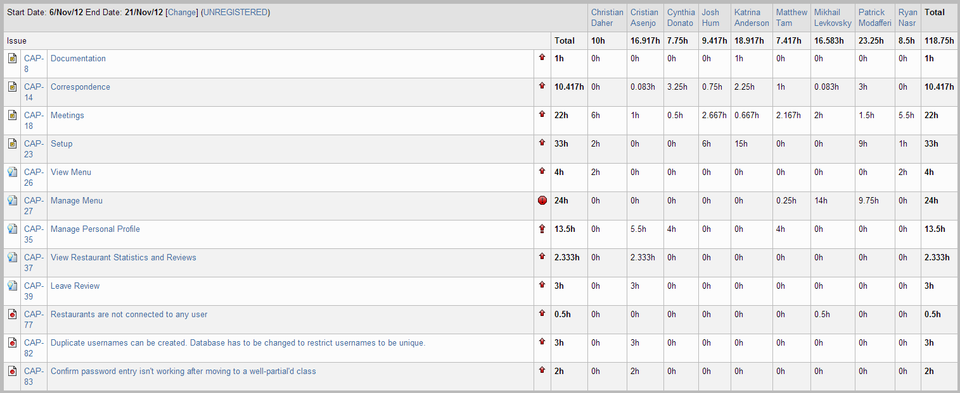

Figure 8‑1 Person-Hour Work Log

## Hour Burndown Chart

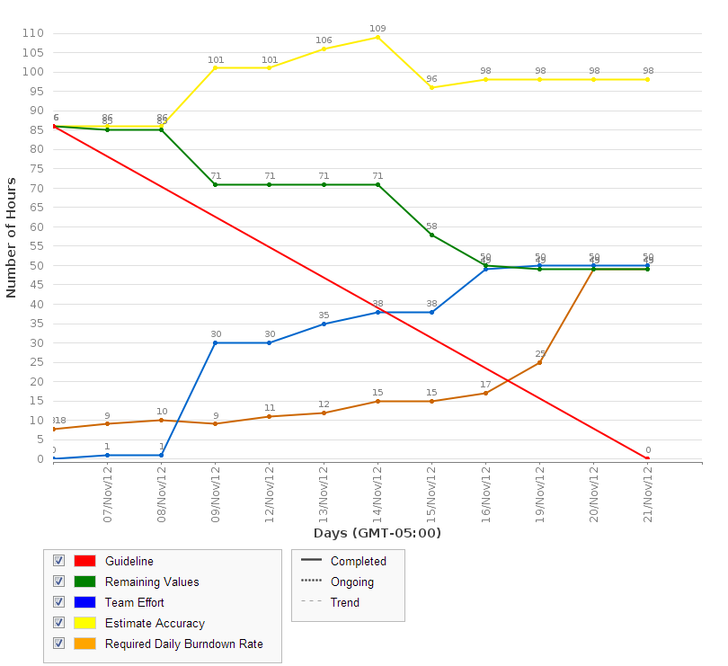

Figure 8‑2 Hour Burndown Chart

As seen in the previous chart, the team was not able to burndown everything that was assigned initially in this sprint. We initially estimated 85 hours were needed to complete all the programming tasks. Although the team put 118 hours of work into this iteration, only 50 were spent working on coding tasks as seen by the blue line. The remaining tasks represented by the green line show that there are 49 hours left before all stories can be burned down. We attribute this discrepancy between our total original estimate (85 hours) and the actual work needed (50 + 49 = 99 hours) to overly optimistic estimates. For example, some tasks took much longer than planned so the burndown was much slower than desired. The following image is an example of one such task.

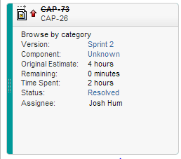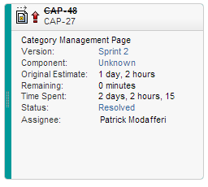

Figure 8‑3 Overestimation of CAP-73 and Underestimation of CAP-48

As shown in the previous two figures, there were both overestimations and underestimations made during our sprint planning. However, the discrepancy between the underestimations and the actual time needed were greater than the overestimations which caused the team to fall behind schedule. There were multiple tasks which were underestimated and only two that were overestimated.

## Issue Burndown Chart

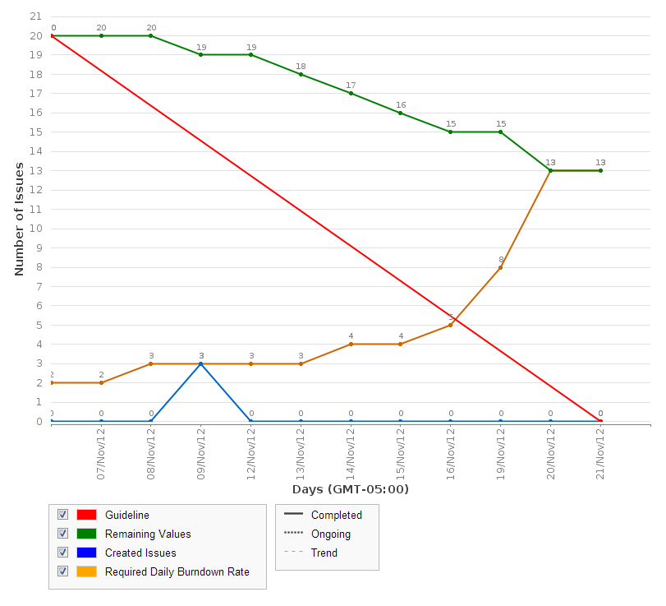

Figure 8‑4 Issue Burndown Chart

As seen in the issue burndown chart, 3 tasks were created during the iteration. This was because we overlooked some sub-tasks that were part of the sprint and needed to be added immediately. We will be working to eliminate such mistakes in the future with more detailed planning.

## Cumulative Velocities vs. Time

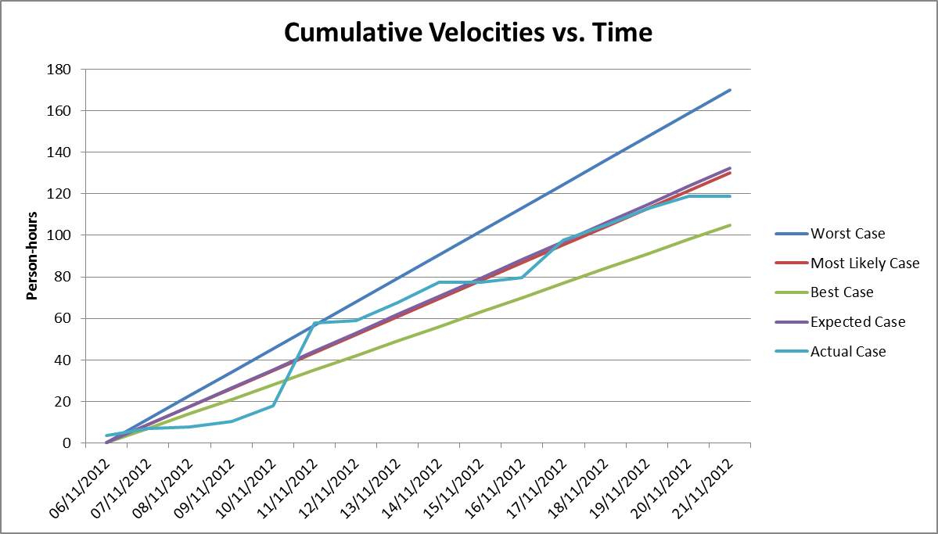

Figure 8‑5 Cumulative Velocities vs. Time

## Cumulative Flow Diagram

The following diagram shows the three stories and how the work progressed. Blue tasks have not been started, purple tasks are in progress and green represents a completed story. This diagram was generated in JIRA.

We attribute the increase in blue areas to inaccurate initial time estimations. Therefore, as we increased our time estimations to complete a story, the blue area also increased. The purple area stays relatively the same over the sprint showing that the work in progress stayed relatively constant.

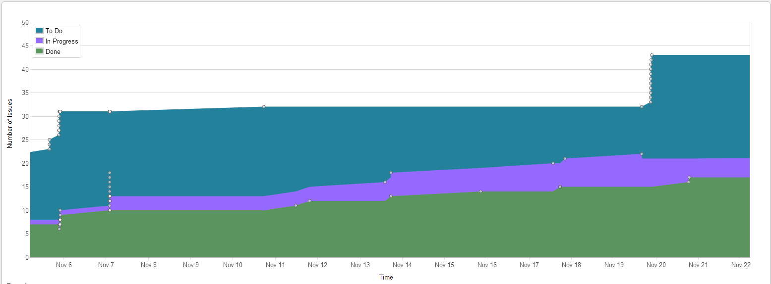

Figure 8‑6 Cumulative Flow Diagram

## Measurement Report

### Code Quality Analysis

The following report was generated after analyzing the code. Only one method did not meet code quality expectations by exceeding the expected number of lines of code. This will be corrected in future iterations.

Analysis tool used: Code Metrics Viewer

Found at: <http://visualstudiogallery.msdn.microsoft.com/9f35524b-a784-4dbc-bd7b-6babd7a5a3b3>

Version: 1.5.3

Last updated: 2/5/2012

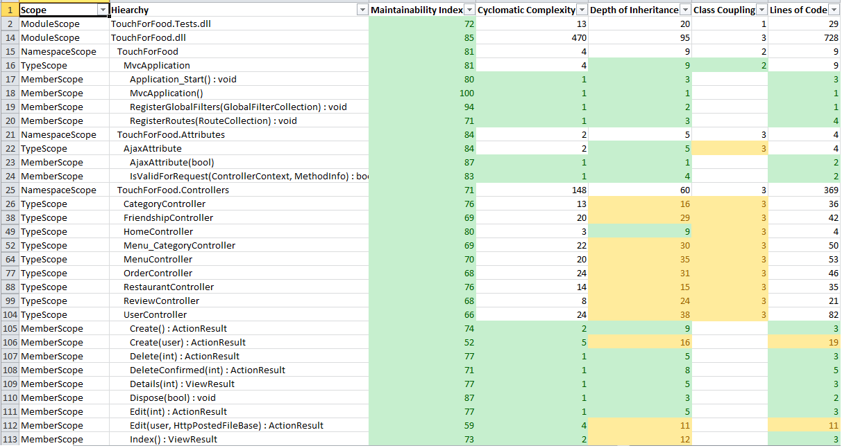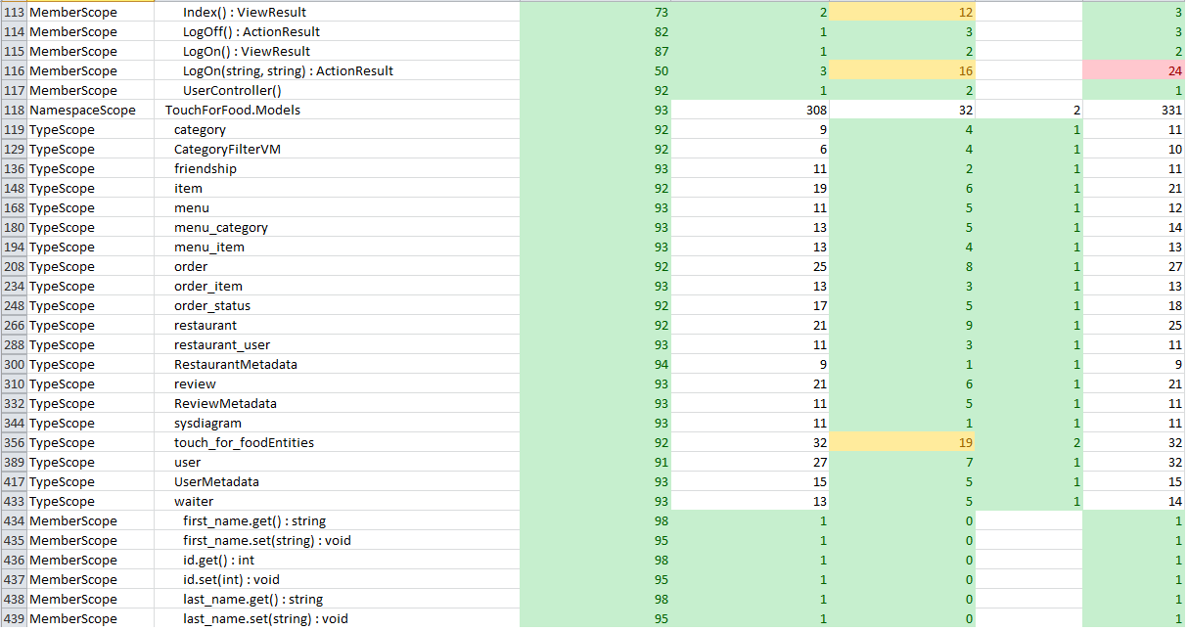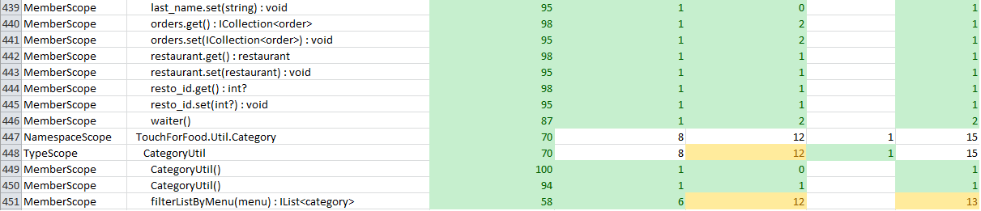

## Retrospective

In Iteration 2, we found that we were overly ambitious. We found that our time estimates were too optimistic which caused us to burn down tasks slower than planned. There were also still issues in learning how to use JIRA and setting up the coding environment. Being in the second sprint, some of these issues are understandable and accounted for in our best case-worst case styled estimates. However, corrective action must be taken immediately to avoid escalating these problems or repeating them further in the process. In this section we will see what the velocity was, what the team did well and did less well, along with what corrective measures we will take to improve our workflow and efficiency.

Our velocity in person-hours for this sprint was 50 person-hours. In terms of story points, our velocity was 0. If we look at cumulative velocity, we must add the velocity from Sprint 1 as well which was 2 story points, giving an average velocity of 1 story point per sprint. Although this figure seems alarming, we must consider that the Manage Personal Profile system is a story worth 34 points which we have started working on and spent over 24 person hours on already. Furthermore, the View Menu and Manage Menu user story are very close to completion. Ultimately, due to the fact that fractions of a user story can’t be considered when measuring this type of velocity, the actual story point number didn’t reflect perfectly the work that is done and what is left to be done.

### What was learned

The following positive and negative points were gathered from this sprint.

Positives:

* We committed more person-hours than previously
* Our processes and procedures became more defined and clear to the team
* Team members slowly becoming more familiar with the technologies in place
* The technologies chosen for the coding environment and framework are powerful and useful

Negatives:

* Did not complete any user stories planned
* The learning curve on setup, JIRA, and coding slowed down general progress
* The times logged are still inaccurate
* The estimates for the time required for each task was generally incorrect
* Many charts and graphs based on story points are misleading

### Changes in methodology

From this sprint a couple of changes in methodology were made. These changes come from the process of refining and perfecting our workflow to match the agile methodology and adapt it to our current project.

First of all, tasks were reorganized in JIRA, and tools were made available to all developers so they may access the specific task and log work under the correct sections. This effort is an attempt to reduce time needed to log one’s time in JIRA and encourage a more involved and accurate timesheet in the end.

Another flaw that was exposed was the lack of planning in the start of the sprint. Many of the tasks in the sprint had their estimates completely wrong and some issues and tasks were not accounted for from the start. This is an unacceptable occurrence and in order to reduce the chances of this occurring again, more thorough sprint planning meetings will be conducted were design for the user stories is discussed in more depth, thus giving the team a better idea of what needs to be done and how complex each task really is. As a result of this meeting, all the tasks should be clearly labelled, estimated and accompanied by a description of what is expected to be done for this task to be resolved.

Finally, there is a more technical adjustment made on the JIRA side. It was noticed that the new GreenHopper tools only displayed graphs based on story points which, as discussed earlier, were not completely representative. The scrum leader then switched the sprint planning and reporting to work with JIRA’s “Classic” functionality which allows more flexibility such as issues burndown and more importantly an hourly burndown chart to track the team’s progress against an estimated guideline.

# Iteration 3 Plan

## Planned Activities

This sprint was scheduled to span four weeks instead of the usual two weeks because the CloudNine team members had responsibilities to complete final projects and final exams. Documentation defects were assigned in this sprint as were the stories: CAP-26 – View Menu and CAP-27 – Manage Menu. There were no expectations to get much work done within the first two weeks as many team members were overwhelmed with other responsibilities. After the first two weeks, CAP-35 – Manage Personal Profile was removed from the sprint as we realized it shouldn’t have been there in the first place. Thus, the following two stories were planned for this sprint.

Table 9‑1 Planned Stories

| **User Story ID** | **Total Story Points** | **Related Use Cases** |
| --- | --- | --- |
| CAP-27, CAP-26 | 11.00 | UC1.1, UC3.1 |

The following defects were also planned. There are no story points associated to these defects.

Table 9‑2 Planned Defects

| **Defect ID** | **Hours Estimated** |
| --- | --- |
| CAP-88, CAP-91, CAP-92, CAP-93, CAP-94, CAP-95, CAP-96, CAP-97, CAP-98, CAP-99, CAP-100 | 15.25 hours |

## Person-Hour Estimation

The Expert Judgement Method was used to calculate person-hour estimations. Estimations were made for the worst case, most likely case, and best case. The worst case and best case are +30% and -30% of the most likely case. The expected case was then calculated with the formula:

Expected case = 1/6([worst case] + 4[most likely case] + [best case])

The numbers are extremely low because these hours only take planned stories into account. Overall however, there were many defects assigned in this sprint that were estimated to take 15.25 hours to complete. Although in time the sprint took place over four weeks, it was planned to be done in the final two weeks so all estimates are based on a fourteen day time period.

Table 9‑3 Person-Hour Estimation

| **User Story ID** | **Worst Case** | **Most Likely Case** | **Best Case** | **Expected Case** |
| --- | --- | --- | --- | --- |
| CAP-27 | 6.5 | 5 | 3.5 | 5 |
| CAP-26 | 8.8 | 6.75 | 4.7 | 6.75 |
| Total (ph) | 15.3 | 11.75 | 8.2 | 11.75 |
| Velocity (ph/day) | 1.09 | 0.84 | 0.59 | 0.84 |
| Velocity (ph/team member/day) | 0.12 | 0.09 | 0.07 | 0.09 |

# Iteration 3 Report

## Person-Hour Work Log

The following table shows the person-hour work log for each team member and activity during this iteration. This table was generated from the JIRA management system. As expected, there were very few hours worked this sprint due to other academic and work responsibilities. These hours reflect time spent on all tasks.

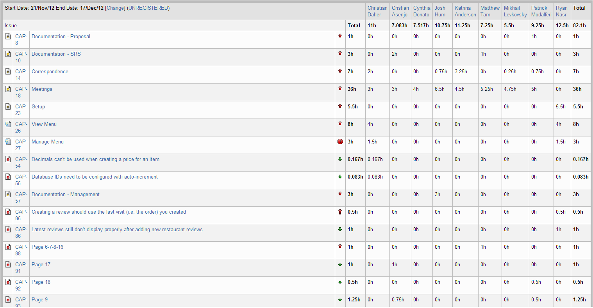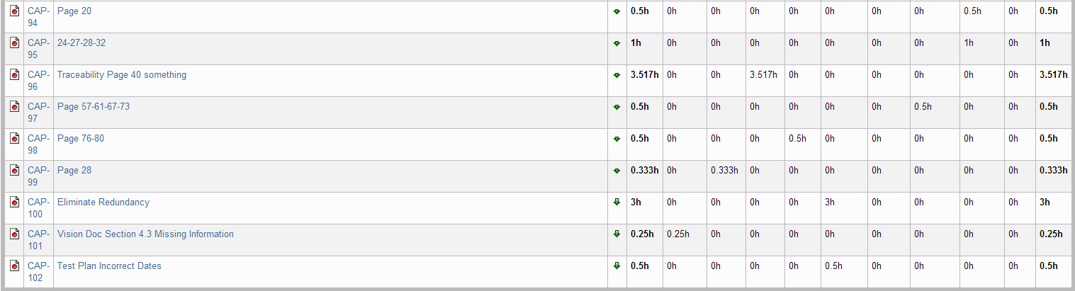

Figure 10‑1 Person-Hour Work Log

## Hour Burndown Chart

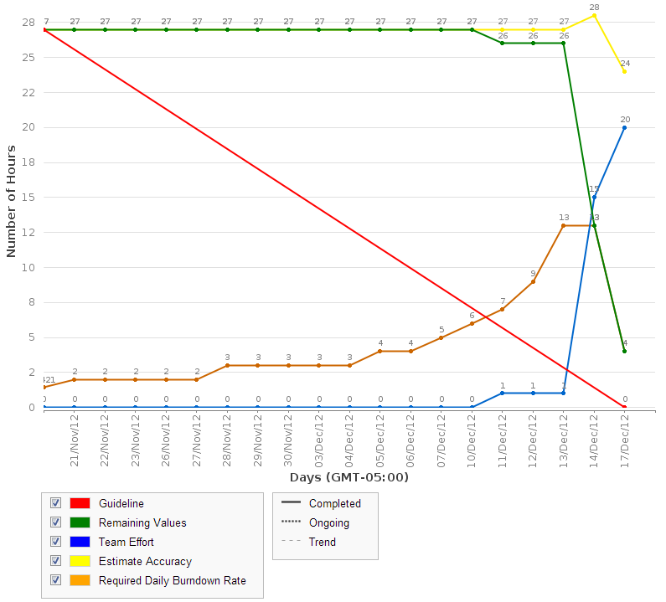

Figure 10‑2 Hour Burndown Chart

In total, between planned stories and defects, there were 27 hours estimated to working. As seen in the above graph, most of the work was either done last minute or logged last minute. Both stories were completed and all defects were completed except for two. Overall, we met our goals for our stories and for most of our defects. However, we were not satisfied with our overall time management because we felt that we did not plan enough and therefore felt no pressure to get more work done.

## Issue Burndown Chart

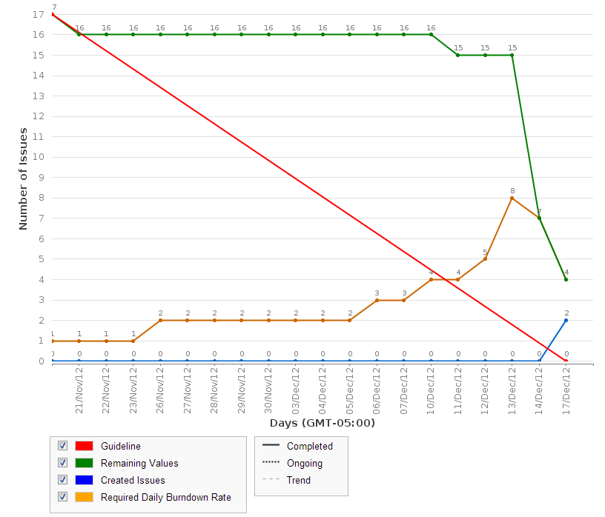

Figure 10‑3 Issue Burndown Chart

As seen in the issue burndown chart, most of the issues (both stories and defects) were completed. The two defects that were not completed were CAP-98 and CAP-100 which we realized would take more time and planning than expected.

## Cumulative Flow Diagram

The following diagram shows the cumulative flow of the project so far based on the number of issues completed, in progress, and to do. Although we are completing issues, we are also finding bugs and adding them to the backlog which explains the increase of issues to do at the end of the sprint.

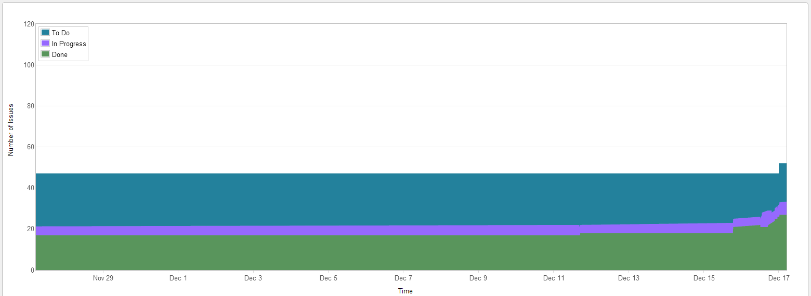

Figure 10‑4 Cumulative Flow Diagram

## Measurement Report

### Code Quality Analysis

The following report was generated after analyzing the code. Only one method did not meet code quality expectations by exceeding the expected number of lines of code. This was found in an earlier iteration and has not been yet corrected.

Analysis tool used: Code Metrics Viewer

Found at: <http://visualstudiogallery.msdn.microsoft.com/9f35524b-a784-4dbc-bd7b-6babd7a5a3b3>

Version: 1.5.3

Last updated: 2/5/2012

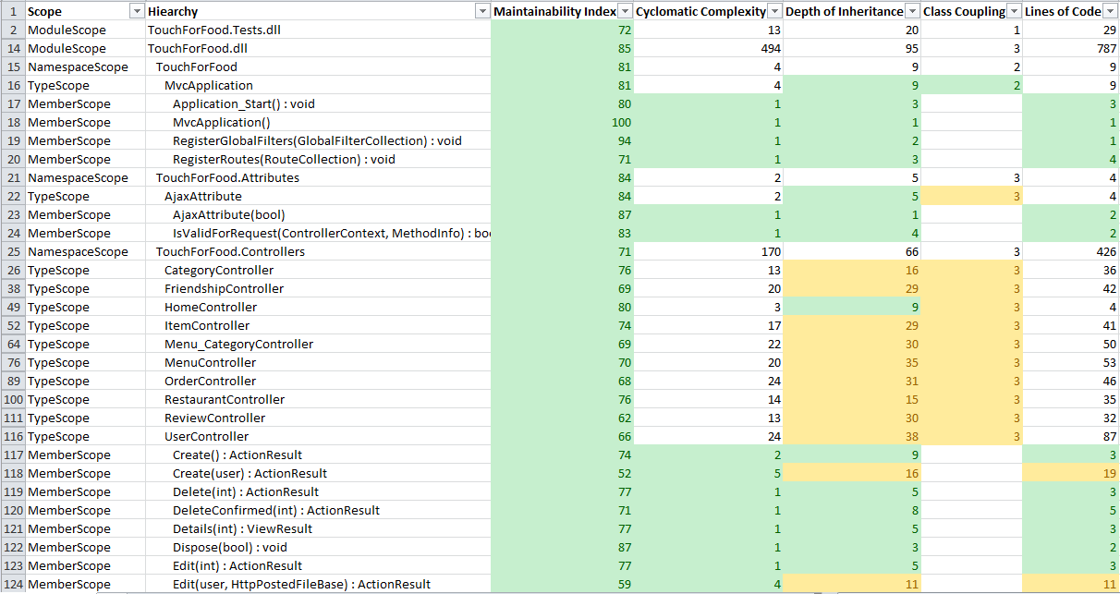

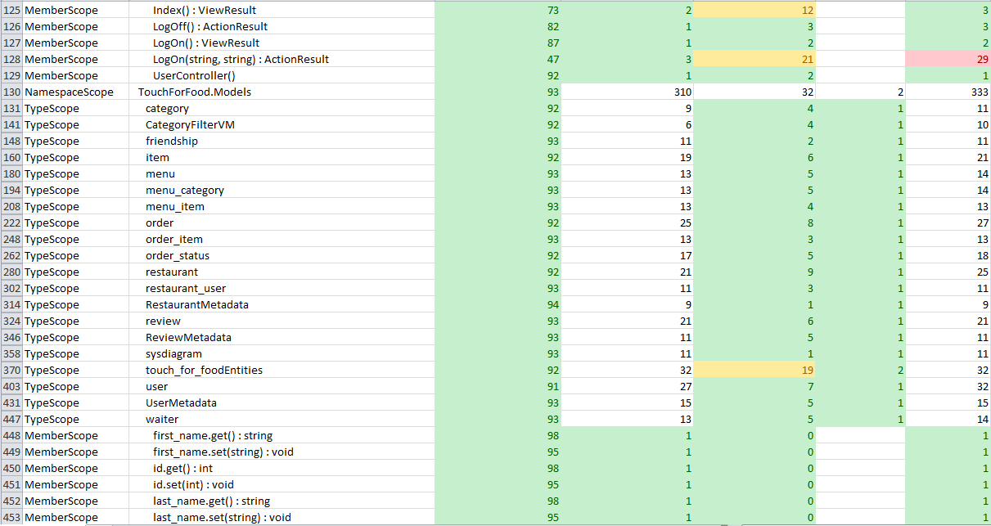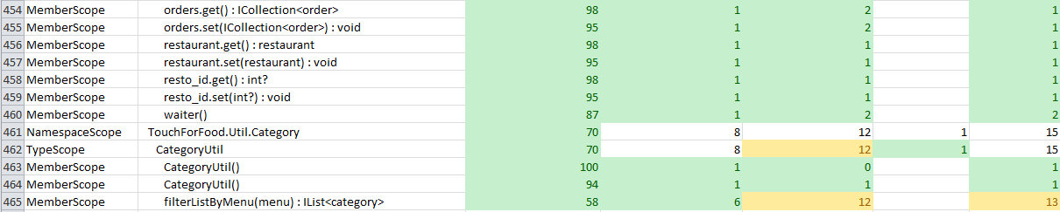

Figure 10‑5 Code Quality Report

## Retrospective

In Iteration 3, we underachieved. Although we met our goals, our goals were probably not set high enough. Even though this was with due reason, it was probably still not enough and we are not satisfied with our overall effort. On the other hand, however, the two stories planned were finished which makes this sprint a success.

### Velocity

Sprint 3 velocity (story points): 11 story points

Cumulative velocity (story points): 13 story points

Average velocity (story points): 4.3 story points

Sprint 3 velocity (p-h): 20 person-hours

Cumulative velocity (p-h): 98 person-hours

Average velocity per sprint: 32.7 person-hours

Our sprint 3 velocity in story points greatly exceeded our previous velocities. However, this was due to the fact that the stories completed did not have much work left to be done. In terms of person-hours, we spent less time working on stories than in the previous two sprints.

### Budget

Total person-hours budgeted to date: 2,484 person-hours

Total person-hours worked to date: 306.725 person-hours

We are grossly under-budget. This can be attributed to both a large over-estimation in the budget and also not enough time commitment from team members.

### What was learned

The following positive and negative points were gathered from this sprint.

Positives:

* Completed 11 story points which is greater than any previous sprint
* Team members slowly becoming more familiar with the technologies in place

Negatives:

* Spent a lot of time on overhead and not so much on coding new stories and moving the project forward
* Did not commit enough time/effort to this sprint
* Still figuring out how to use JIRA to its full potential

# Iteration 4 Plan

## Planned Activities

The stories planned for this sprint are CAP-25 – Order Food and CAP-29 – Manage Order. They are necessary to complete before moving forward with other aspects of the application as well as comprise the most important aspects of the Touch for Food application.

Table 11‑1 Planned Stories

| **User Story ID** | **Total Story Points** |
| --- | --- |
| CAP-25, CAP-29 | 18.00 |

The following defects were also planned. There are no story points associated to these defects.

Table 11‑2 Planned Defects

| **Defect ID** | **Hours Estimated** |
| --- | --- |
| CAP-98, CAP-100, CAP-111, CAP-125, CAP-156, CAP-160, CAP-168 | 15.00 hours |

## Person-Hour Estimation

The Expert Judgement Method was used to calculate person-hour estimations. Estimations were made for the worst case, most likely case, and best case. The worst case and best case are +30% and -30% of the most likely case. The expected case was then calculated with the formula:

Expected case = 1/6([worst case] + 4[most likely case] + [best case])

Table 11‑3 Person-Hour Estimation

| **User Story ID** | **Worst Case** | **Most Likely Case** | **Best Case** | **Expected Case** |
| --- | --- | --- | --- | --- |
| CAP-25 | 89.7 | 69 | 48.3 | 69 |
| CAP-29 | 75.4 | 58 | 40.6 | 58 |
| Total (ph) | 165.1 | 127 | 88.9 | 127 |
| Velocity (ph/day) | 11.8 | 9.1 | 6.4 | 9.1 |
| Velocity (ph/team member/day) | 1.3 | 1.0 | 0.7 | 1.0 |

# Iteration 4 Report

## Person-Hour Work Log

The following table shows the person-hour work log for each team member and activity during this iteration. This table was generated from the JIRA management system. As planned, much more time was committed this sprint and it is reflected in this work log. These hours reflect time spent on all tasks.

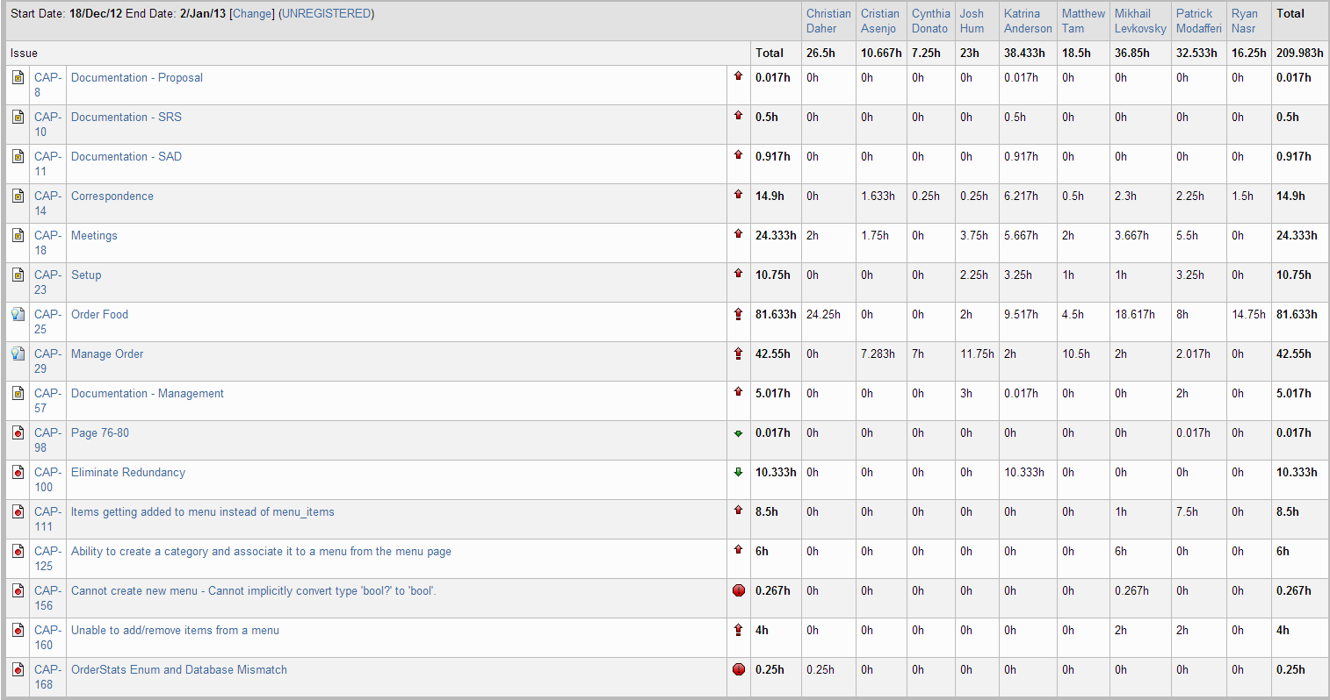

Figure 12‑1 Person-Hour Work Log

## Hour Burndown Chart

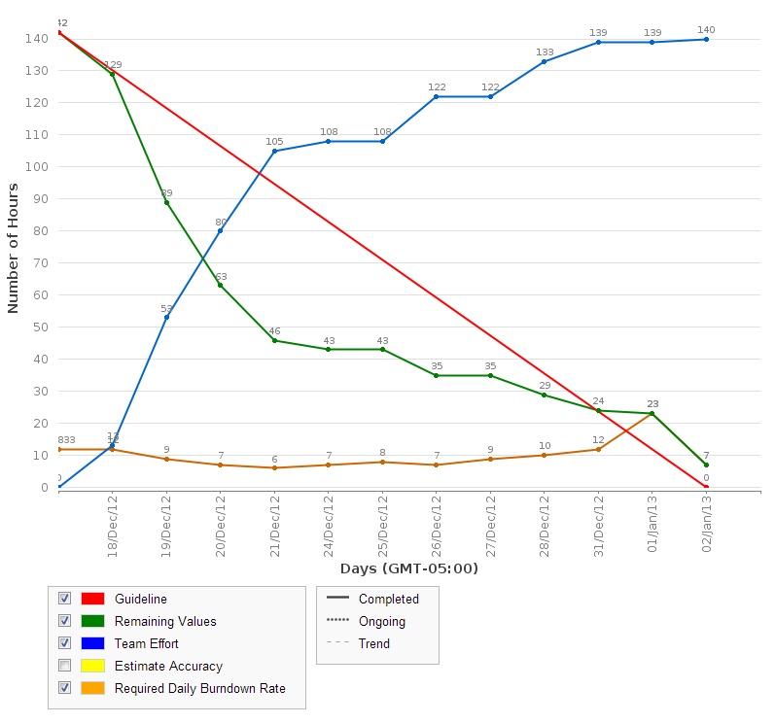

Figure 12‑2 Hour Burndown Chart

For the first time, the estimated number of hours worked and the actual number of hours worked were very close. By the end of the sprint, we worked 7 hours less than initially planned. However, there was no delay in working and tasks were started at the beginning of the sprint. This is a very positive thing for the team.

## Issue Burndown Chart

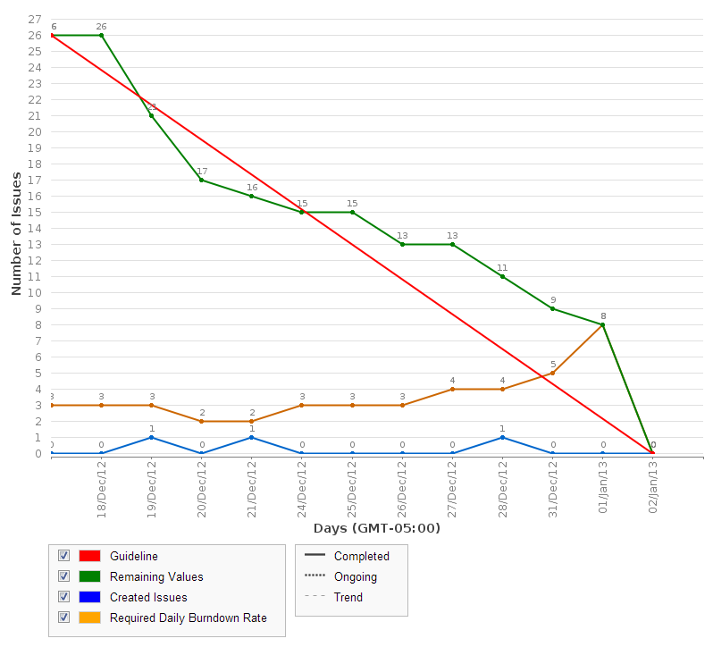

Figure 12‑3 Issue Burndown Chart

As seen in the issue burndown chart, all of the issues planned were completed. Tasks were completed in a timely manner and burned down at a relatively steady rate.

## Cumulative Flow Diagram

The following diagram shows the cumulative flow of the project so far based on the number of issues completed, in progress, and to do. Although we are completing issues, we are also finding bugs and adding them to the backlog which explains the increase of issues to do at the end of the sprint.

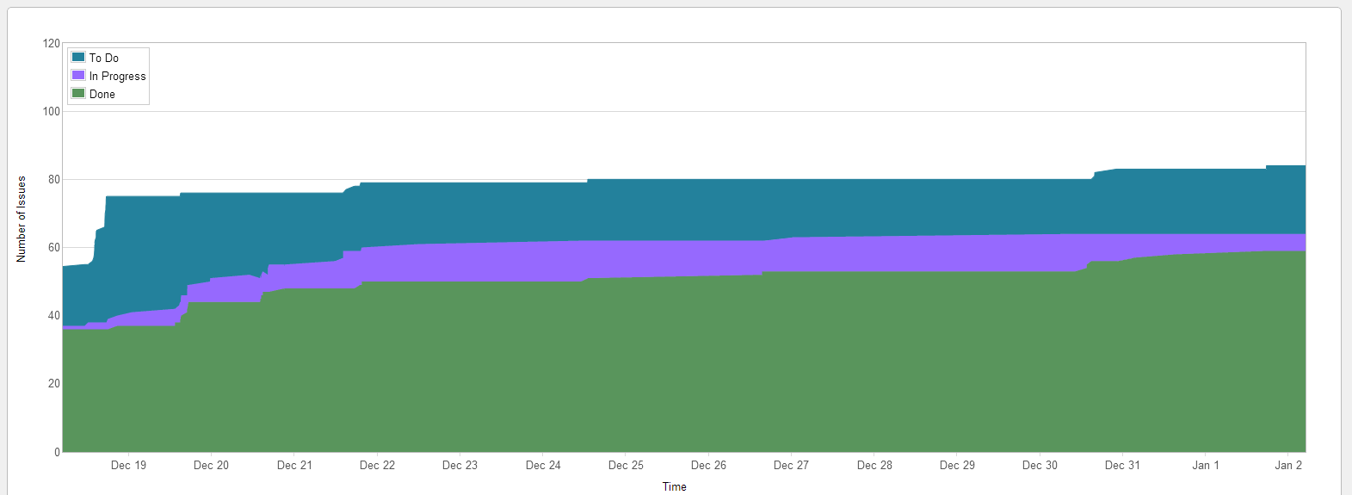

Figure 12‑4 Cumulative Flow Diagram

## Measurement Report

### Code Quality Analysis

The following report was generated after analyzing the code. Three methods did not meet code quality goals by exceeding the expected number of lines of code. One of these was found in an earlier iteration and has not been yet corrected while the other two instances were introduced in this sprint. All of them have been entered as bugs and will be fixed in a future iteration.

Analysis tool used: Code Metrics Viewer

Found at: <http://visualstudiogallery.msdn.microsoft.com/9f35524b-a784-4dbc-bd7b-6babd7a5a3b3>

Version: 1.5.3

Last updated: 2/5/2012

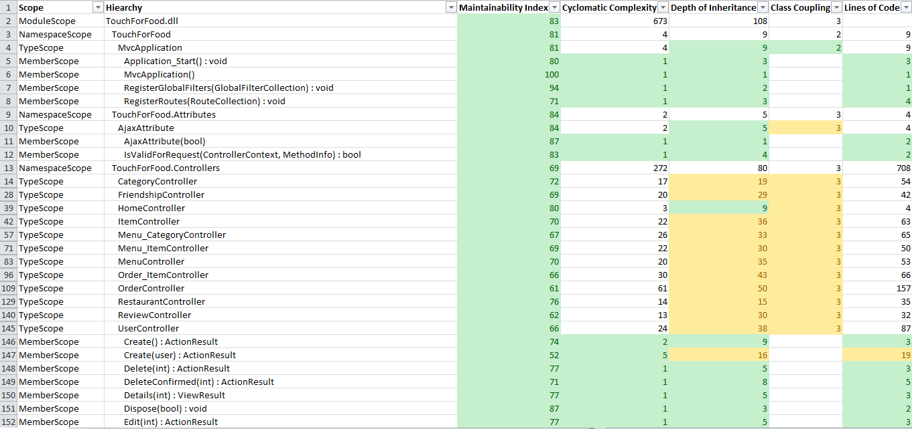

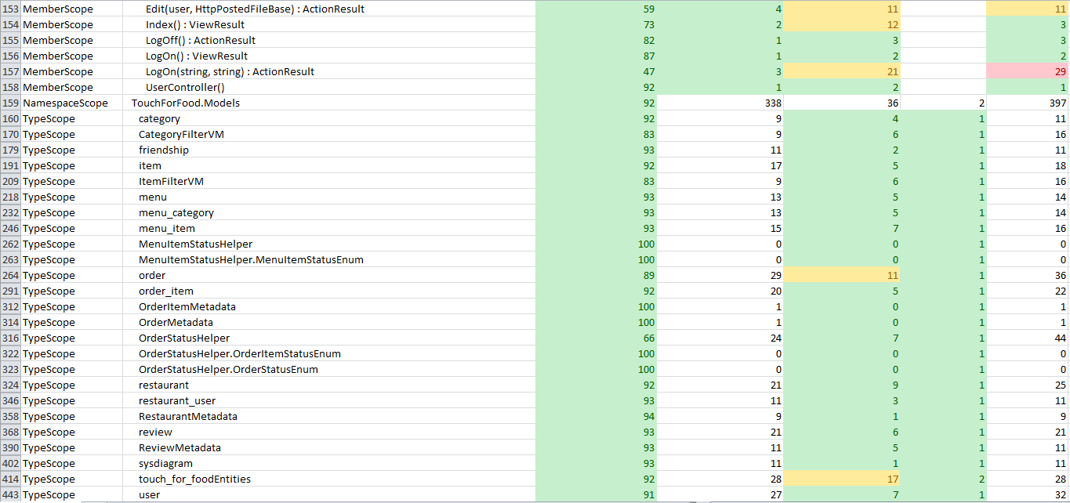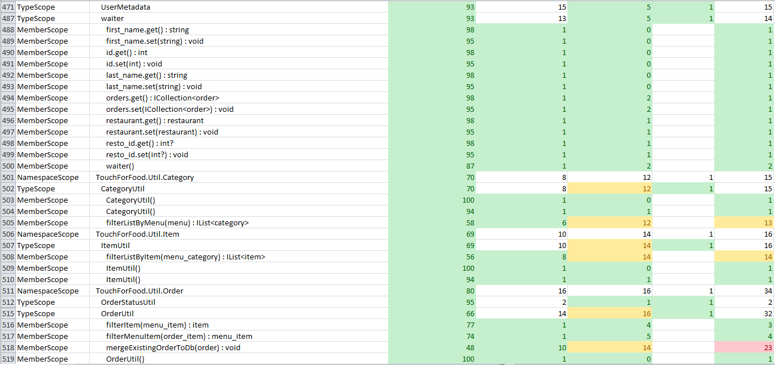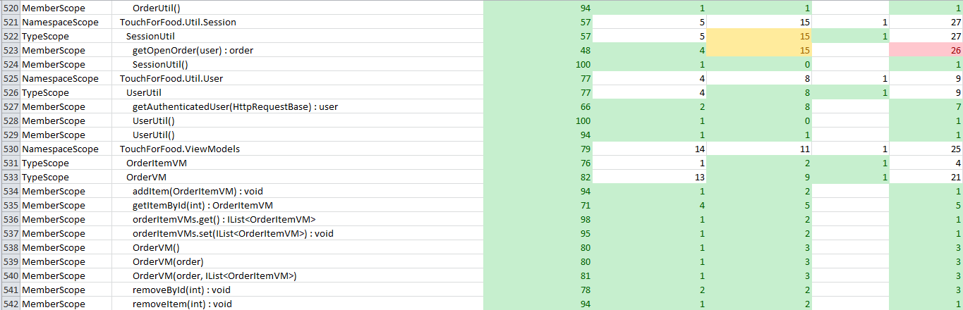

Figure 12‑5 Code Quality Report

## Retrospective

Iteration 4 was a success because we completed all the stories planned for this sprint. The project started gaining momentum as both the stories completed were critical. There was a greater effort put forth by the entire team and this produced immediate results. All other issues planned were also completed.

### Velocity

Sprint 4 velocity (story points): 18 story points

Cumulative velocity (story points): 31 story points

Average velocity (story points): 7.75 story points

Sprint 4 velocity (p-h): 124.2 person-hours

Cumulative velocity (p-h): 222.2 person-hours

Average velocity per sprint: 55.6 person-hours

In sprint 4, the team’s velocity in story points increased once again compared to previous sprints. We attribute this to simply more time being spent on coding than previously. The team’s velocity in person-hours also increased. It is clear that as we dedicate more person-hours to the stories planned, the results will follow.

### Budget

Total person-hours budgeted to date: 2,898 person-hours

Total person-hours worked: 516.705 person-hours

Person-hours budgeted per sprint: 414 person-hours

Person-hours worked in Sprint 4: 209.98 person-hours

Although we are still under budget, the effort produced in this sprint exceeded previous sprints. There was an over-estimation in the budget so it is unlikely to ever match the budget, but an effort closer to 300 person-hours will probably be necessary in future sprints.

### What was learned

The following positive and negative points were gathered from this sprint.

Positives:

* Completed 18 story points which is greater than any previous sprint
* Greater team effort and contribution overall
* Critical stories were completed
* More organized configuration management
* Team members more familiar with the technologies in place

Negatives:

* Still need to catch up to get back on schedule

# Iteration 5 Plan

In iteration 5, the plan is to make up for a lack of quality or thoroughness in past sprints. The story point count is low so that the team can focus on catching up on testing, documenting and amending defects. In addition, the user interface will be implemented throughout the application during this sprint.

## Planned Activities

Tables featured in this section of the document were created with JIRA [2].

### Tasks

Table 13‑1 Iteration 5 Planned Tasks

|  |  |  |  |  |
| --- | --- | --- | --- | --- |
| **Key** | **Issue Type** | **Priority** | **Assignee** | **Original Estimate (hours)** |
| CAP-164 | Task | Major | Katrina Anderson | 0.00 |
| CAP-165 | Sub-task | Major | Katrina Anderson | 10.00 |
| CAP-166 | Sub-task | Major | Katrina Anderson | 10.00 |
| CAP-172 | Sub-task | Major | Katrina Anderson | 1.00 |
| CAP-57 | Task | Major | *Unassigned* | 0.00 |
| CAP-173 | Sub-task | Minor | Mikhail Levkovsky | 1.00 |
| CAP-174 | Sub-task | Minor | Mikhail Levkovsky | 1.00 |
| CAP-175 | Sub-task | Minor | Mikhail Levkovsky | 1.00 |
| CAP-176 | Sub-task | Minor | Mikhail Levkovsky | 1.00 |
| CAP-177 | Sub-task | Major | Patrick Modafferi | 1.00 |
| CAP-178 | Sub-task | Minor | Patrick Modafferi | 1.00 |
| CAP-180 | Sub-task | Minor | Josh Hum | 1.00 |
| CAP-181 | Sub-task | Minor | Josh Hum | 1.00 |
| CAP-182 | Sub-task | Minor | Katrina Anderson | 1.00 |
| CAP-183 | Sub-task | Minor | Josh Hum | 1.50 |
| CAP-184 | Sub-task | Minor | Josh Hum | 1.50 |
| CAP-185 | Sub-task | Minor | Josh Hum | 1.50 |
| CAP-186 | Sub-task | Minor | Josh Hum | 2.00 |
| CAP-187 | Sub-task | Minor | Josh Hum | 2.00 |
| CAP-188 | Sub-task | Minor | Josh Hum | 2.00 |
| CAP-189 | Sub-task | Minor | Josh Hum | 5.00 |
| CAP-11 | Task | Major | *Unassigned* | 0.00 |
| CAP-215 | Sub-task | Minor | Katrina Anderson | 2.00 |
| CAP-162 | Task | Major | Josh Hum, Patrick Modafferi & Matt Tam | 0.00 |
| CAP-197 | Sub-task (CAP-162) | Major | Josh Hum | 2.00 |
| CAP-202 | Sub-task (CAP-162) | Major | Patrick Modafferi | 6.00 |
| CAP-208 | Sub-task (CAP-162) | Major | Patrick Modafferi | 5.00 |
| CAP-209 | Sub-task (CAP-162) | Major | Josh Hum, Patrick Modafferi & Matt Tam | 16.00 |
| CAP-210 | Sub-task (CAP-162) | Major | Josh Hum, Patrick Modafferi & Matt Tam | 16.00 |
| CAP-211 | Sub-task (CAP-162) | Major | Patrick Modafferi | 4.00 |
| CAP-212 | Sub-task (CAP-162) | Major | Patrick Modafferi | 18.00 |
| CAP-213 | Sub-task (CAP-162) | Major | Matthew Tam | 16.00 |
| CAP-214 | Sub-task (CAP-162) | Major | Josh Hum, Patrick Modafferi & Matt Tam | 8.00 |
| CAP-216 | Sub-task (CAP-162) | Major | Josh Hum, Patrick Modafferi & Matt Tam | 10.00 |
| CAP-217 | Sub-task (CAP-162) | Major | Josh Hum | 4.00 |
| CAP-218 | Sub-task (CAP-162) | Major | Josh Hum | 6.00 |
| CAP-230 | Sub-task (CAP-162) | Major | Josh Hum | 4.00 |
| CAP-231 | Sub-task (CAP-162) | Major | *Unassigned* | 5.00 |
| CAP-198 | Task | Major | Mikhail Levkovsky, Katrina Anderson & Cristian Asenjo | 0.00 |
| CAP-199 | Sub-task (CAP-198) | Major | Katrina Anderson | 3.00 |
| CAP-200 | Sub-task (CAP-198) | Major | Katrina Anderson | 3.00 |
| CAP-201 | Sub-task (CAP-198) | Major | Mikhail Levkovsky | 3.00 |
| CAP-203 | Sub-task (CAP-198) | Major | Cristian Asenjo | 16.00 |
| CAP-204 | Sub-task (CAP-198) | Major | Mikhail Levkovsky | 3.00 |
| CAP-205 | Sub-task (CAP-198) | Major | Mikhail Levkovsky | 5.00 |
| CAP-206 | Sub-task (CAP-198) | Major | Katrina Anderson | 6.00 |
| CAP-207 | Sub-task (CAP-198) | Major | Mikhail Levkovsky | 1.00 |
|  |  |  | **TOTAL** | **207.50** |

### Stories

In this iteration, two stories are planned to be resolved, for a total of six story points.

Table 13‑2 Iteration 5 Planned Stories

|  |  |  |  |  |  |
| --- | --- | --- | --- | --- | --- |
| **Key** | **Issue Type** | **Priority** | **Assignee** | **Story Points** | **Original Estimate (hours)** |
| CAP-40 | Story | Critical | Cristian Asenjo & Cynthia Donato | 3.00 | 0.00 |
| CAP-163 | Sub-task (CAP-40) | Major | Cristian Asenjo & Cynthia Donato |  | 16.00 |
| CAP-194 | Sub-task (CAP-40) | Major | Cristian Asenjo & Cynthia Donato |  | 4.00 |
| CAP-196 | Sub-task (CAP-40) | Major | Cristian Asenjo & Cynthia Donato |  | 12.00 |
| CAP-192 | Story | Blocker | Christian Daher & Ryan Nasr | 3.00 | 0.00 |
| CAP-219 | Sub-task (CAP-192) | Major | Ryan Nasr |  | 8.00 |
| CAP-220 | Sub-task (CAP-192) | Major | Ryan Nasr |  | 8.00 |
| CAP-221 | Sub-task (CAP-192) | Major | Christian Daher & Ryan Nasr |  | 20.00 |
| CAP-222 | Sub-task (CAP-192) | Major | Ryan Nasr |  | 6.00 |
| CAP-224 | Sub-task (CAP-192) | Major | Christian Daher & Ryan Nasr |  | 4.00 |
| CAP-225 | Sub-task (CAP-192) | Major | Christian Daher & Ryan Nasr |  | 16.00 |
| CAP-244 | Sub-task (CAP-192) | Major | Christian Daher & Ryan Nasr |  | 2.00 |
| CAP-245 | Sub-task (CAP-192) | Major | Christian Daher & Ryan Nasr |  | 2.00 |
|  | | | **TOTAL** | **6.00** | **98.00** |

### Defects

In this iteration, twelve defects are planned to be resolved. Blocker or Critical category defects can be added to the iteration at any time.

Table 13‑3 Iteration 5 Planned Defects

|  |  |  |  |  |  |
| --- | --- | --- | --- | --- | --- |
| **Key** | **Issue Type** | **Priority** | **Assignee** | **Reporter** | **Original Estimate (hours)** |
| CAP-85 | Bug | Critical | Ryan Nasr | Cristian Asenjo | 0.50 |
| CAP-108 | Bug | Minor | Christian Daher | Christian Daher | 4.00 |
| CAP-109 | Bug | Major | Mikhail Levkovsky | Christian Daher | 4.00 |
| CAP-128 | Bug | Trivial | Mikhail Levkovsky | Patrick Modafferi | 2.00 |
| CAP-158 | Bug | Minor | Mikhail Levkovsky | Katrina Anderson | 3.00 |
| CAP-159 | Bug | Major | Ryan Nasr | Matthew Tam | 0.50 |
| CAP-161 | Bug | Critical | Patrick Modafferi | Cynthia Donato | 0.17 |
| CAP-169 | Bug | Major | Cynthia Donato | Katrina Anderson | 5.00 |
| CAP-170 | Bug | Trivial | Katrina Anderson | Katrina Anderson | 0.25 |
| CAP-190 | Bug | Major | Ryan Nasr | Patrick Modafferi | 4.00 |
| CAP-191 | Bug | Minor | Cristian Asenjo | Cristian Asenjo | 4.00 |
| CAP-193 | Bug | Minor | Patrick Modafferi | Patrick Modafferi | 6.00 |
| CAP-226 | Sub-task (CAP-193) | Major | Patrick Modafferi | Patrick Modafferi | 0.00 |
| CAP-227 | Sub-task (CAP-193) | Major | Patrick Modafferi | Patrick Modafferi | 0.00 |
| CAP-228 | Sub-task (CAP-193) | Major | Patrick Modafferi | Patrick Modafferi | 0.00 |
|  | | | | **TOTAL** | **33.42** |

## Person-Hour Estimation

The Expert Judgement Method was used to calculate person-hour estimations.

Table 13‑4 Iteration 5 Person-Hour Estimation

|  |  |  |  |  |
| --- | --- | --- | --- | --- |
| **Description** | **Worst Case** | **Most Likely Case** | **Best Case** | **Expected Case** |
| **Tasks** | 269.75 | 207.50 | 145.25 | 207.50 |
| **Stories** | 127.40 | 98.00 | 68.60 | 98.00 |
| **Defects** | 43.45 | 33.42 | 23.39 | 33.42 |
| **Total(ph)** | 440.60 | 338.92 | 237.24 | 338.92 |
| **Velocity(ph/day)** | 31.47 | 24.21 | 16.95 | 24.21 |
| **Velocity (ph/team member/day)** | 3.50 | 2.69 | 1.88 | 2.69 |

# Iteration 5 Report

## Person-Hour Work Log

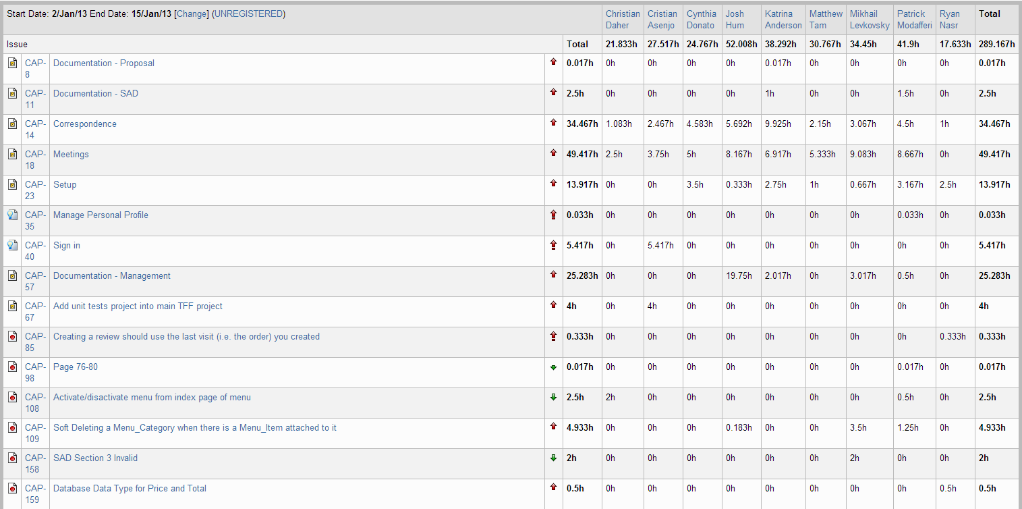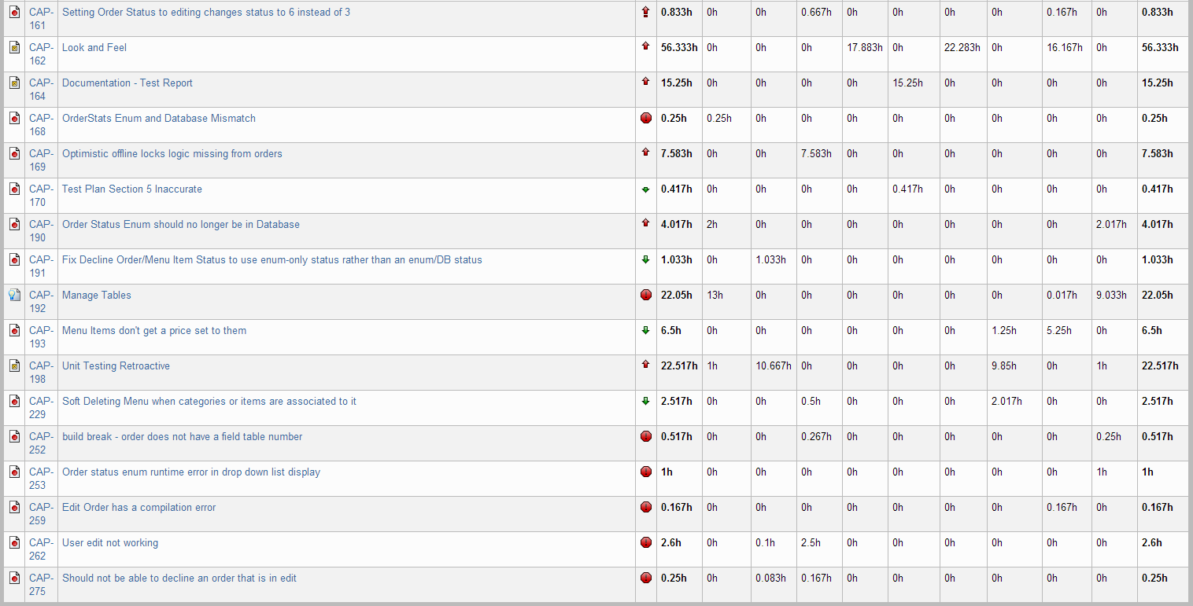

Figure 14‑1 Person-Hour Work Log

## Hour Burndown Chart

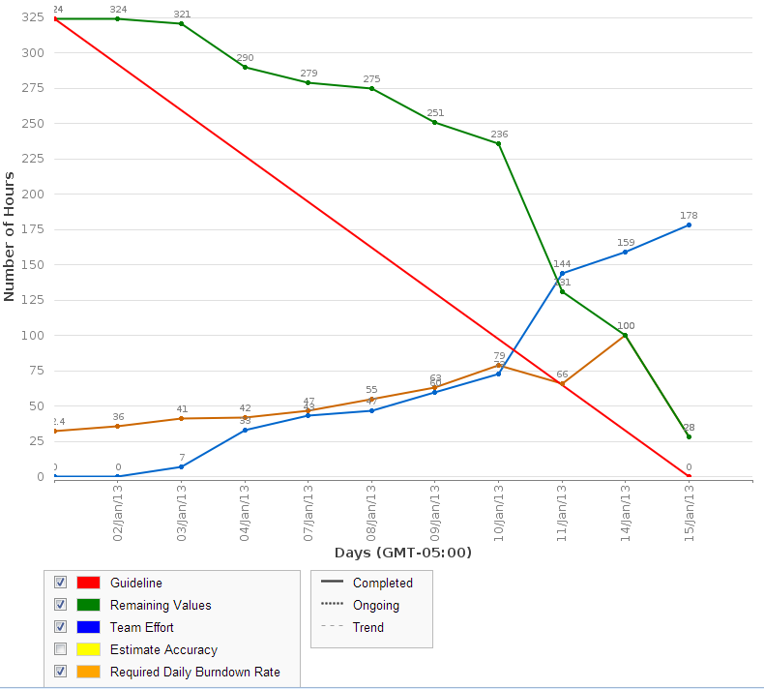

Figure 14‑2 Hour Burndown Chart

Almost 300 hours were spent working in Iteration 5. The effort was steady as can be seen by this graph with quite a few hours being worked from the beginning of the sprint.

## Issue Burndown Chart

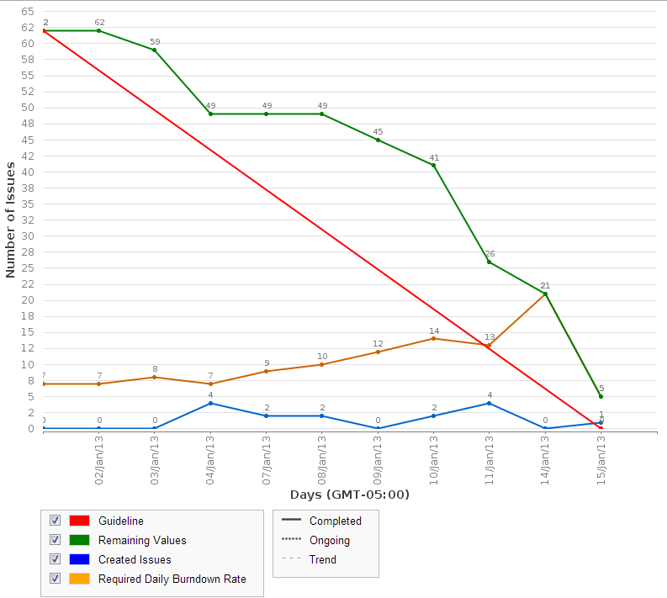

Figure 14‑3 Issue Burndown Chart

As seen in the above chart, issues were burned down in correspondence with the amount of effort put in. Again, almost all the issues planned in this sprint were completed. CAP-40 – Sign In was pushed to the next sprint because it was not yet completed.

## Cumulative Flow Diagram

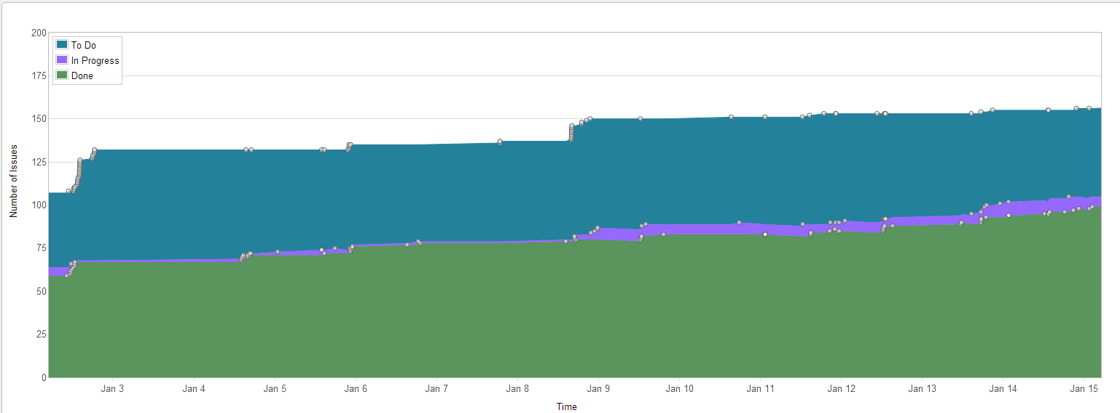

Figure 14‑4 Cumulative Flow Diagram

Although new bugs are found and added as issues, our progress is steady in completing issues. Overall, almost 100 issues have been completed, leaving 50 more issues to complete until completing the project. Of course, we expect the number of remaining issues to increase as more bugs are added or new tasks defined.

## Measurement Report

### Code Quality Analysis

The following report was generated after analyzing the code. Four methods did not meet code quality goals by exceeding the expected number of lines of code. Three of these were found in an earlier iteration and had not been corrected yet while the new instances were introduced in this sprint. All of them have been entered as bugs and will be fixed in a future iteration.

Analysis tool used: Code Metrics Viewer

Found at: <http://visualstudiogallery.msdn.microsoft.com/9f35524b-a784-4dbc-bd7b-6babd7a5a3b3>

Version: 1.5.3

Last updated: 2/5/2012

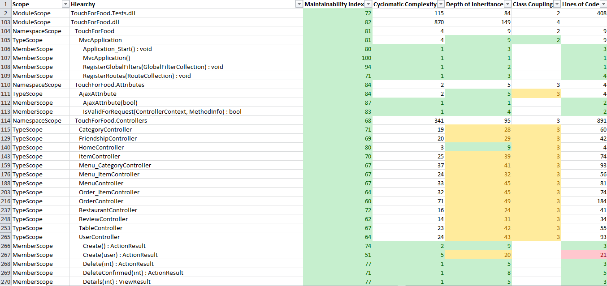

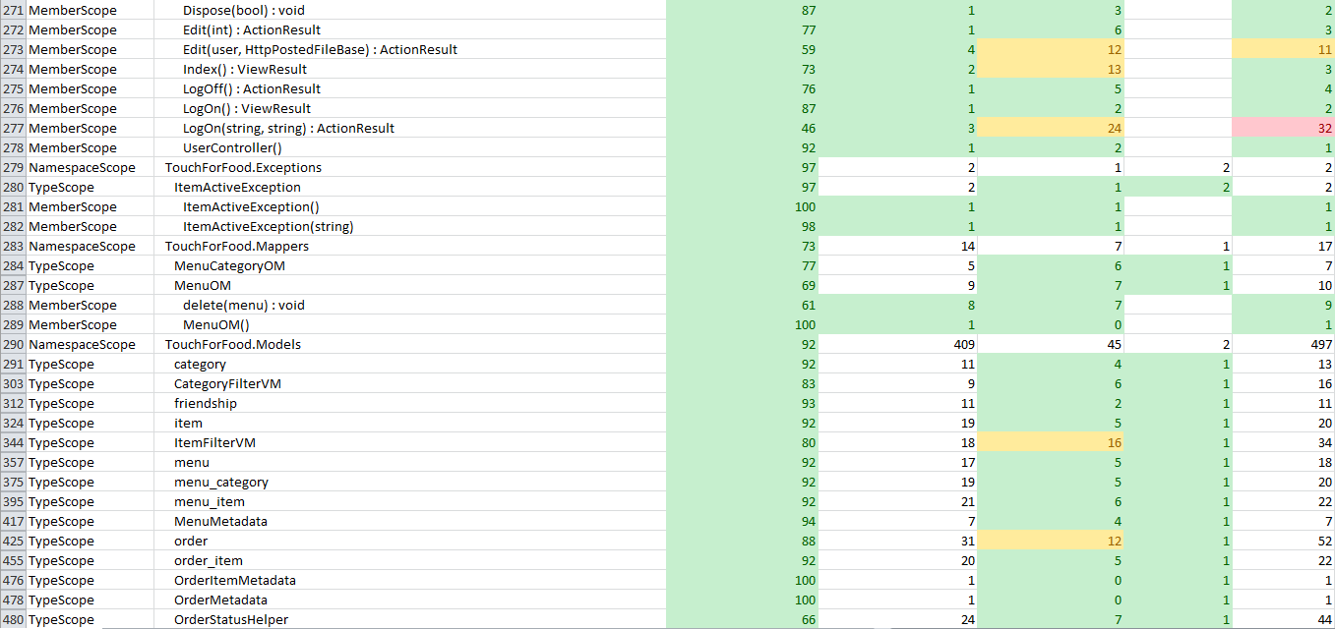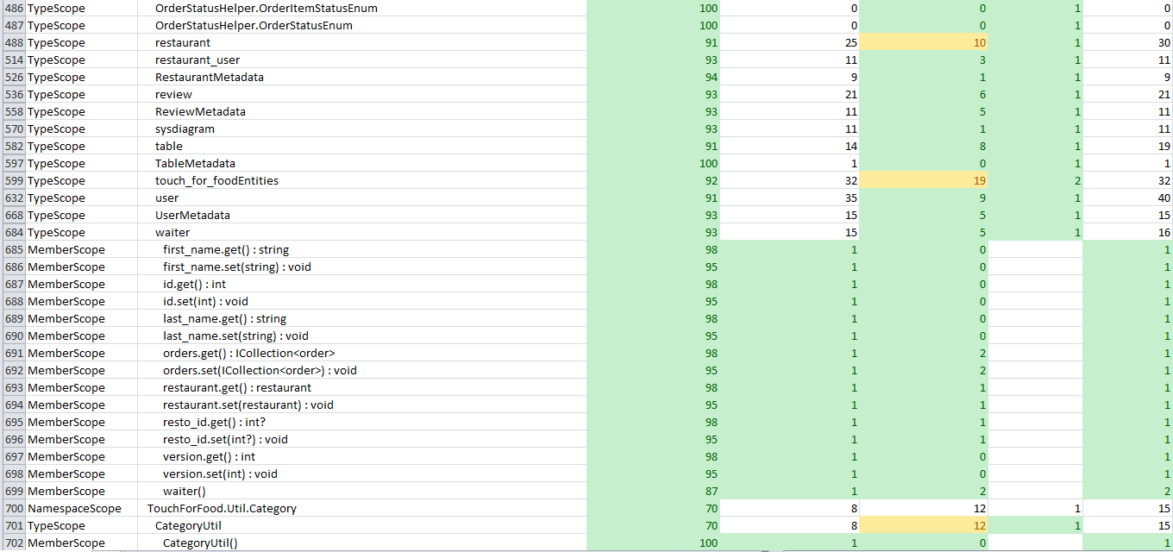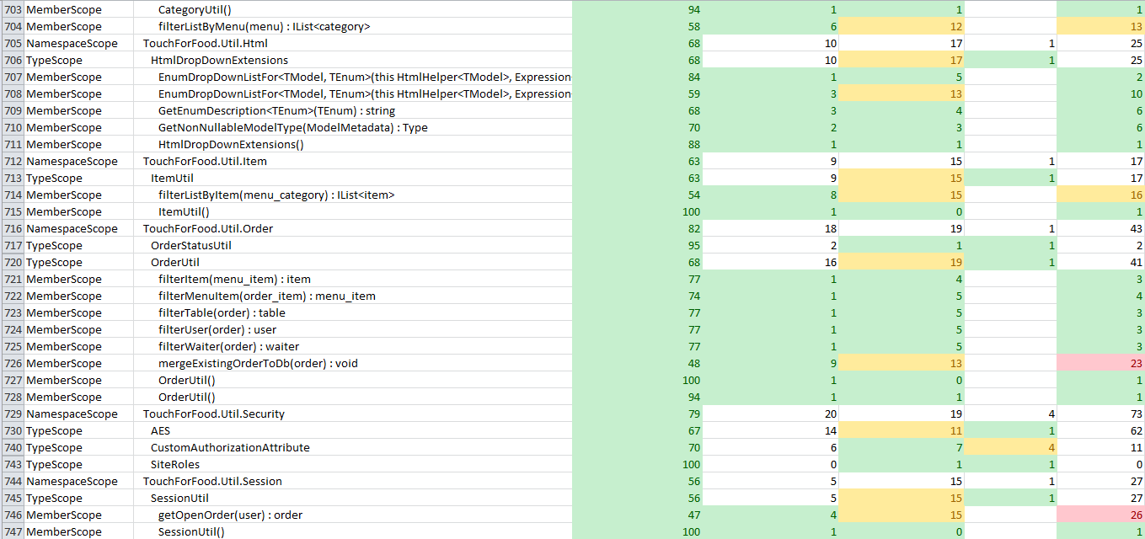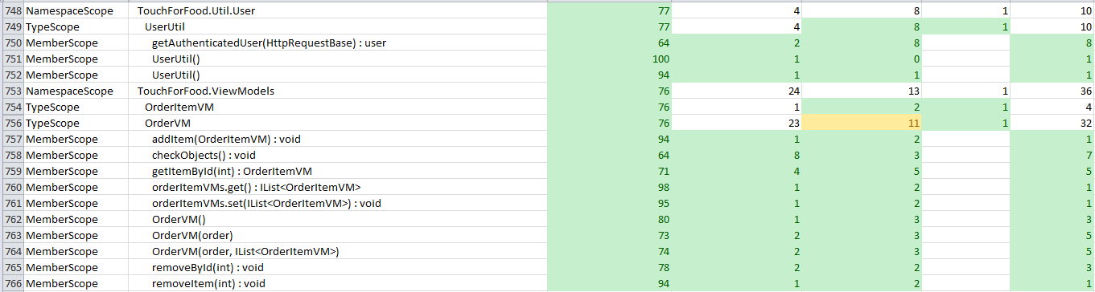

Figure 14‑5 Code Quality Report

## Retrospective

In iteration 5, we completed 3 out of a planned 6 story points. Although this decreases our story point velocity, many other important issues were addressed and completed. As planned, we focused this sprint on testing, defects and missing documentation. The incomplete story was moved to the next sprint for completion.

### Velocity

Sprint 5 velocity (story points): 3 story points

Cumulative velocity (story points): 34 story points

Average velocity (story points): 6.8 story points

Sprint 5 velocity (p-h): 289.17 person-hours

Cumulative velocity (p-h):805.872 person-hours

Average velocity per sprint:161.17 person-hours

It should be noted that velocity in person-hours was being calculated as just counting tasks with story points associated to them. From now on, it will be calculated to include all person-hours worked.

### Budget

Total person-hours budgeted to date: 2,898 person-hours

Total person-hours worked to date: 805.872 person-hours

Person-hours budgeted per sprint: 414 person-hours

Person-hours worked in Sprint 5: 289.17 person-hours

The number of hours worked has increased each sprint and this was no exception. With our person-hour effort reaching almost 300 hours this iteration, many issues were taken care of and rapid progress is being made in terms of catching up to where we need to be in the project.

### What was learned

The following positive and negative points were gathered from this sprint.

Positives:

* Completed 3 story points
* Greater team effort and contribution overall
* More organized and structured meetings
* Better processes established
* Many lingering issues (documents, defects, etc.) were dealt with

Negatives:

* Still need to catch up to get back on schedule

# Iteration 6 Plan

In iteration 6, the goal is to continue working on increasing quality of our work while also moving the project forward. New user stories will be worked on while we will have one person dedicated to fixing bugs and one other person doing QA. To build off our last iteration, all new pages will include the UI theme that was implemented in sprint 5.

## Planned Activities

Tables featured in this section of the document were created with JIRA [2].

Table 15‑1 Planned Activities

|  |  |  |  |  |
| --- | --- | --- | --- | --- |
| **Key** | **Issue Type** | **Priority** | **Assignee** | **Original Estimate (hours)** |
| CAP-26 | Story | Major | Josh Hum |  |
| CAP-42 | Story | Major | Ryan Nasr |  |
| CAP-72 | Sub-task | Major | Josh Hum | 24 |
| CAP-110 | Task | Major | Unassigned | 0 |
| CAP-128 | Bug | Trivial | Christian Daher | 2 |
| CAP-130 | Sub-task | Major | Cynthia Donato | 2 |
| CAP-131 | Sub-task | Major | Cristian Asenjo | 4 |
| CAP-134 | Sub-task | Major | Mikhail Levkovsky | 2 |
| CAP-135 | Sub-task | Major | Christian Daher | 1 |
| CAP-136 | Sub-task | Major | Matthew Tam | 4 |
| CAP-137 | Sub-task | Major | Katrina Anderson | 3 |
| CAP-139 | Sub-task | Major | Ryan Nasr | 3 |
| CAP-141 | Sub-task | Major | Josh Hum | 3 |
| CAP-142 | Sub-task | Major | Patrick Modafferi | 0.25 |
| CAP-143 | Sub-task | Major | Patrick Modafferi | 0.25 |
| CAP-144 | Sub-task | Major | Cristian Asenjo | 0.5 |
| CAP-145 | Sub-task | Major | Cynthia Donato | 0.5 |
| CAP-147 | Sub-task | Major | Patrick Modafferi | 0.5 |
| CAP-148 | Sub-task | Major | Matthew Tam | 0.5 |
| CAP-149 | Sub-task | Major | Katrina Anderson | 0.5 |
| CAP-150 | Sub-task | Major | Josh Hum | 0.5 |
| CAP-151 | Sub-task | Major | Mikhail Levkovsky | 0.5 |
| CAP-152 | Sub-task | Major | Christian Daher | 0.5 |
| CAP-153 | Sub-task | Major | Ryan Nasr | 0.083333333 |
| CAP-154 | Sub-task | Major | Ryan Nasr | 0.083333333 |
| CAP-155 | Sub-task | Major | Katrina Anderson | 0.5 |
| CAP-169 | Bug | Major | Cynthia Donato | 5 |
| CAP-194 | Sub-task | Major | Unassigned | 4 |
| CAP-196 | Sub-task | Major | Cristian Asenjo | 12 |
| CAP-198 | Task | Major | Matthew Tam | 0 |
| CAP-199 | Sub-task | Major | Matthew Tam | 3 |
| CAP-205 | Sub-task | Major | Matthew Tam | 5 |
| CAP-206 | Sub-task | Major | Matthew Tam | 6 |
| CAP-234 | Sub-task | Minor | Unassigned | 0 |
| CAP-235 | Bug | Critical | Christian Daher | 2 |
| CAP-236 | Bug | Critical | Christian Daher | 2 |
| CAP-237 | Bug | Critical | Christian Daher | 2 |
| CAP-238 | Bug | Critical | Christian Daher | 2 |
| CAP-239 | Bug | Critical | Christian Daher | 2 |
| CAP-240 | Bug | Critical | Christian Daher | 2 |
| CAP-241 | Bug | Critical | Christian Daher | 2 |
| CAP-242 | Bug | Critical | Christian Daher | 2 |
| CAP-243 | Bug | Critical | Christian Daher | 2 |
| CAP-246 | Bug | Critical | Christian Daher | 1 |
| CAP-247 | Task | Minor | Unassigned | 0 |
| CAP-250 | Bug | Minor | Christian Daher | 8 |
| CAP-251 | Bug | Minor | Unassigned | 0 |
| CAP-255 | Improvement | Minor | Mikhail Levkovsky | 4 |
| CAP-261 | Bug | Major | Ryan Nasr | 8 |
| CAP-263 | Sub-task | Minor | Josh Hum | 2 |
| CAP-265 | Sub-task | Major | Matthew Tam | 10 |
| CAP-267 | Sub-task | Major | Patrick Modafferi | 3 |
| CAP-268 | Sub-task | Major | Mikhail Levkovsky | 3 |
| CAP-269 | Sub-task | Major | Christian Daher | 3 |
| CAP-270 | Sub-task | Major | Cynthia Donato | 3 |
| CAP-271 | Sub-task | Major | Ryan Nasr | 3 |
| CAP-272 | Sub-task | Major | Cristian Asenjo | 3 |
| CAP-273 | Sub-task | Major | Katrina Anderson | 3 |
| CAP-274 | Bug | Major | Ryan Nasr | 8 |
| CAP-276 | Bug | Minor | Cristian Asenjo | 3 |
| CAP-277 | Bug | Critical | Christian Daher | 3 |
| CAP-278 | Sub-task | Major | Josh Hum | 16 |
| CAP-281 | Sub-task | Major | Mikhail Levkovsky | 2 |
| CAP-282 | Sub-task | Major | Cynthia Donato | 8 |
| CAP-283 | Sub-task | Major | Mikhail Levkovsky | 1 |
| CAP-284 | Sub-task | Major | Katrina Anderson | 8 |
| CAP-285 | Sub-task | Major | Katrina Anderson | 2 |
| CAP-286 | Sub-task | Major | Cynthia Donato | 2 |
| CAP-287 | Sub-task | Major | Cynthia Donato | 2 |
| CAP-288 | Sub-task | Major | Unassigned | 2 |
| CAP-289 | Sub-task | Major | Mikhail Levkovsky | 2 |
| CAP-290 | Sub-task | Major | Mikhail Levkovsky | 4 |
| CAP-291 | Sub-task | Major | Katrina Anderson | 5 |
| CAP-292 | Sub-task | Major | Katrina Anderson | 2 |
| CAP-293 | Sub-task | Major | Unassigned | 3 |
| CAP-294 | Sub-task | Minor | Josh Hum | 4 |
| CAP-295 | Sub-task | Minor | Mikhail Levkovsky | 0.5 |
| CAP-296 | Sub-task | Minor | Josh Hum | 0.75 |
| CAP-297 | Sub-task | Minor | Josh Hum | 2 |
| CAP-298 | Sub-task | Minor | Josh Hum | 2 |
| CAP-299 | Improvement | Major | Patrick Modafferi | 0 |
| CAP-300 | Sub-task | Major | Ryan Nasr | 5 |
| CAP-301 | Sub-task | Major | Ryan Nasr | 8 |
| CAP-302 | Sub-task | Major | Christian Daher | 4 |
| CAP-303 | Sub-task | Major | Ryan Nasr | 12 |
| CAP-304 | Sub-task | Major | Ryan Nasr | 6 |
| CAP-305 | Sub-task | Major | Unassigned | 8 |
| CAP-306 | Sub-task | Major | Unassigned | 8 |
| CAP-307 | Sub-task | Major | Unassigned | 4 |
| CAP-308 | Bug | Major | Ryan Nasr |  |
|  |  |  | **TOTAL** | **297.62** |

## Person-Hour Estimation

The Expert Judgement Method was used to calculate person-hour estimations.

|  |  |  |  |  |
| --- | --- | --- | --- | --- |
| **Description** | **Worst Case** | **Most Likely Case** | **Best Case** | **Expected Case** |
| **Activities** | 386.91 | 297.62 | 208.33 | 297.62 |
| **Total(ph)** | 386.91 | 297.62 | 208.33 | 297.62 |
| **Velocity(ph/day)** | 27.64 | 21.26 | 14.88 | 21.26 |
| **Velocity (ph/team member/day)** | 3.07 | 2.36 | 1.65 | 2.36 |

# Iteration 6 Report

## Person-Hour Work Log

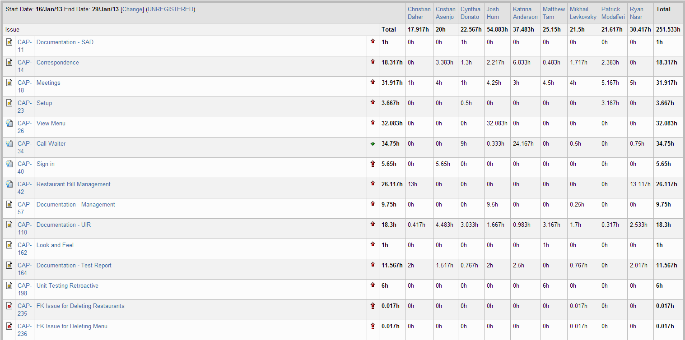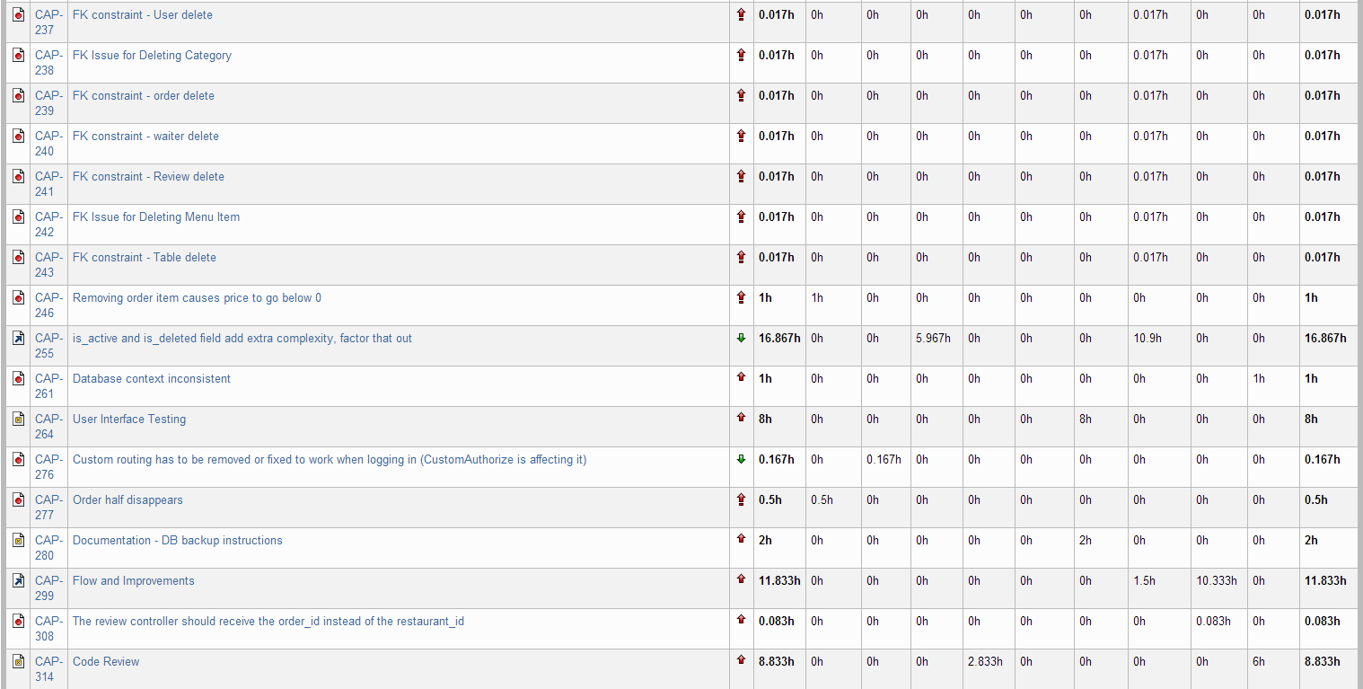



Figure 16‑1 Person-Hour Work Log

The above table shows the person-hours spent on various tasks in Sprint 6. The effort continued to be high as the team worked 251 hours in total. These hours include overhead tasks such as communication and setup.

## Hour Burndown Chart

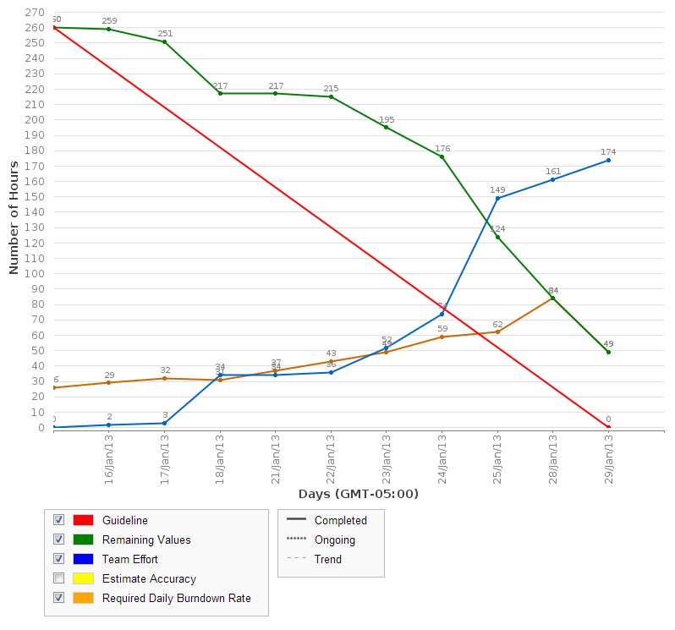

Figure 16‑2 Hour Burndown Chart

Approximately 210 of the 260 estimated hours were completed. Some hours remained as a few tasks had to be carried over into Iteration 7. As seen in the chart, the team effort was pretty consistent with a little more effort being put in at the end of the sprint.

## Issue Burndown Chart

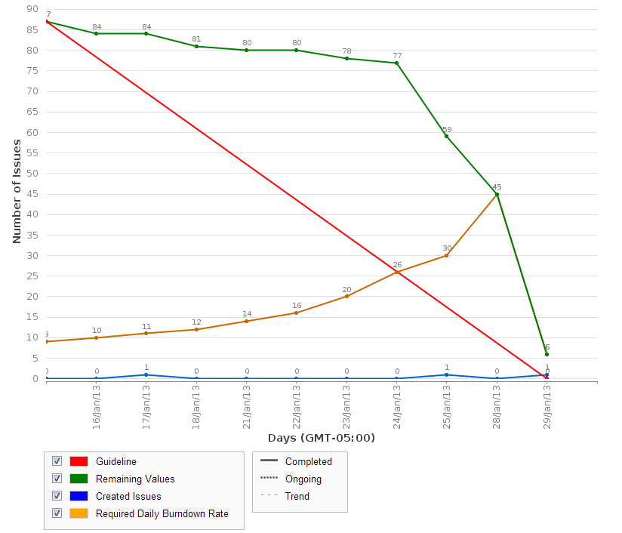

Figure 16‑3 Issue Burndown Chart

Considering that 81 out of the 87 planned issues were burned down, we are happy with our progress. The two major issues not completed were CAP-350 – Search Menu and CAP-34 – Call Waiter. However, the majority of the work on them was done and they will be completed in Iteration 7. After discussing in our weekly meeting, it was noted that a few of the issues completed earlier in the sprint were not marked as resolved which is why the line is fairly flat and then shoots down at the end.

## Cumulative Flow Diagram

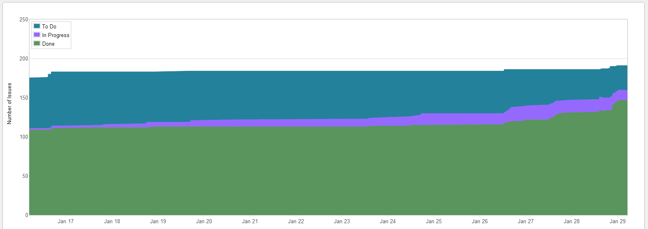

Figure 16‑4 Cumulative Flow Diagram

Since each new task that we take on gets new subtasks created, there is always an increase in “to do” tasks at the end of the sprint as we start planning the next one. However, progress is continuous and the tasks that are done are starting to catch up to the tasks to do.

## Measurement Report

### Code Quality Analysis

The following report was generated after analyzing the code. Five methods did not meet code quality goals by exceeding the expected number of lines of code. Four of these were found in an earlier iteration and have not been yet corrected while the new instance was introduced in this sprint. All of them have been entered as bugs and will be fixed in a future iteration. Since it is a minor bug, the priority is not high for it.

Since our only issues have been with lines of code, we took note for the future that the following scale defines lines of code quality:

0: red

1 – 10: green

11 – 10: yellow

21+: red

Analysis tool used: Code Metrics Viewer

Found at: <http://visualstudiogallery.msdn.microsoft.com/9f35524b-a784-4dbc-bd7b-6babd7a5a3b3>

Version: 1.5.3

Last updated: 2/5/2012

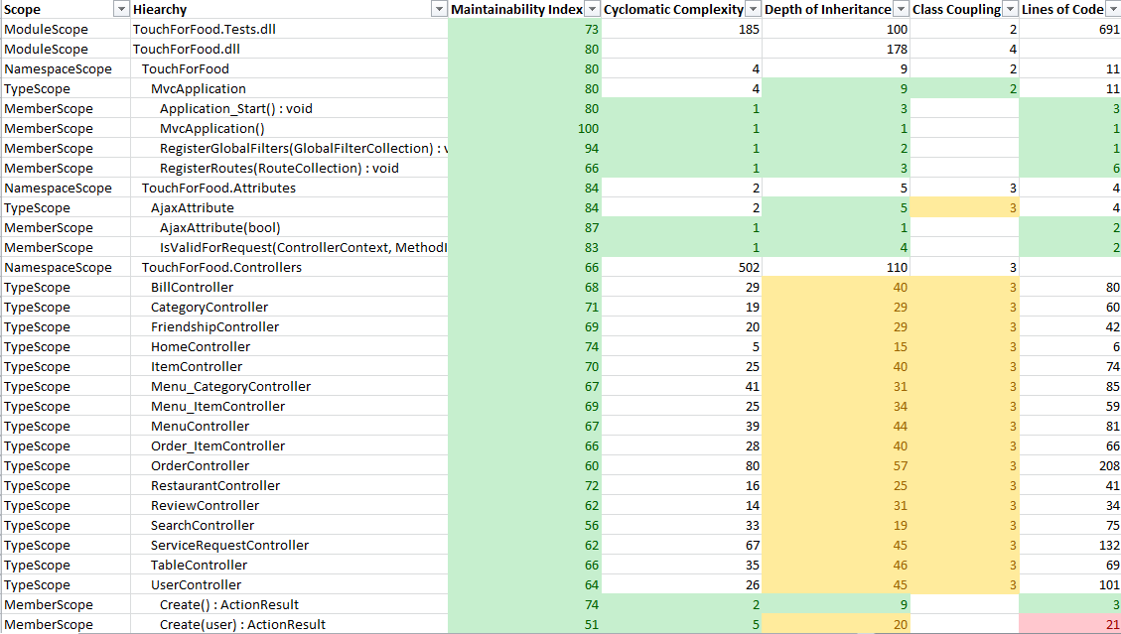

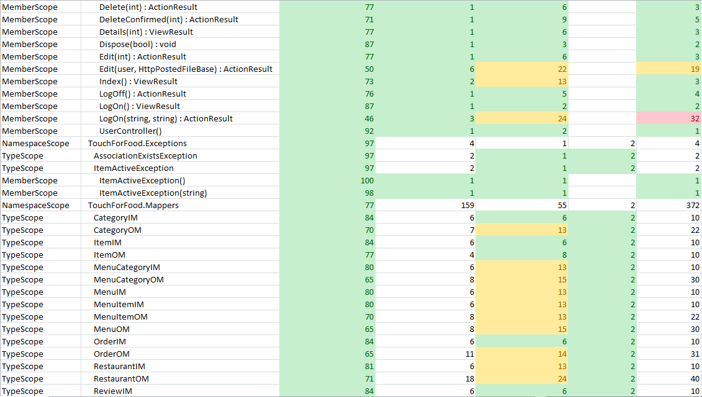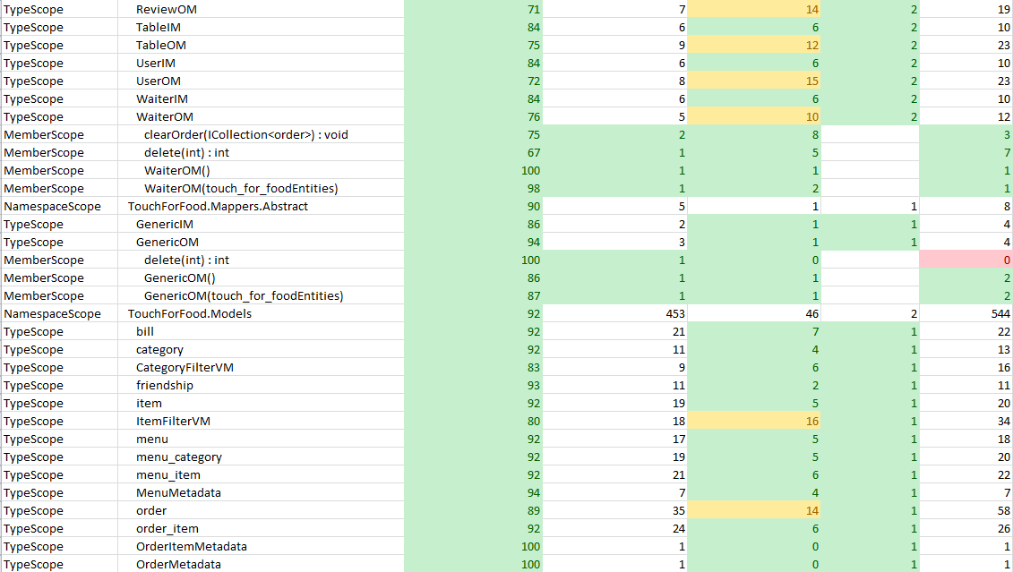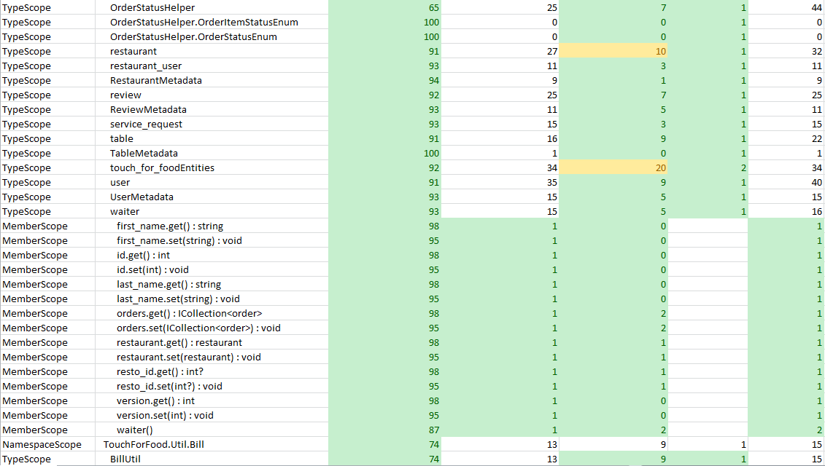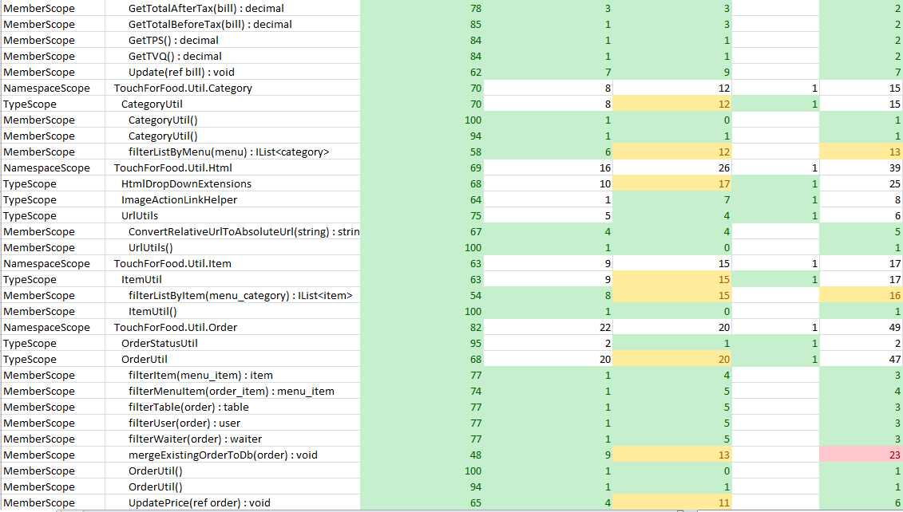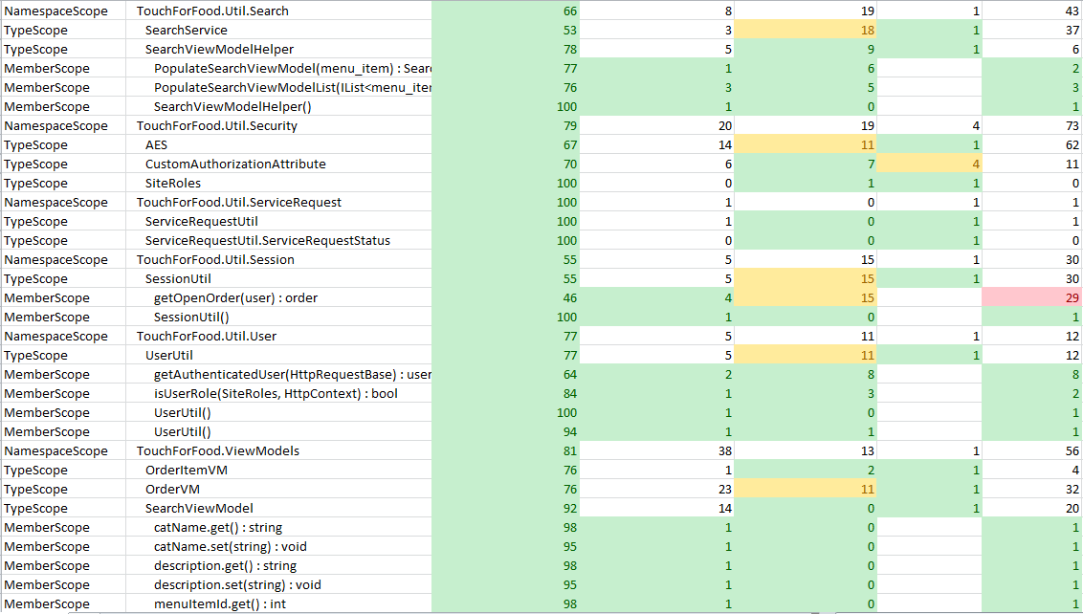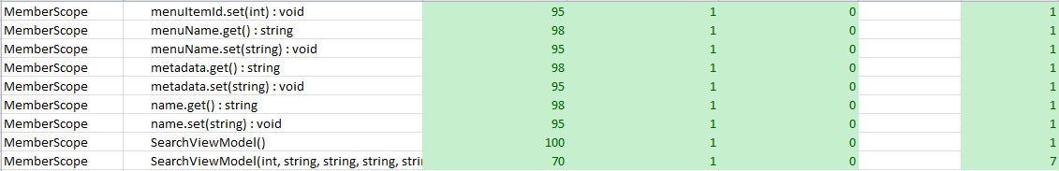

Figure 16‑5 Code Quality Report

## Retrospective

In iteration 6, we completed 11 out of a planned 15 story points. The two stories CAP-350 – Search Menu and CAP-34 – Call Waiter were added to the next sprint as they were almost but not yet complete. We also introduced the official roles of bug basher and QA. From Sprint 6 and onward, everyone in the team will take a turn being one of these two positions. There was also one person appointed to working on the overall flow of the application. Code reviews were also established. Everyone works in their own branch and code has to be reviewed before being committed back to the trunk. There are three designated code reviewers per sprint although anyone can review code and leave feedback.

See Appendix B Glossary for definitions of Bug Basher, QA, and flow fixer.

### Velocity

Sprint 6 velocity (story points): 11 story points

Cumulative velocity (story points): 45 story points

Average velocity (story points): 7.5 story points

Sprint 6 velocity (p-h): 251.53 person-hours

Cumulative velocity (p-h):1,057.40 person-hours

Average velocity per sprint:176.23 person-hours

Our average velocity in story points increased this iteration as did our average velocity in person-hours. The amount of effort is staying consistent above 200 hours. If we continue at this rate, we should be able to complete the project on time.

### Budget

Total person-hours budgeted to date: 3,312 person-hours

Total person-hours worked to date: 1,057.40 person-hours

Person-hours budgeted per sprint: 414 person-hours

Person-hours worked in Sprint 6: 251.53 person-hours

Since the budget was over-estimated, our new goal is to work at least 200 hours per sprint. If this goal is reached, the project should be finished on time. In Iteration 6, we met this goal.

### What was learned

The following positive and negative points were gathered from this sprint.

Positives:

* Completed 11 story points
* New roles such as QA, Bug basher, Flow fixer, and code reviewers improved the overall quality of the project
* UIR was created
* Back on schedule to finish the project in time

Negatives:

* None

# Iteration 7 Plan

The goal of Iteration 7 is to continue our current progress on the project while also start preparing for presentations. We will be having meetings with our stakeholder and project supervisor during the sprint. We will also hand in deliverable 2 at the end of the sprint. Thus, the focus of the sprint is to make our documentation consistent and prepare for our meetings. We will continue to finish open stories and work on new stories. We will also have people working on QA, bug bashing, fixing flow, and reviewing code.

## Planned Activities

Tables featured in this section of the document were created with JIRA [2].

Table 17‑1 Planned Activities

|  |  |  |  |  |
| --- | --- | --- | --- | --- |
| **Key** | **Issue Type** | **Priority** | **Assignee** | **Original Estimate (hours)** |
| CAP-128 | Bug | Trivial | Mikhail Levkovsky | 2 |
| CAP-234 | Sub-task | Minor | Cynthia Donato | 1 |
| CAP-247 | Task | Minor | Unassigned | 0 |
| CAP-251 | Bug | Minor | Unassigned | 0 |
| CAP-255 | Improvement | Minor | Cynthia Donato | 4 |
| CAP-263 | Sub-task | Minor | Josh Hum | 2 |
| CAP-276 | Bug | Minor | Cristian Asenjo | 3 |
| CAP-294 | Sub-task | Minor | Josh Hum | 4 |
| CAP-295 | Sub-task | Minor | Mikhail Levkovsky | 0.5 |
| CAP-296 | Sub-task | Minor | Josh Hum | 0.75 |
| CAP-297 | Sub-task | Minor | Josh Hum | 2 |
| CAP-298 | Sub-task | Minor | Josh Hum | 2 |
| CAP-375 | Sub-task | Minor | Josh Hum | 32 |
| CAP-26 | Story | Major | Josh Hum | 0 |
| CAP-42 | Story | Major | Ryan Nasr | 0 |
| CAP-110 | Task | Major | Unassigned | 0 |
| CAP-130 | Sub-task | Major | Cynthia Donato | 2 |
| CAP-131 | Sub-task | Major | Cristian Asenjo | 4 |
| CAP-134 | Sub-task | Major | Mikhail Levkovsky | 2 |
| CAP-135 | Sub-task | Major | Christian Daher | 1 |
| CAP-136 | Sub-task | Major | Matthew Tam | 4 |
| CAP-137 | Sub-task | Major | Katrina Anderson | 3 |
| CAP-139 | Sub-task | Major | Ryan Nasr | 3 |
| CAP-141 | Sub-task | Major | Josh Hum | 3 |
| CAP-142 | Sub-task | Major | Patrick Modafferi | 0.25 |
| CAP-143 | Sub-task | Major | Patrick Modafferi | 0.25 |
| CAP-144 | Sub-task | Major | Cristian Asenjo | 0.5 |
| CAP-145 | Sub-task | Major | Cynthia Donato | 0.5 |
| CAP-147 | Sub-task | Major | Patrick Modafferi | 0.5 |
| CAP-148 | Sub-task | Major | Matthew Tam | 0.5 |
| CAP-149 | Sub-task | Major | Katrina Anderson | 0.5 |
| CAP-150 | Sub-task | Major | Josh Hum | 0.5 |
| CAP-151 | Sub-task | Major | Mikhail Levkovsky | 0.5 |
| CAP-152 | Sub-task | Major | Christian Daher | 0.5 |
| CAP-153 | Sub-task | Major | Ryan Nasr | 0.083333333 |
| CAP-154 | Sub-task | Major | Ryan Nasr | 0.083333333 |
| CAP-155 | Sub-task | Major | Katrina Anderson | 0.5 |
| CAP-169 | Bug | Major | Cynthia Donato | 5 |
| CAP-194 | Sub-task | Major | Cristian Asenjo | 4 |
| CAP-196 | Sub-task | Major | Cristian Asenjo | 12 |
| CAP-198 | Task | Major | Katrina Anderson | 0 |
| CAP-199 | Sub-task | Major | Katrina Anderson | 3 |
| CAP-205 | Sub-task | Major | Katrina Anderson | 5 |
| CAP-206 | Sub-task | Major | Katrina Anderson | 6 |
| CAP-261 | Bug | Major | Ryan Nasr | 8 |
| CAP-265 | Sub-task | Major | Matthew Tam | 10 |
| CAP-267 | Sub-task | Major | Patrick Modafferi | 3 |
| CAP-268 | Sub-task | Major | Mikhail Levkovsky | 3 |
| CAP-269 | Sub-task | Major | Christian Daher | 3 |
| CAP-270 | Sub-task | Major | Cynthia Donato | 3 |
| CAP-271 | Sub-task | Major | Ryan Nasr | 3 |
| CAP-272 | Sub-task | Major | Cristian Asenjo | 3 |
| CAP-273 | Sub-task | Major | Katrina Anderson | 3 |
| CAP-274 | Bug | Major | Mikhail Levkovsky | 8 |
| CAP-278 | Sub-task | Major | Josh Hum | 16 |
| CAP-281 | Sub-task | Major | Mikhail Levkovsky | 2 |
| CAP-282 | Sub-task | Major | Katrina Anderson | 8 |
| CAP-283 | Sub-task | Major | Mikhail Levkovsky | 1 |
| CAP-284 | Sub-task | Major | Katrina Anderson | 8 |
| CAP-285 | Sub-task | Major | Katrina Anderson | 2 |
| CAP-286 | Sub-task | Major | Cynthia Donato | 2 |
| CAP-287 | Sub-task | Major | Cynthia Donato | 2 |
| CAP-288 | Sub-task | Major | Ryan Nasr | 2 |
| CAP-289 | Sub-task | Major | Mikhail Levkovsky | 2 |
| CAP-290 | Sub-task | Major | Mikhail Levkovsky | 4 |
| CAP-291 | Sub-task | Major | Katrina Anderson | 5 |
| CAP-292 | Sub-task | Major | Katrina Anderson | 2 |
| CAP-293 | Sub-task | Major | Cynthia Donato | 3 |
| CAP-299 | Improvement | Major | Josh Hum | 0 |
| CAP-300 | Sub-task | Major | Ryan Nasr | 5 |
| CAP-301 | Sub-task | Major | Ryan Nasr | 8 |
| CAP-302 | Sub-task | Major | Christian Daher | 4 |
| CAP-303 | Sub-task | Major | Ryan Nasr | 12 |
| CAP-304 | Sub-task | Major | Ryan Nasr | 6 |
| CAP-305 | Sub-task | Major | Patrick Modafferi | 8 |
| CAP-306 | Sub-task | Major | Patrick Modafferi | 8 |
| CAP-307 | Sub-task | Major | Patrick Modafferi | 4 |
| CAP-308 | Bug | Major | Ryan Nasr | 0 |
| CAP-350 | Sub-task | Major | Josh Hum | 24 |
| CAP-235 | Bug | Critical | Christian Daher | 2 |
| CAP-236 | Bug | Critical | Christian Daher | 2 |
| CAP-237 | Bug | Critical | Christian Daher | 2 |
| CAP-238 | Bug | Critical | Christian Daher | 2 |
| CAP-239 | Bug | Critical | Christian Daher | 2 |
| CAP-240 | Bug | Critical | Christian Daher | 2 |
| CAP-241 | Bug | Critical | Christian Daher | 2 |
| CAP-242 | Bug | Critical | Christian Daher | 2 |
| CAP-243 | Bug | Critical | Christian Daher | 2 |
| CAP-246 | Bug | Critical | Christian Daher | 1 |
| CAP-277 | Bug | Critical | Christian Daher | 3 |
| CAP-319 | Bug | Blocker | Unassigned | 2 |
|  |  |  | **TOTAL** | **324.42** |

## Person-Hour Estimation

The Expert Judgement Method was used to calculate person-hour estimations.

Table 17‑2 Person-Hour Estimation

|  |  |  |  |  |
| --- | --- | --- | --- | --- |
| **Description** | **Worst Case** | **Most Likely Case** | **Best Case** | **Expected Case** |
| **Activities** | 421.75 | 324.42 | 227.09 | 324.42 |
| **Total(ph)** | 421.75 | 324.42 | 227.09 | 324.42 |
| **Velocity(ph/day)** | 30.12 | 23.17 | 16.22 | 23.17 |
| **Velocity (ph/team member/day)** | 3.35 | 2.57 | 1.80 | 2.57 |

## Activity-on-Node Planning

The following graph reflects the progress of the planned user stories. The numbers represent the Early Start, Duration, Early Finish, Late Start, Slack, and Late Finish in days. View Menu was reopened to do search functionality. Toppings and Sides should have been completed earlier but it was missed. Both Customer and Restaurant Bill Management will have to be slightly edited after Toppings and Sides are complete.

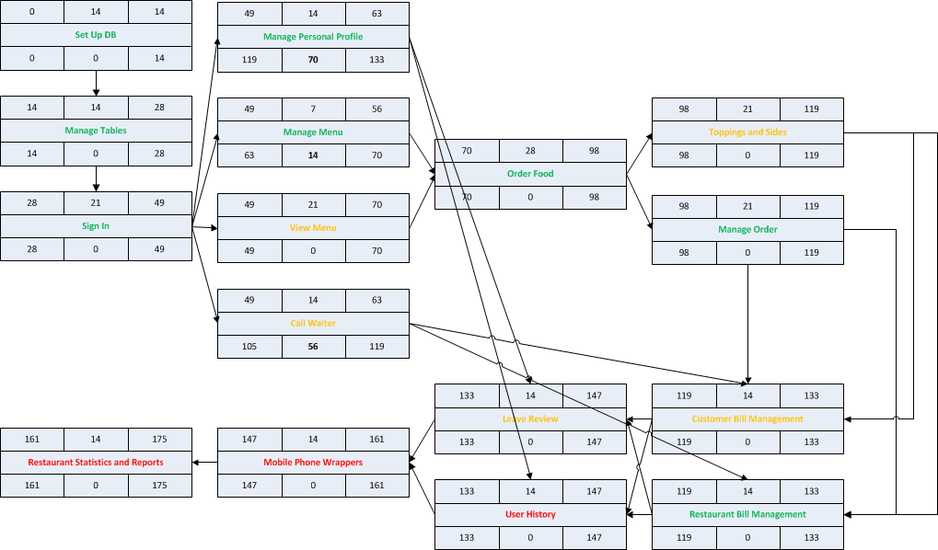

Figure 17‑1 Activity-on-Node Diagram

# Iteration 7 Report

## Person-Hour Work Log

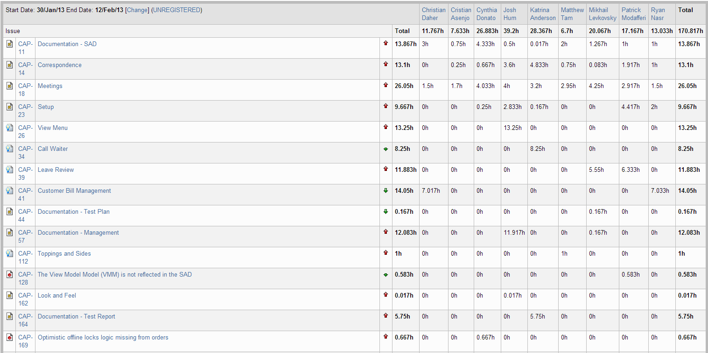

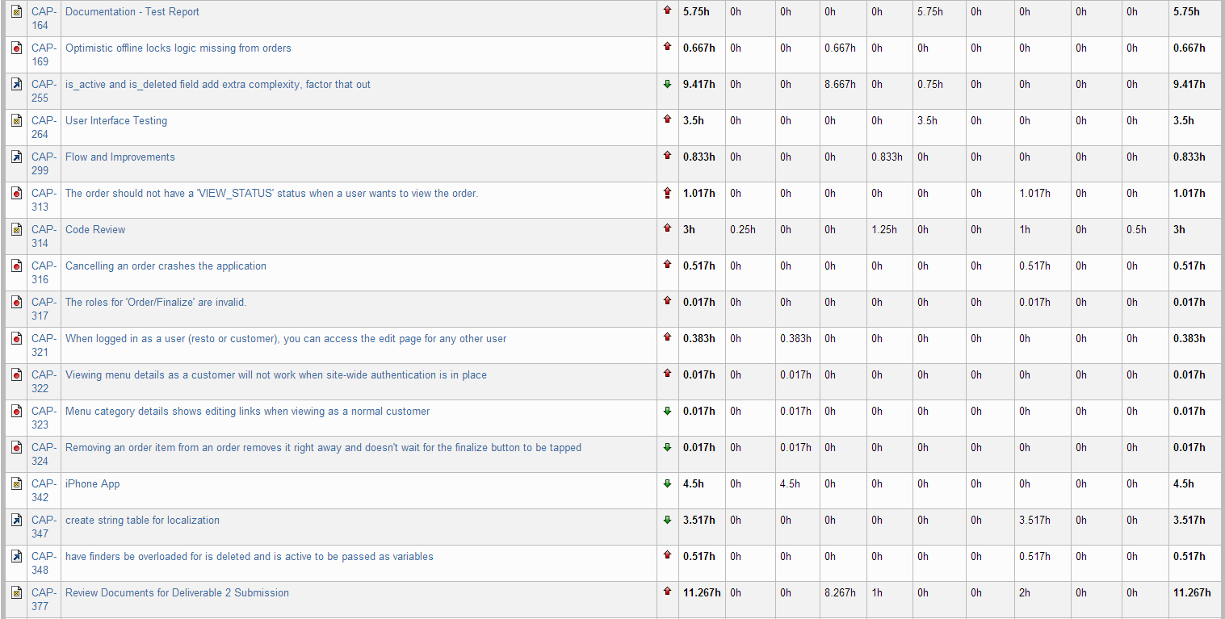

Figure 18‑1 Person-Hour Work Log

The above table shows the person-hours spent on various tasks in Sprint 7. The overall number of hours worked was lower than the past few iterations. See the iteration 7 retrospective for further explanation.

## Hour Burndown Chart

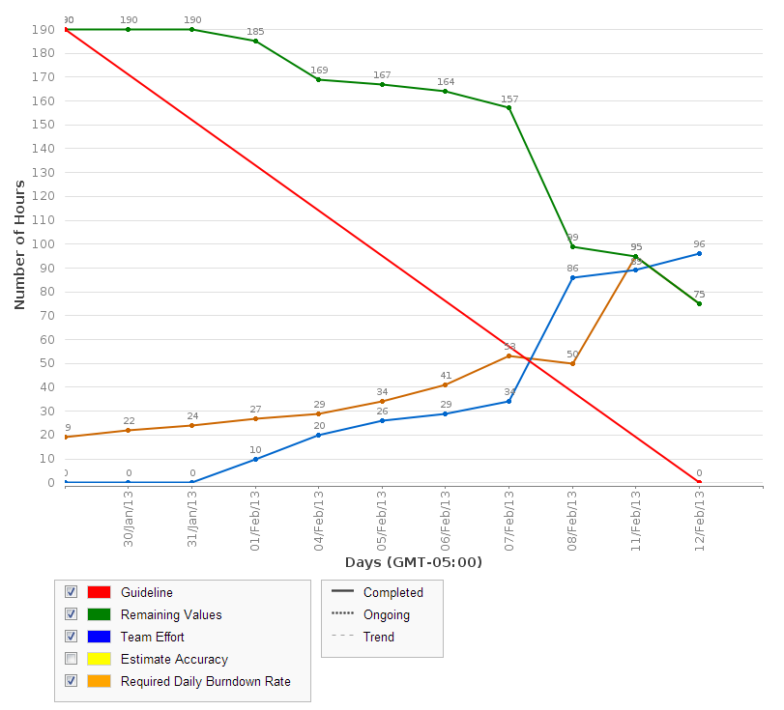

Figure 18‑2 Hour Burndown Chart

Due to various reasons, there were 75 estimated hours left that were not burned down. This is not critical as essential parts of the system still got done. The chart above shows that the first week was slow in terms of effort but that more hours were worked at the end of the sprint. This was due to a SVN trunk merge that did not go well and other responsibilities preventing the team from working as much as usual.

## Issue Burndown Chart

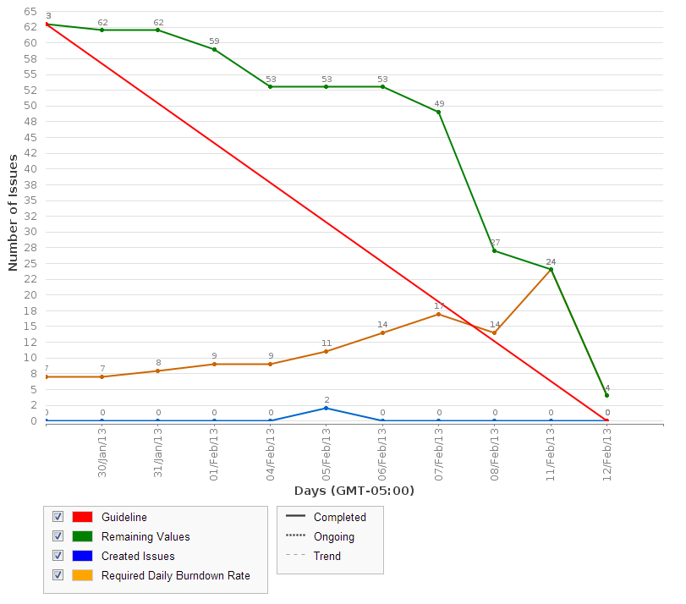

Figure 18‑3 Issue Burndown Chart

Most issues were completed. However, two stories were not completed. These two stories are CAP-39 Leave Review and CAP-112 Toppings and Sides. They are scheduled to be pushed and completed in sprint 8.

## Cumulative Flow Diagram

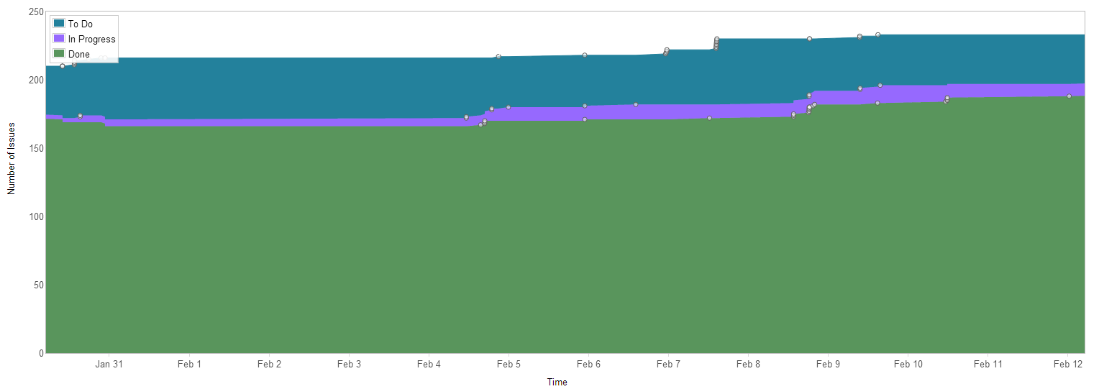

Figure 18‑4 Cumulative Flow Diagram

The figure above shows that there has been a lot of progress since the beginning of the project. There is still work to do but many of the larger issues are getting cleared out quickly.

## Measurement Report

### Code Quality Analysis

The following report was generated after analyzing the code. Five methods did not meet code quality goals by exceeding the expected number of lines of code. All five were found in previous iterations. They have been entered as bugs and will be fixed in a future iteration. Since it is a minor bug, the priority is not high for it which is why they occur repeatedly in the code quality analysis report.

Since our only issues have been with lines of code, we took note for the future that the following scale defines lines of code quality:

0: red

1 – 10: green

11 – 10: yellow

21+: red

Analysis tool used: Code Metrics Viewer

Found at: <http://visualstudiogallery.msdn.microsoft.com/9f35524b-a784-4dbc-bd7b-6babd7a5a3b3>

Version: 1.5.3

Last updated: 2/5/2012

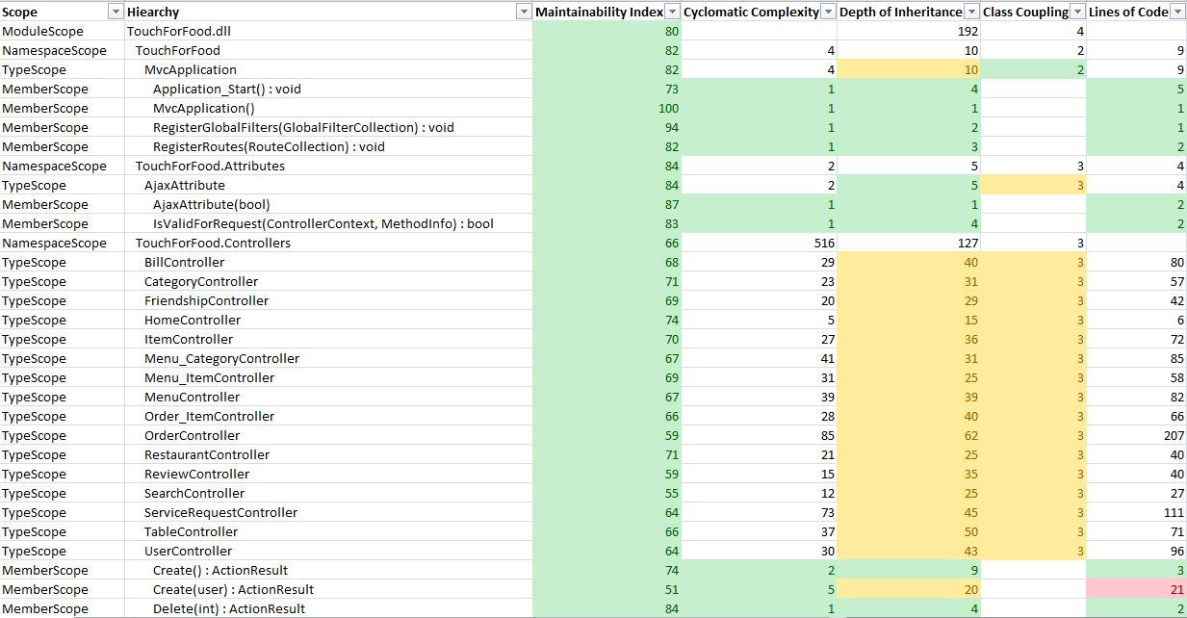

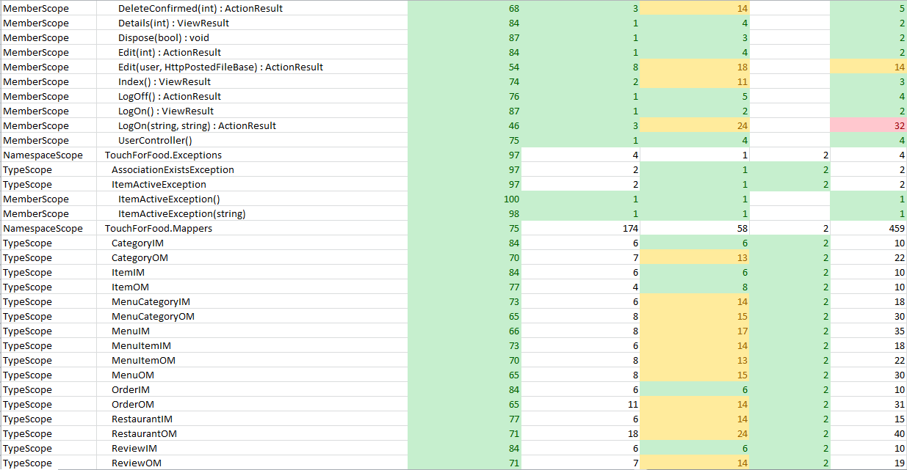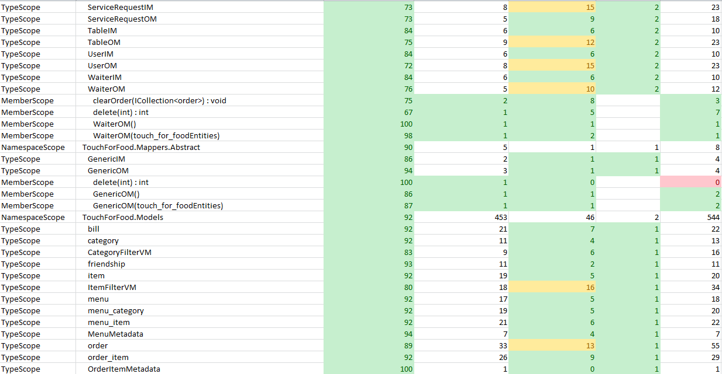

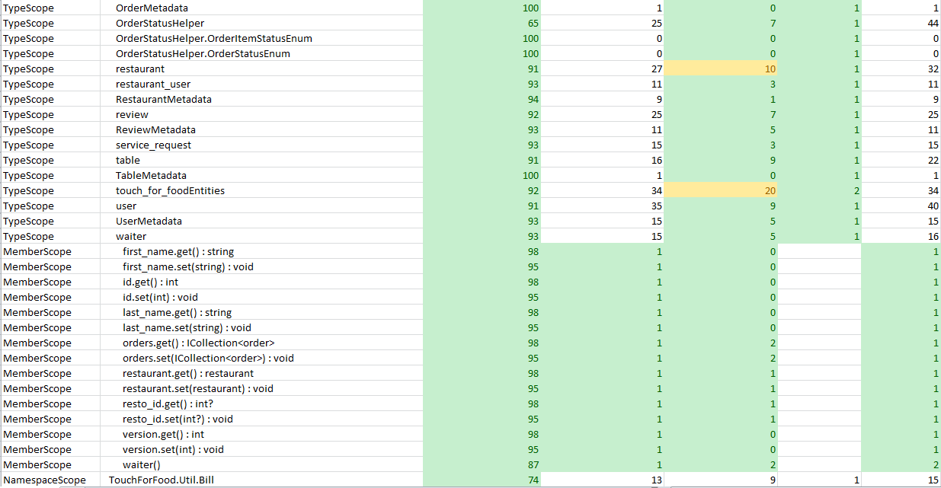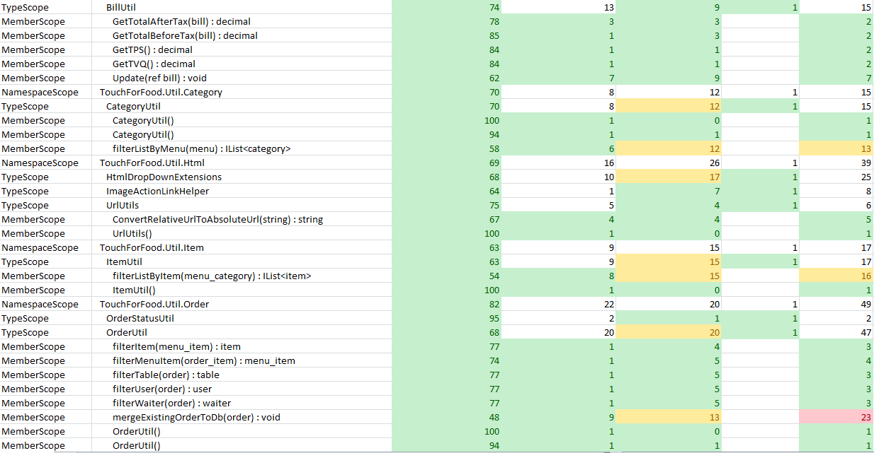

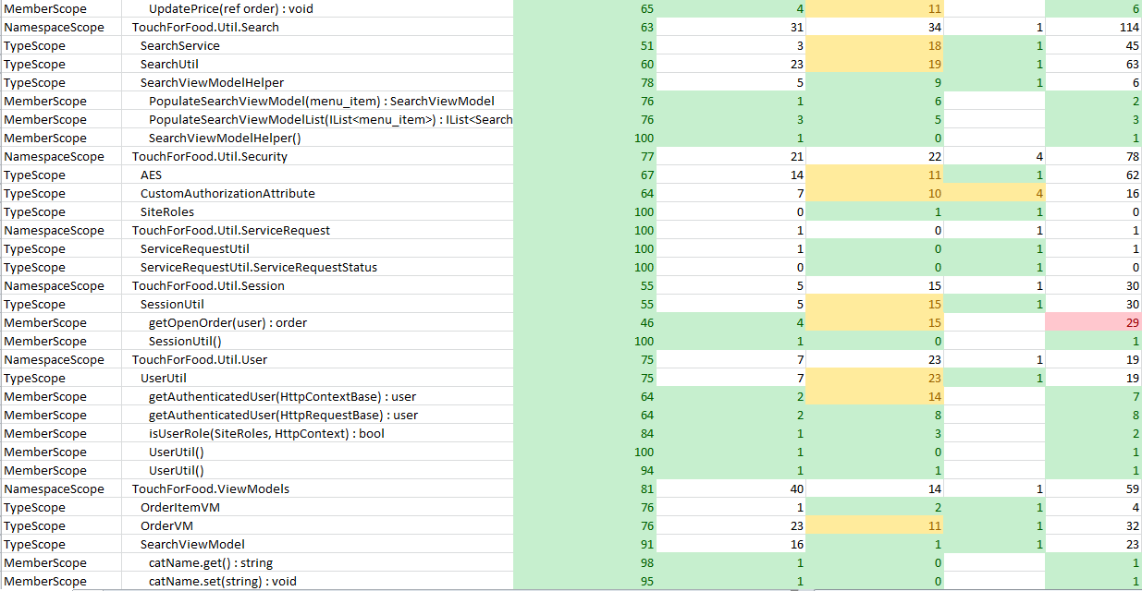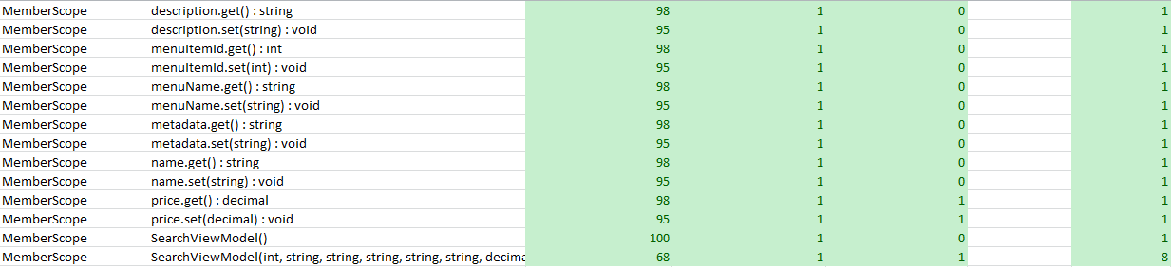

Figure 18‑5 Code Quality Report

## Retrospective

In iteration 7, we completed 11 out of a planned 22 story points. The two stories CAP-39 – Leave Review and CAP-112 – Topping and Sides were added to the next sprint as they were not yet complete.

There was less time spent working this iteration than in the previous two. This can be attributed to a few things. There was a problem with the SVN when we merged a branch with the trunk. It took a few days to solve and code could not be worked on during that time. Also, other classes took time away from the TFF project. Quizzes and assignments happened to fall on the last day of this sprint which made it difficult to get a lot of work done. One team member was also out of the country for most of the iteration.

The team also had two meetings during iteration 7, one with Dr. Grogono and one with Dr. Constantinides. The meeting with Dr. Grogono was to introduce him to the project and get his feedback as he is our new stakeholder since Dr. Ormandjieva left. Everything went well and he seemed satisfied with the progress thus far. There were no changes to the requirements.

All things considered, the team achieved a satisfactory amount of work this iteration. We did not complete everything planned, but we are looking to complete all the rest of the user stories by the end of iteration 8. This is possible because the team has a one week break from school during iteration 8. Thus, we will make up the time lost in iteration 7 and more during iteration 8.

### Velocity

Sprint 7 velocity (story points): 11 story points

Cumulative velocity (story points): 56 story points

Average velocity (story points): 8 story points

Sprint 7 velocity (p-h): 170.82 person-hours

Cumulative velocity (p-h):1,228.22 person-hours

Average velocity per sprint:175.46 person-hours

Our average velocity in story points increased this iteration. Our average velocity in person-hours dropped by one hour. Overall, we’re expecting our velocity to increase next sprint as we have a one week break from school. This should give us much more time to commit to the project and complete it on time.

### Budget

Total person-hours budgeted to date: 3,726 person-hours

Total person-hours worked to date: 1,228.22 person-hours

Person-hours budgeted per sprint: 414 person-hours

Person-hours worked in Sprint 7: 170.82 person-hours

We did not meet our goal of working at least 200 person-hours per sprint. However, we were missing one person because they were out of the country. Other school and work responsibilities also led to us not meeting our budget. In iteration 8, the team is planning to make up for that lost time.

### What was learned

The following positive and negative points were gathered from this sprint.

Positives:

* Completed 11 story points
* Roles such as QA, Bug basher, Flow fixer, and code reviewers continued to improve the quality of the project
* Still on schedule to finish the project in time
* Communication and meetings are going very well
* Met with our stakeholder and project supervisor

Negatives:

* Did not meet our goal in person-hours worked
* Did not finish the planned stories

# Iteration 8 Plan

The goal of Iteration 8 is to finish all stories left in the project. We are aware that there are a lot of stories to do, but we have a week without classes this sprint so some of the team members will be able to work more than in previous sprints. The reason we want to finish this sprint is to leave the last two sprints for fixing defects and focusing on testing and quality assurance. There is no official “flow fixer” this sprint as most people have higher priority tasks assigned to them.

## Planned Activities

Tables featured in this section of the document were created with JIRA [2].

Table 19‑1 Planned Activities

|  |  |  |  |  |
| --- | --- | --- | --- | --- |
| **Key** | **Issue Type** | **Priority** | **Assignee** | **Original Estimate (hours)** |
| CAP-390 | Bug | Trivial | Ryan Nasr | 0.5 |
| CAP-394 | Improvement | Trivial | Josh Hum | 0.083333333 |
| CAP-400 | Improvement | Trivial | Josh Hum | 0.083333333 |
| CAP-342 | Task | Minor | Cristian Asenjo | 24 |
| CAP-345 | Sub-task | Minor | Cristian Asenjo | 4 |
| CAP-386 | Bug | Minor | Unassigned | 0 |
| CAP-391 | Bug | Minor | Ryan Nasr | 0.5 |
| CAP-392 | Bug | Minor | Josh Hum | 0.5 |
| CAP-393 | Bug | Minor | Josh Hum | 0.5 |
| CAP-405 | Improvement | Minor | Unassigned | 4 |
| CAP-414 | Bug | Minor | Ryan Nasr | 0 |
| CAP-418 | Sub-task | Minor | Unassigned | 8 |
| CAP-449 | Sub-task | Minor | Josh Hum | 3 |
| CAP-450 | Sub-task | Minor | Josh Hum | 2 |
| CAP-451 | Sub-task | Minor | Josh Hum | 2 |
| CAP-452 | Sub-task | Minor | Josh Hum | 0.5 |
| CAP-453 | Sub-task | Minor | Mikhail Levkovsky | 0.5 |
| CAP-36 | Story | Major | Cynthia Donato | 0 |
| CAP-39 | Story | Major | Mikhail Levkovsky | 0 |
| CAP-112 | Story | Major | Matthew Tam | 0 |
| CAP-169 | Bug | Major | Cynthia Donato | 5 |
| CAP-198 | Task | Major | Katrina Anderson | 0 |
| CAP-199 | Sub-task | Major | Katrina Anderson | 3 |
| CAP-200 | Sub-task | Major | Katrina Anderson | 5 |
| CAP-201 | Sub-task | Major | Katrina Anderson | 7 |
| CAP-204 | Sub-task | Major | Katrina Anderson | 5 |
| CAP-205 | Sub-task | Major | Katrina Anderson | 5 |
| CAP-206 | Sub-task | Major | Katrina Anderson | 9 |
| CAP-207 | Sub-task | Major | Katrina Anderson | 4 |
| CAP-258 | Sub-task | Major | Katrina Anderson | 5 |
| CAP-267 | Sub-task | Major | Patrick Modafferi | 3 |
| CAP-279 | Story | Major | Patrick Modafferi | 0 |
| CAP-343 | Sub-task | Major | Cristian Asenjo | 5 |
| CAP-344 | Sub-task | Major | Cristian Asenjo | 10 |
| CAP-352 | Sub-task | Major | Mikhail Levkovsky | 0.5 |
| CAP-354 | Sub-task | Major | Patrick Modafferi | 16 |
| CAP-355 | Sub-task | Major | Patrick Modafferi | 1 |
| CAP-356 | Sub-task | Major | Mikhail Levkovsky | 6 |
| CAP-357 | Sub-task | Major | Patrick Modafferi | 6 |
| CAP-362 | Sub-task | Major | Cynthia Donato | 0.5 |
| CAP-387 | Bug | Major | Ryan Nasr | 3 |
| CAP-402 | Bug | Major | Ryan Nasr | 1 |
| CAP-403 | Bug | Major | Ryan Nasr | 2 |
| CAP-404 | Bug | Major | Ryan Nasr | 1 |
| CAP-406 | Sub-task | Major | Katrina Anderson | 0.75 |
| CAP-407 | Sub-task | Major | Josh Hum | 6 |
| CAP-408 | Task | Major | Unassigned | 0 |
| CAP-409 | Sub-task | Major | Christian Daher | 2 |
| CAP-410 | Sub-task | Major | Christian Daher | 2 |
| CAP-411 | Sub-task | Major | Christian Daher | 2 |
| CAP-412 | Sub-task | Major | Christian Daher | 2 |
| CAP-413 | Bug | Major | Ryan Nasr | 1 |
| CAP-415 | Bug | Major | Ryan Nasr | 2 |
| CAP-416 | Sub-task | Major | Patrick Modafferi | 16 |
| CAP-417 | Sub-task | Major | Mikhail Levkovsky | 8 |
| CAP-419 | Sub-task | Major | Cynthia Donato | 2 |
| CAP-420 | Sub-task | Major | Cynthia Donato | 2 |
| CAP-421 | Sub-task | Major | Cynthia Donato | 2 |
| CAP-422 | Sub-task | Major | Cynthia Donato | 2 |
| CAP-424 | Sub-task | Major | Unassigned | 0.5 |
| CAP-425 | Sub-task | Major | Unassigned | 2 |
| CAP-428 | Sub-task | Major | Cynthia Donato | 0.5 |
| CAP-429 | Sub-task | Major | Cynthia Donato | 0.5 |
| CAP-430 | Sub-task | Major | Cynthia Donato | 0.5 |
| CAP-432 | Sub-task | Major | Unassigned | 12 |
| CAP-433 | Sub-task | Major | Matthew Tam | 32 |
| CAP-434 | Sub-task | Major | Unassigned | 4 |
| CAP-435 | Sub-task | Major | Unassigned | 3 |
| CAP-436 | Sub-task | Major | Unassigned | 3 |
| CAP-437 | Sub-task | Major | Unassigned | 3 |
| CAP-438 | Sub-task | Major | Cynthia Donato | 0.5 |
| CAP-439 | Sub-task | Major | Cynthia Donato | 0.5 |
| CAP-440 | Sub-task | Major | Josh Hum | 4 |
| CAP-441 | Sub-task | Major | Katrina Anderson | 3 |
| CAP-442 | Sub-task | Major | Cynthia Donato | 1 |
| CAP-443 | Sub-task | Major | Cynthia Donato | 0.5 |
| CAP-444 | Sub-task | Major | Josh Hum | 3 |
| CAP-445 | Sub-task | Major | Josh Hum | 3 |
| CAP-446 | Sub-task | Major | Katrina Anderson | 3 |
| CAP-447 | Sub-task | Major | Josh Hum | 10 |
| CAP-448 | Sub-task | Major | Josh Hum | 8 |
| CAP-454 | Sub-task | Major | Katrina Anderson | 1 |
| CAP-455 | Sub-task | Major | Unassigned | 0.5 |
| CAP-456 | Sub-task | Major | Katrina Anderson | 3 |
| CAP-457 | Sub-task | Major | Patrick Modafferi | 3 |
|  |  |  | **TOTAL** | **307.92** |

## Person-Hour Estimation

The Expert Judgement Method was used to calculate person-hour estimations.

Table 19‑2 Person-Hour Estimation

|  |  |  |  |  |
| --- | --- | --- | --- | --- |
| **Description** | **Worst Case** | **Most Likely Case** | **Best Case** | **Expected Case** |
| **Activities** | 400.30 | 307.92 | 215.54 | 307.92 |
| **Total(ph)** | 400.30 | 307.92 | 215.54 | 307.92 |
| **Velocity(ph/day)** | 28.59 | 21.99 | 15.40 | 21.99 |
| **Velocity (ph/team member/day)** | 3.18 | 2.44 | 1.71 | 2.44 |

## Activity-on-Node Planning

The following graph reflects the progress of the planned user stories. The numbers represent the Early Start, Duration, Early Finish, Late Start, Slack, and Late Finish in days. All remaining stories are currently in progress. The goal is to complete all of them this sprint so that the final two sprints can be spent on fixing defects and ensuring a high quality product.



Figure 19‑1 Activity-On-Node Diagram

# Iteration 8 Report

## Person-Hour Work Log

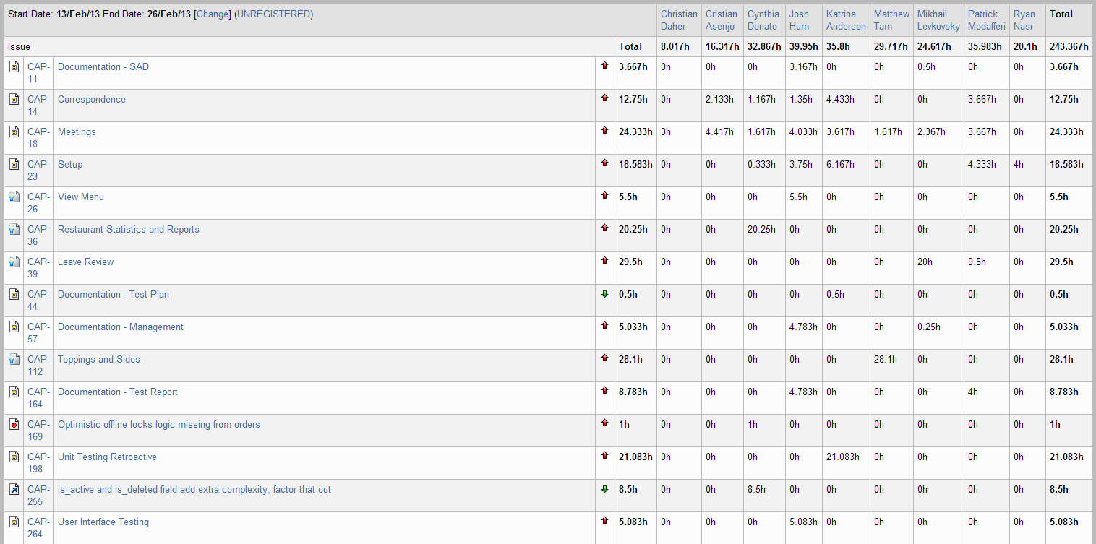

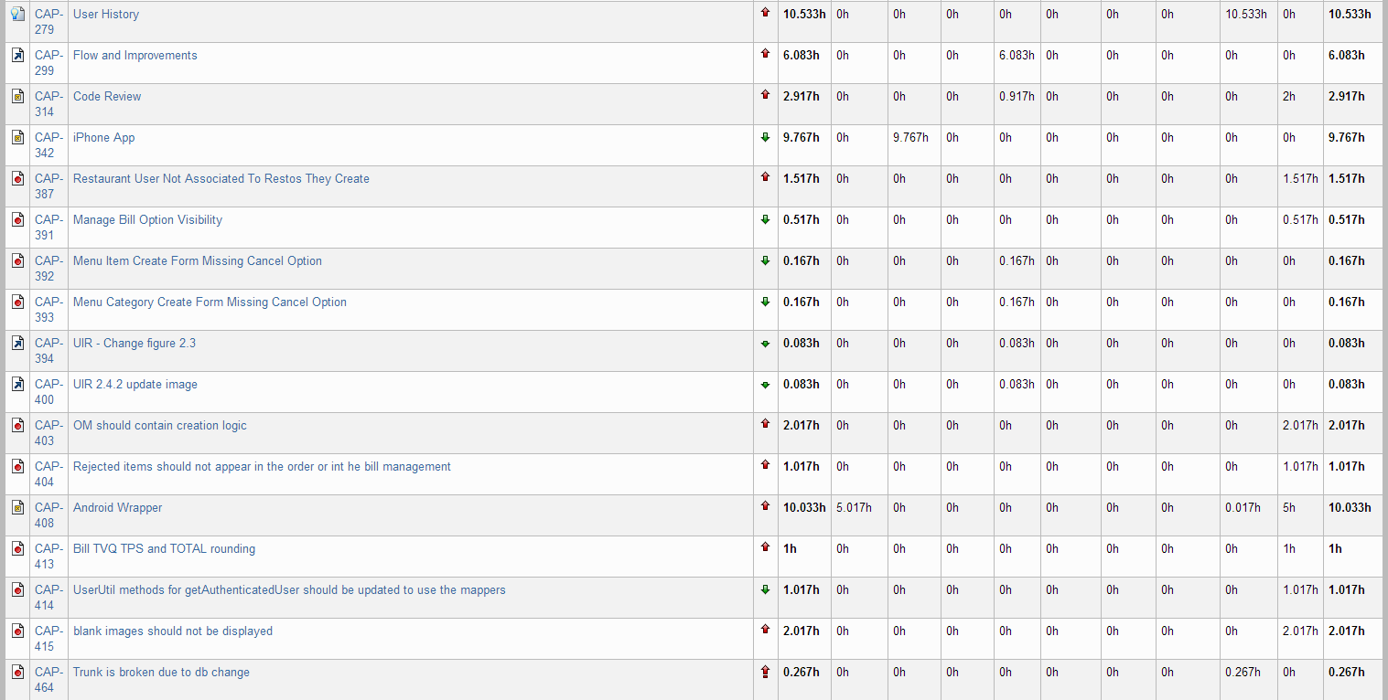



Figure 20‑1 Person-Hour Work Log

We are satisfied by the effort that we put into Iteration 8. The hours worked went up to 250 hours from 170 hours in Iteration 7. Team members will able to work more hours on the project since we had one week off school. Obviously, other courses had to be worked on as well so it wasn’t a full week dedicated to the project, but it was more time than usual.

## Hour Burndown Chart

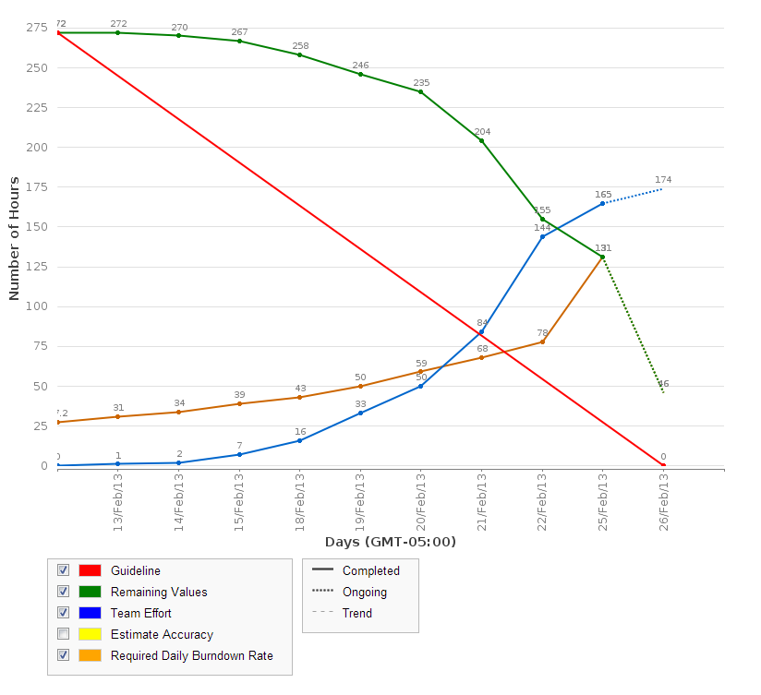

Figure 20‑2 Hour Burndown Chart

There are 131 estimated hours that are not burned down. This can be attributed to the fact that although most of the coding functionality tasks were completed, some documentation and unit testing tasks were not and will have to be pushed till next sprint. The hours for those incomplete tasks are thus reflected here. 243 hours were worked this sprint in total and 272 hours were estimated. With the 131 hours remaining, this proves that 102 hours were spent working on overhead, other non-scheduled tasks, or our tasks took more time than estimated.

## Issue Burndown Chart

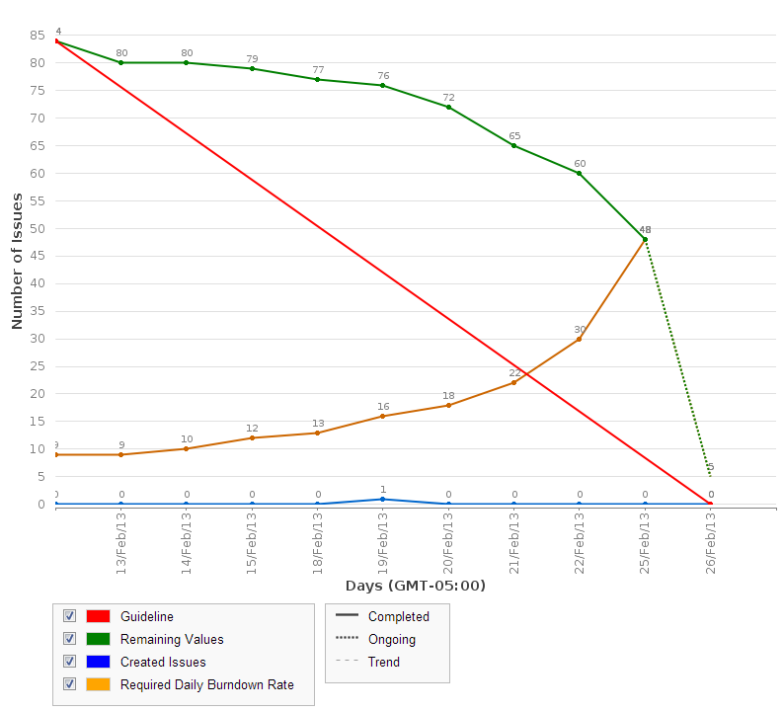

Figure 20‑3 Issue Burndown Chart

48 out of the 84 tasks were not completed. However, as mentioned previously, the main functionality of the planned stories is done. The 48 incomplete tasks reflect documentation or unit testing which will be completed next sprint. Although the goal was to complete all the planned issues, we are still satisfied with the amount and quality of work completed.

## Cumulative Flow Diagram

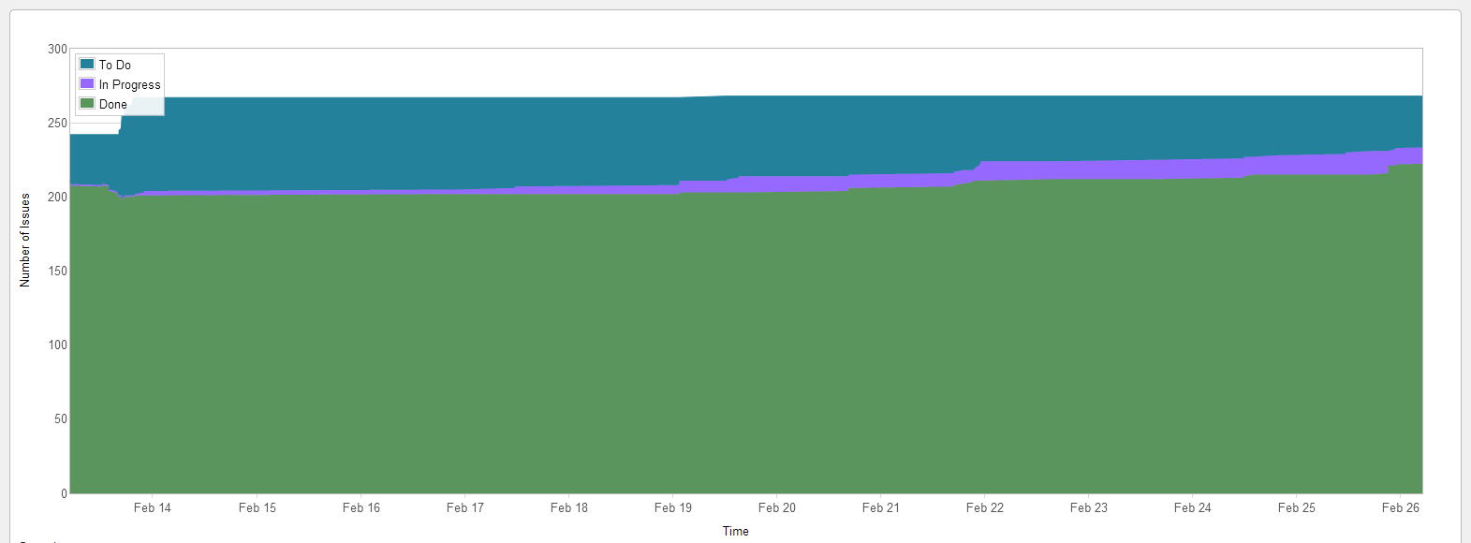

Figure 20‑4 Cumulative Flow Diagram

The figure above reflects the steady progress that our team is making. With only two sprints left, we plan to close out all remaining planned tasks in order of priority. If a couple low priority tasks are left incomplete, it is not that critical.

## Measurement Report

### Code Quality Analysis

The following report was generated after analyzing the code. Five methods did not meet code quality goals by exceeding the expected number of lines of code. All five were found in previous iterations. They have been entered as bugs and will be fixed in a future iteration. Since it is a minor bug, the priority is not high for it which is why they occur repeatedly in the code quality analysis report.

Since our only issues have been with lines of code, we took note for the future that the following scale defines lines of code quality:

0: red

1 – 10: green

11 – 10: yellow

21+: red

Analysis tool used: Code Metrics Viewer

Found at: <http://visualstudiogallery.msdn.microsoft.com/9f35524b-a784-4dbc-bd7b-6babd7a5a3b3>

Version: 1.5.3

Last updated: 2/5/2012

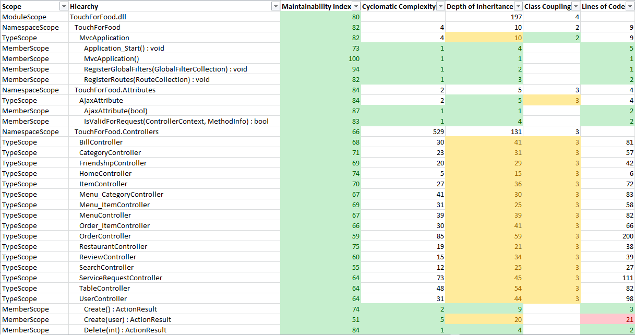

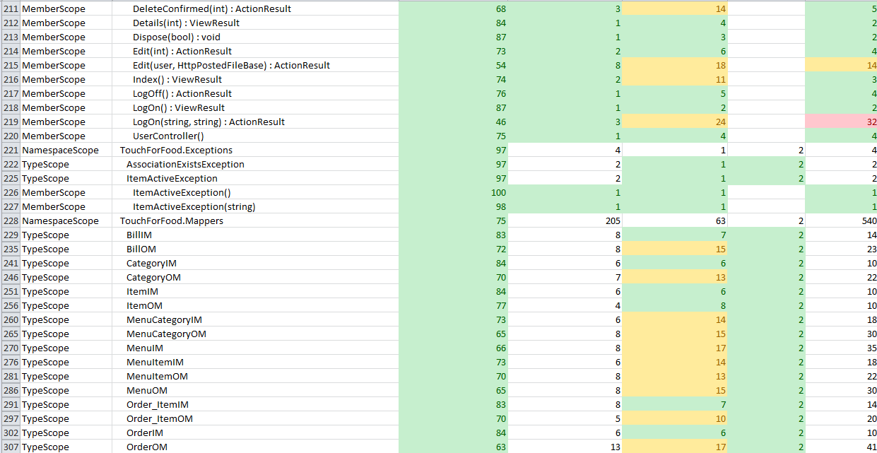

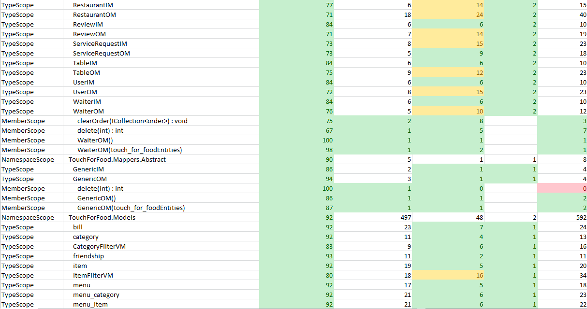

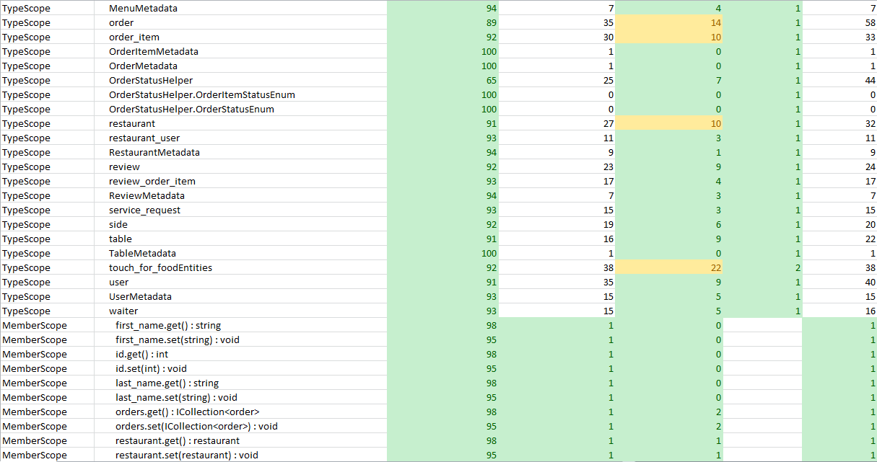

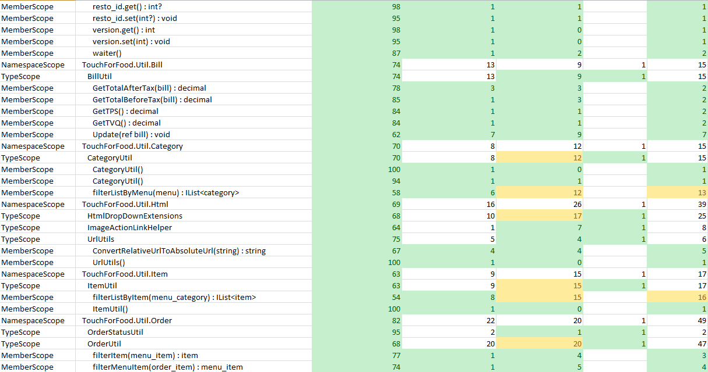

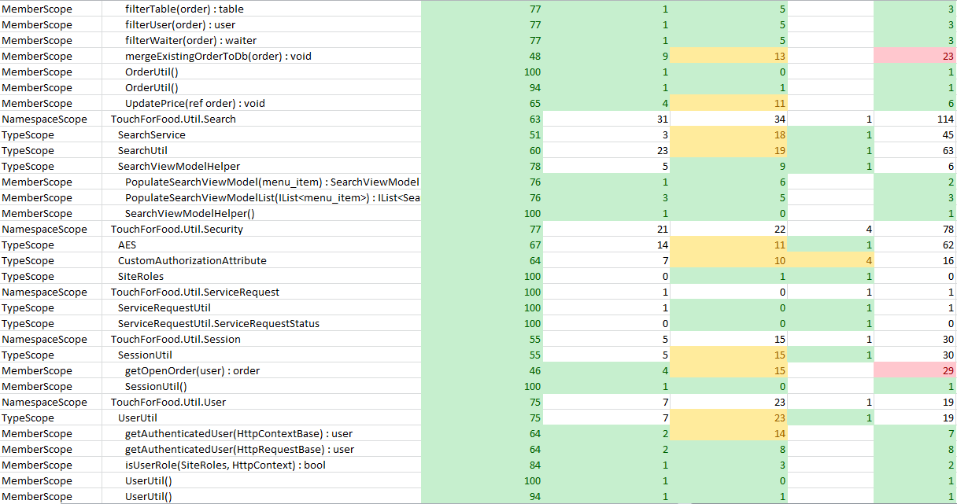

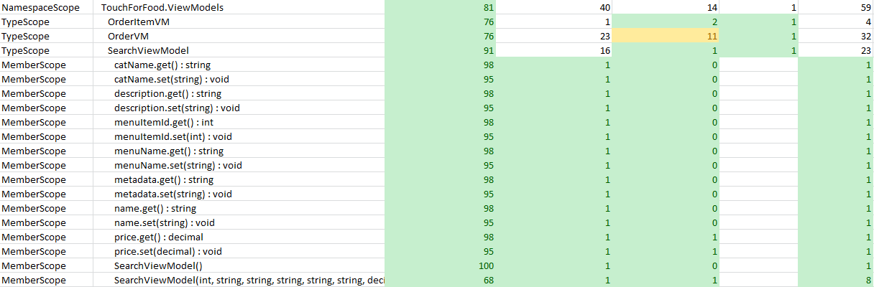

Figure 20‑5 Code Quality Report

## Retrospective

In Iteration 8, we completed 3 out of a planned 40 user story points. This seems alarming at first glance. However, the story with the most points assigned to it was CAP-36 – Restaurant Statistics and Reports. We did not implement as much functionality as was originally planned, thus it was not really worth 21 story points. The functionality for CAP-36 was implemented this sprint; unit testing and docs for the story must still be completed. CAP-112 – Toppings and Sides and CAP-279 – User History were almost completed as well; unit testing must be finished for those stories as well.

The goal of this sprint was to finish implementing all desired functionality for the project to give us time to work on bugs, documentation, and quality during the last two sprints. Although the stories planned were not completed, the implementation part of the stores was completed. Since only unit testing and documentation is left for those stories, we are considering Iteration 8 a successful iteration.

One of our team members ran into computer issues this sprint where her laptop crashed which forced her to re-setup the entire environment and project. This slowed the progress on some of the tasks. There were a couple merge issues as well. However, the team worked hard and accomplished the main goals of this sprint. The main implementation of the project is done and we will now look forward to fixing defects, testing, and documentation.

### Velocity

Sprint 8 velocity (story points): 3 story points

Cumulative velocity (story points): 65 story points

Average velocity (story points): 8.1 story points

Sprint 8 velocity (p-h): 243.37 person-hours

Cumulative velocity (p-h): 1,471.59 person-hours

Average velocity per sprint: 183.95 person-hours

Our person-hour velocity went up this iteration as we worked almost 250 hours. This is a considerable increase (up 80 hours from last sprint). We are hoping to stay around 200 person-hours per sprint in the last two iterations. The average story point velocity also increased but that is because of a calculation where our cumulative story points were wrong. It is now correct.

### Budget

Total person-hours budgeted to date: 4,140 person-hours

Total person-hours worked to date: 1,471.59 person-hours

Person-hours budgeted per sprint: 414 person-hours

Person-hours worked in Sprint 8: 243.37 person-hours

In Iteration 8, we made up for the less time spent working in Iteration 7 (170 person-hours). We are still significantly under budget but we are meeting our adjusted goal to be around 200 hours per sprint.

### What was learned

The following positive and negative points were gathered from this sprint.

Positives:

* On schedule to finish the project in time
* Communication and meetings are going very well
* Everyone is doing their part and working as a team
* Met our goal in person-hours worked

Negatives:

* Did not completely finish the planned stories

# Iteration 9 Plan

The goal of Iteration 9 is twofold. In the first week, we will focus on documentation (Requirements, Analysis, and Architecture) while in the second week we will work on bugs and testing. There are quite a few bugs that need to be addressed before our presentation so we will have at least half the team working on bugs. The other half will complete unfinished stories and do testing.

## Planned Activities

Tables featured in this section of the document were created with JIRA [2].

Table 21‑1 Planned Activities

|  |  |  |  |  |
| --- | --- | --- | --- | --- |
| **Key** | **Issue Type** | **Priority** | **Assignee** | **Original Estimate (hours)** |
| CAP-390 | Bug | Trivial | Ryan Nasr | 0.5 |
| CAP-486 | Bug | Trivial | Josh Hum | 0.333333333 |
| CAP-488 | Bug | Trivial | Mikhail Levkovsky | 0.166666667 |
| CAP-491 | Bug | Trivial | Cristian Asenjo | 1.5 |
| CAP-508 | Bug | Trivial | Christian Daher | 1 |
| CAP-342 | Task | Minor | Cristian Asenjo | 24 |
| CAP-345 | Sub-task | Minor | Cristian Asenjo | 4 |
| CAP-405 | Improvement | Minor | Matthew Tam | 4 |
| CAP-460 | Bug | Minor | Ryan Nasr | 0.5 |
| CAP-462 | Bug | Minor | Ryan Nasr | 1 |
| CAP-481 | Bug | Minor | Mikhail Levkovsky | 3 |
| CAP-487 | Bug | Minor | Patrick Modafferi | 0.5 |
| CAP-489 | Bug | Minor | Mikhail Levkovsky | 0.25 |
| CAP-490 | Bug | Minor | Cristian Asenjo | 4 |
| CAP-492 | Bug | Minor | Josh Hum | 0 |
| CAP-493 | Bug | Minor | Josh Hum | 1.5 |
| CAP-509 | Bug | Minor | Christian Daher | 2 |
| CAP-513 | Bug | Minor | Cristian Asenjo | 2 |
| CAP-520 | Sub-task | Minor | Josh Hum | 2 |
| CAP-521 | Sub-task | Minor | Josh Hum | 2 |
| CAP-522 | Sub-task | Minor | Josh Hum | 2 |
| CAP-523 | Sub-task | Minor | Josh Hum | 0.5 |
| CAP-524 | Sub-task | Minor | Mikhail Levkovsky | 0.5 |
| CAP-525 | Sub-task | Minor | Josh Hum | 2 |
| CAP-526 | Sub-task | Minor | Josh Hum | 2 |
| CAP-36 | Story | Major | Cynthia Donato | 0 |
| CAP-112 | Story | Major | Matthew Tam | 0 |
| CAP-198 | Task | Major | Katrina Anderson | 0 |
| CAP-199 | Sub-task | Major | Katrina Anderson | 3 |
| CAP-204 | Sub-task | Major | Katrina Anderson | 5 |
| CAP-205 | Sub-task | Major | Katrina Anderson | 5 |
| CAP-206 | Sub-task | Major | Katrina Anderson | 9 |
| CAP-207 | Sub-task | Major | Katrina Anderson | 4 |
| CAP-258 | Sub-task | Major | Katrina Anderson | 5 |
| CAP-344 | Sub-task | Major | Cristian Asenjo | 10 |
| CAP-402 | Bug | Major | Ryan Nasr | 1 |
| CAP-413 | Bug | Major | Mikhail Levkovsky | 1 |
| CAP-422 | Sub-task | Major | Cynthia Donato | 2 |
| CAP-429 | Sub-task | Major | Cynthia Donato | 3 |
| CAP-432 | Sub-task | Major | Matthew Tam | 12 |
| CAP-433 | Sub-task | Major | Matthew Tam | 32 |
| CAP-434 | Sub-task | Major | Matthew Tam | 4 |
| CAP-435 | Sub-task | Major | Matthew Tam | 3 |
| CAP-438 | Sub-task | Major | Cynthia Donato | 0.5 |
| CAP-439 | Sub-task | Major | Cynthia Donato | 0.5 |
| CAP-442 | Sub-task | Major | Cynthia Donato | 1 |
| CAP-446 | Sub-task | Major | Katrina Anderson | 3 |
| CAP-456 | Sub-task | Major | Katrina Anderson | 3 |
| CAP-459 | Bug | Major | Ryan Nasr | 3 |
| CAP-461 | Bug | Major | Ryan Nasr | 3 |
| CAP-463 | Bug | Major | Patrick Modafferi | 1 |
| CAP-466 | Sub-task | Major | Katrina Anderson | 0.5 |
| CAP-467 | Sub-task | Major | Katrina Anderson | 0.5 |
| CAP-468 | Sub-task | Major | Katrina Anderson | 0.5 |
| CAP-469 | Sub-task | Major | Mikhail Levkovsky | 2 |
| CAP-470 | Sub-task | Major | Christian Daher | 8 |
| CAP-471 | Sub-task | Major | Mikhail Levkovsky | 1 |
| CAP-472 | Sub-task | Major | Patrick Modafferi | 0.5 |
| CAP-473 | Sub-task | Major | Ryan Nasr | 1 |
| CAP-474 | Sub-task | Major | Josh Hum | 4 |
| CAP-475 | Sub-task | Major | Josh Hum | 3 |
| CAP-476 | Sub-task | Major | Josh Hum | 1 |
| CAP-477 | Sub-task | Major | Patrick Modafferi | 0.5 |
| CAP-478 | Sub-task | Major | Matthew Tam | 1.5 |
| CAP-480 | Bug | Major | Ryan Nasr | 3 |
| CAP-484 | Bug | Major | Patrick Modafferi | 2 |
| CAP-485 | Sub-task | Major | Katrina Anderson | 3 |
| CAP-494 | Bug | Major | Josh Hum | 1.5 |
| CAP-495 | Bug | Major | Josh Hum | 1.5 |
| CAP-496 | Bug | Major | Josh Hum | 1 |
| CAP-497 | Bug | Major | Josh Hum | 1.5 |
| CAP-498 | Bug | Major | Josh Hum | 0.166666667 |
| CAP-499 | Bug | Major | Josh Hum | 1.5 |
| CAP-500 | Bug | Major | Patrick Modafferi | 2 |
| CAP-501 | Bug | Major | Cristian Asenjo | 5 |
| CAP-502 | Bug | Major | Ryan Nasr | 2 |
| CAP-503 | Bug | Major | Christian Daher | 2 |
| CAP-504 | Bug | Major | Cristian Asenjo | 2 |
| CAP-505 | Bug | Major | Cristian Asenjo | 3 |
| CAP-506 | Bug | Major | Christian Daher | 2 |
| CAP-507 | Bug | Major | Christian Daher | 2 |
| CAP-510 | Bug | Major | Mikhail Levkovsky | 0 |
| CAP-511 | Bug | Major | Mikhail Levkovsky | 1 |
| CAP-512 | Bug | Major | Cristian Asenjo | 4 |
| CAP-514 | Sub-task | Major | Patrick Modafferi | 7 |
| CAP-515 | Sub-task | Major | Mikhail Levkovsky | 6 |
| CAP-516 | Bug | Major | Patrick Modafferi | 4 |
| CAP-519 | Sub-task | Major | Mikhail Levkovsky | 10 |
| CAP-527 | Sub-task | Major | Josh Hum | 10 |
| CAP-528 | Sub-task | Major | Katrina Anderson | 1 |
| CAP-529 | Sub-task | Major | Cristian Asenjo | 10 |
| CAP-530 | Sub-task | Major | Katrina Anderson | 3 |
| CAP-531 | Sub-task | Major | Katrina Anderson | 3 |
| CAP-532 | Sub-task | Major | Katrina Anderson | 3 |
| CAP-533 | Sub-task | Major | Katrina Anderson | 3 |
| CAP-534 | Sub-task | Major | Katrina Anderson | 15 |
| CAP-535 | Sub-task | Major | Katrina Anderson | 10 |
| CAP-536 | Bug | Major | Katrina Anderson | 1 |
| CAP-539 | Sub-task | Major | Cynthia Donato | 2 |
| CAP-540 | Sub-task | Major | Cynthia Donato | 3 |
| CAP-541 | Sub-task | Major | Cynthia Donato | 0.5 |
| CAP-542 | Sub-task | Major | Cynthia Donato | 0.5 |
| CAP-543 | Sub-task | Major | Cynthia Donato | 5 |
| CAP-544 | Sub-task | Major | Cynthia Donato | 1 |
| CAP-558 | Bug | Major | Mikhail Levkovsky | 2 |
| CAP-546 | Bug | Critical | Cristian Asenjo | 1 |
| CAP-553 | Bug | Critical | Katrina Anderson | 6 |
| CAP-517 | Bug | Blocker | Christian Daher | 4 |
| CAP-518 | Bug | Blocker | Christian Daher | 4 |
| CAP-569 | Bug | Blocker | Katrina Anderson | 2 |
|  |  |  | **TOTAL** | **356.42** |

## Person-Hour Estimation

The Expert Judgement Method was used to calculate person-hour estimations.

Table 21‑2 Person-Hour Estimation

|  |  |  |  |  |
| --- | --- | --- | --- | --- |
| **Description** | **Worst Case** | **Most Likely Case** | **Best Case** | **Expected Case** |
| **Activities** | 463.35 | 356.42 | 249.49 | 356.42 |
| **Total(ph)** | 463.35 | 356.42 | 249.49 | 356.42 |
| **Velocity(ph/day)** | 33.10 | 25.46 | 17.82 | 25.46 |
| **Velocity (ph/team member/day)** | 3.68 | 2.83 | 1.98 | 2.83 |

## Activity-on-Node Planning

The following graph reflects the progress of the planned user stories. The numbers represent the Early Start, Duration, Early Finish, Late Start, Slack, and Late Finish in days. All remaining stories are currently in progress.

Although a few tasks are still left to complete, they involve just unit testing and documentation. The functionality will not change. By sprint 10, all stories should be complete. We are still on track to complete in time for our presentation.



Figure 21‑1 Activity on Node Diagram

# Iteration 9 Report

## Person-Hour Work Log

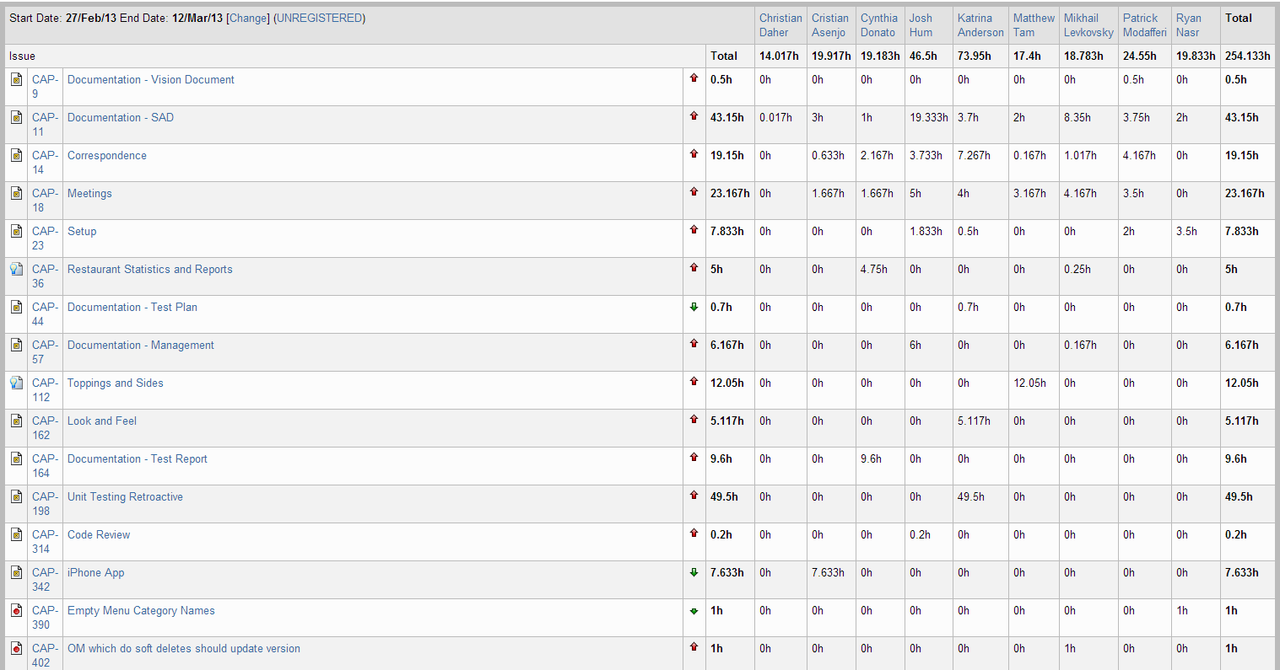

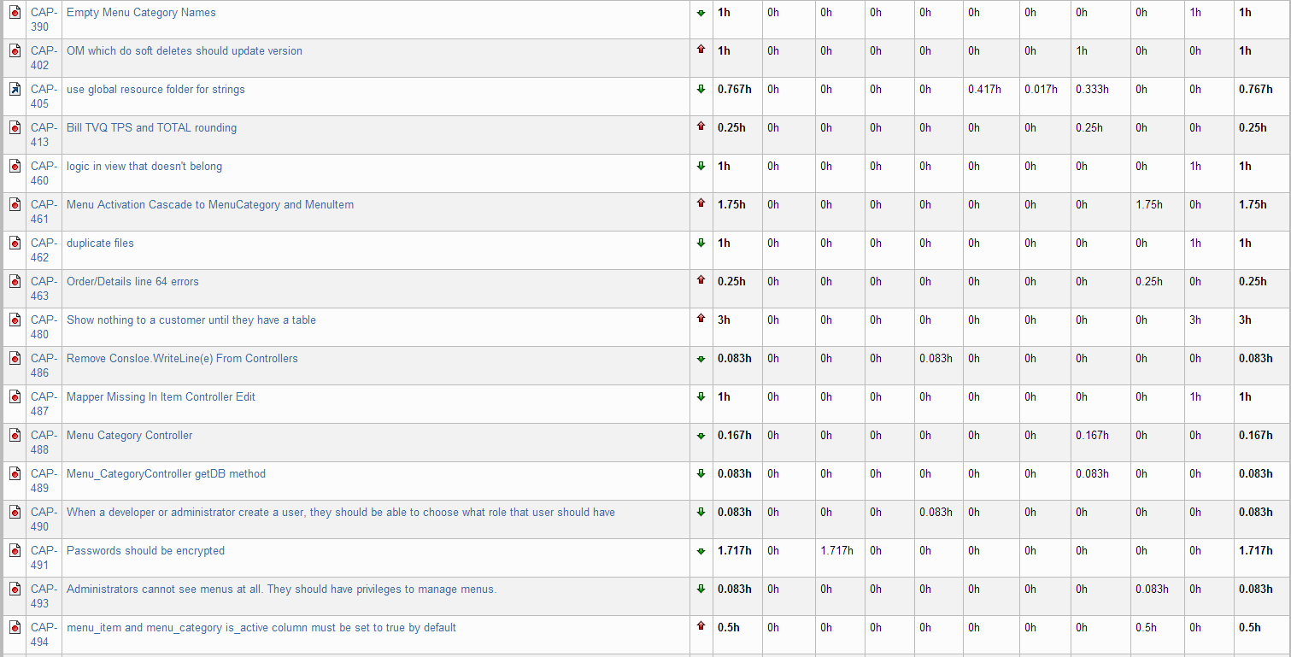

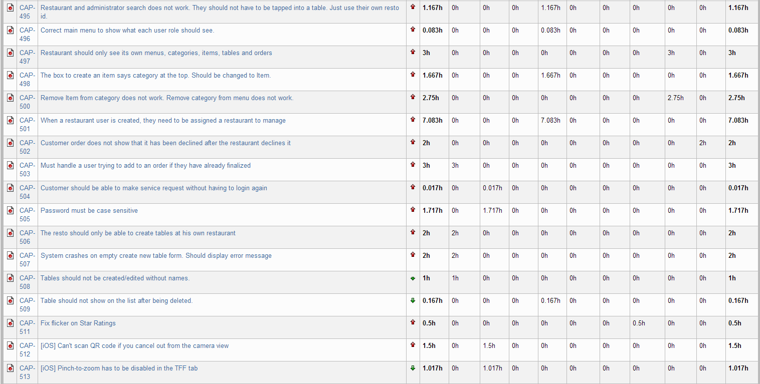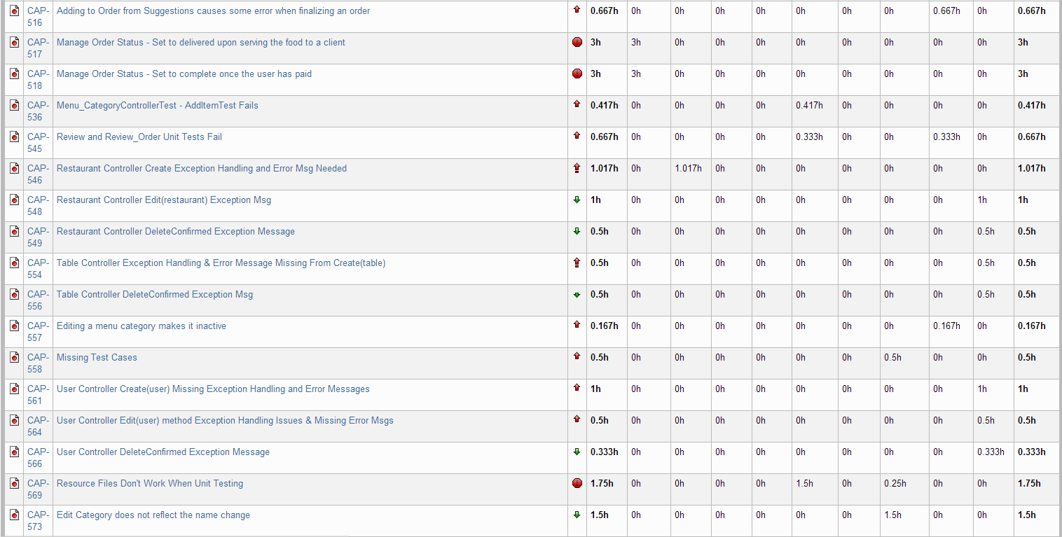

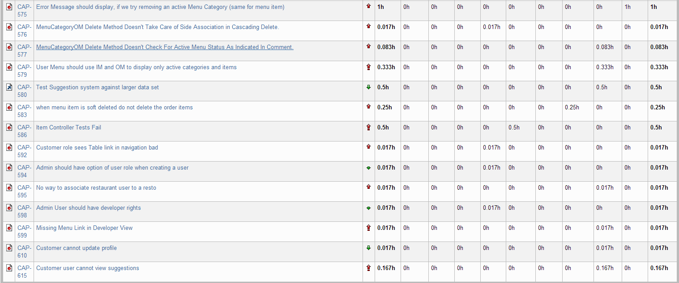

Figure 22‑1 Person-Hour Work Log

Our goal to work over 200 hours per sprint was once again met. Every team member put in the required hours to complete their tasks. We are satisfied with our progress and the project is advancing as desired towards completion.

## Hour Burndown Chart

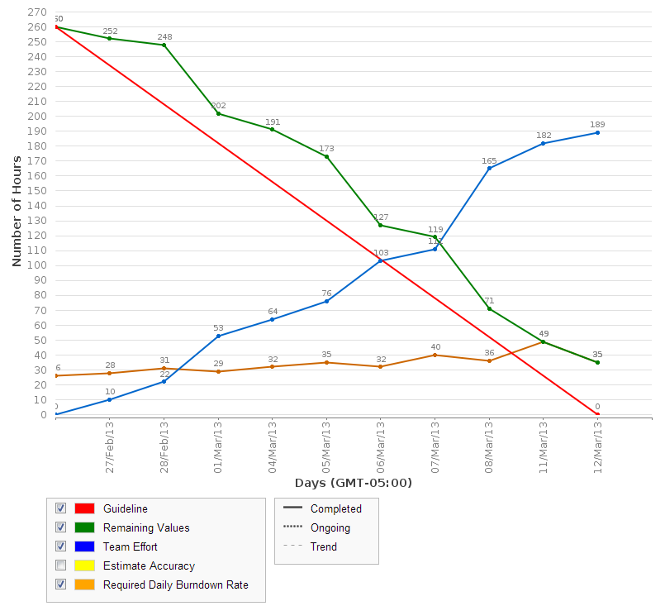

Figure 22‑2 Hour Burndown Chart

Out of 260 estimated hours on all tasks, only 35 were not burned down. The 35 incomplete hours can be attributed to a few tasks that were not completed. The chart shows that there was a consistent burndown as team members worked continuously throughout the sprint.

## Issue Burndown Chart

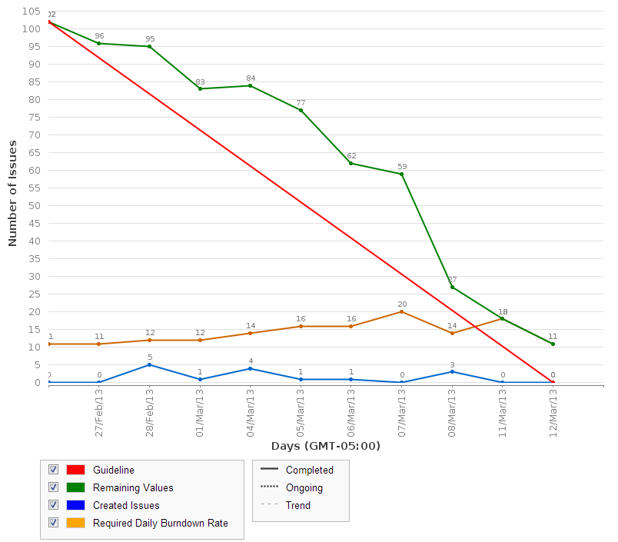

Figure 22‑3 Issue Burndown Chart

91 out of the 102 planned tasks were completed this sprint. This is excellent and we are quite happy with our progress. With the upcoming sprint as the last planned sprint to work on coding tasks, we are well on our way to completion of the project.

## Cumulative Flow Diagram

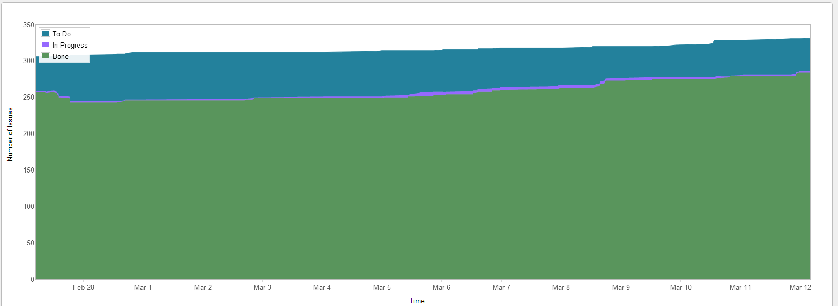

Figure 22‑4 Cumulative Flow Diagram

The figure above reflects the steady progress that our team is making. With one full sprint left and having completed around 280 tasks, we are looking to close out the majority of the remaining tasks next sprint.

## Measurement Report

### Code Quality Analysis

The following report was generated after analyzing the code. Thirteen methods did not meet code quality goals by exceeding the expected number of lines of code or having none. They have been entered as bugs and will be fixed in a future iteration. Since it is a minor bug, the priority is not high for it which is why they occur repeatedly in the code quality analysis report. Given that there is only one sprint left, we will look to fix these issues in the next sprint or in the half sprint following it.

Since our only issues have been with lines of code, we took note for the future that the following scale defines lines of code quality:

0: red

1 – 10: green

11 – 10: yellow

21+: red

Analysis tool used: Code Metrics Viewer

Found at: <http://visualstudiogallery.msdn.microsoft.com/9f35524b-a784-4dbc-bd7b-6babd7a5a3b3>

Version: 1.5.3

Last updated: 2/5/2012

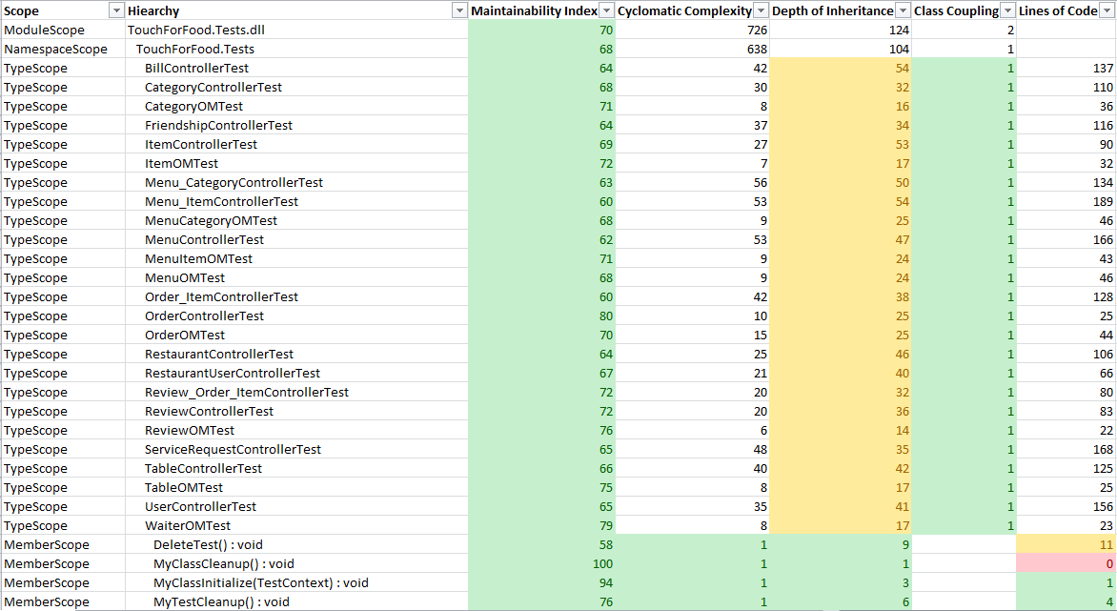

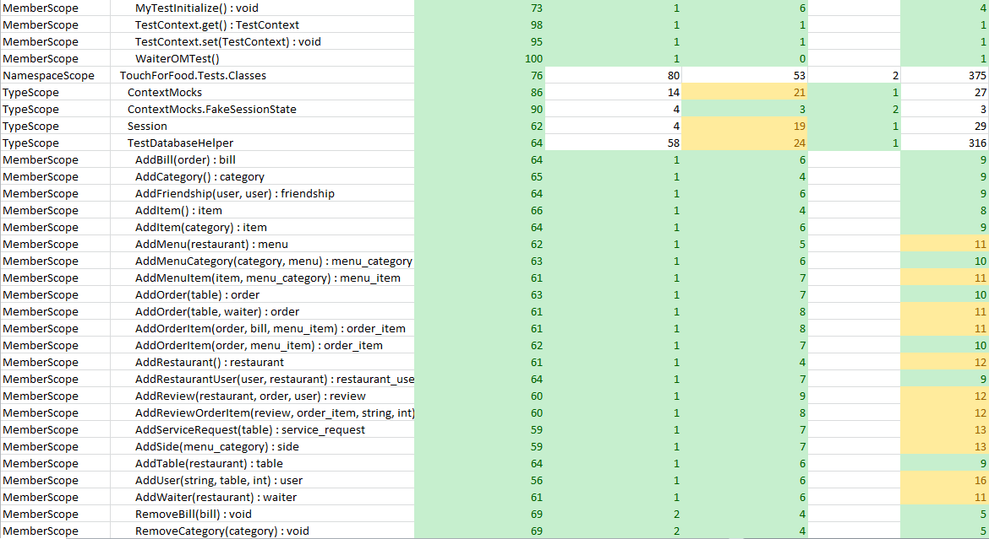

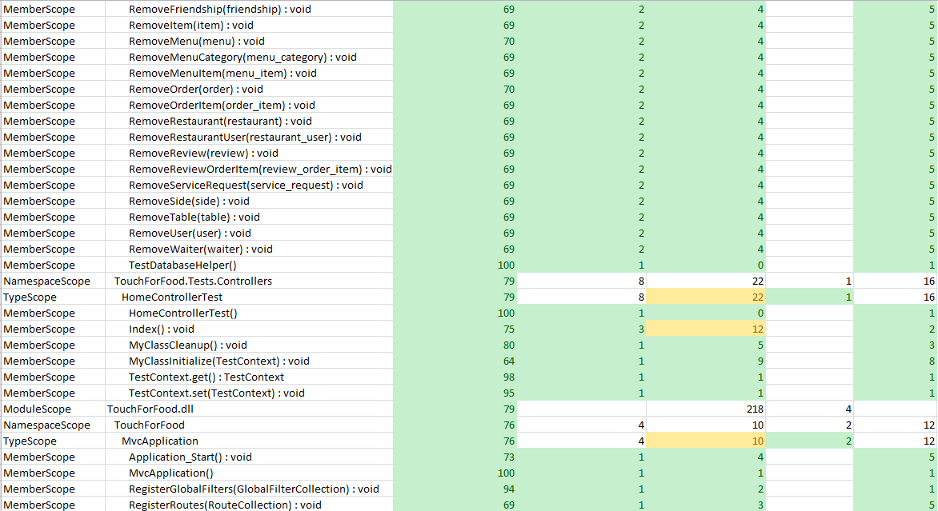

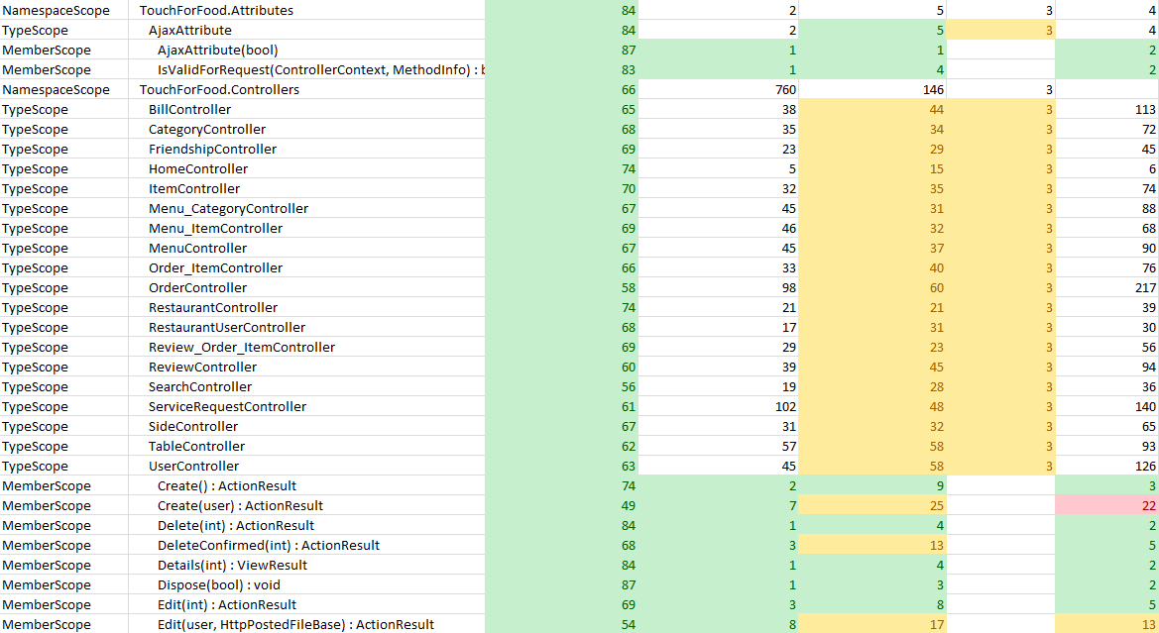

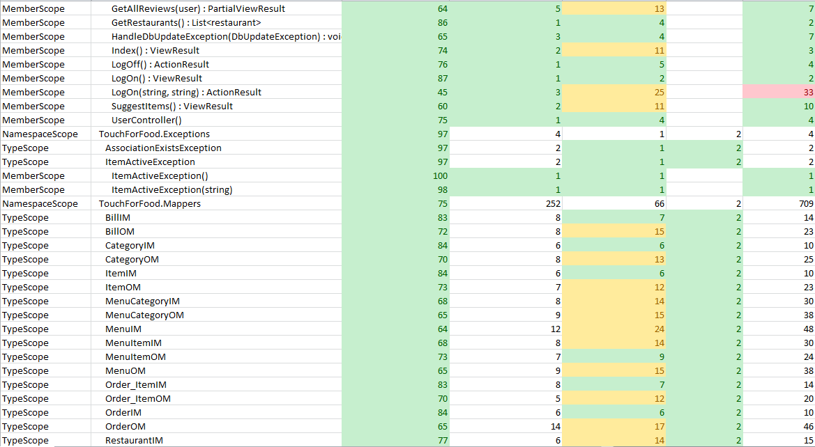

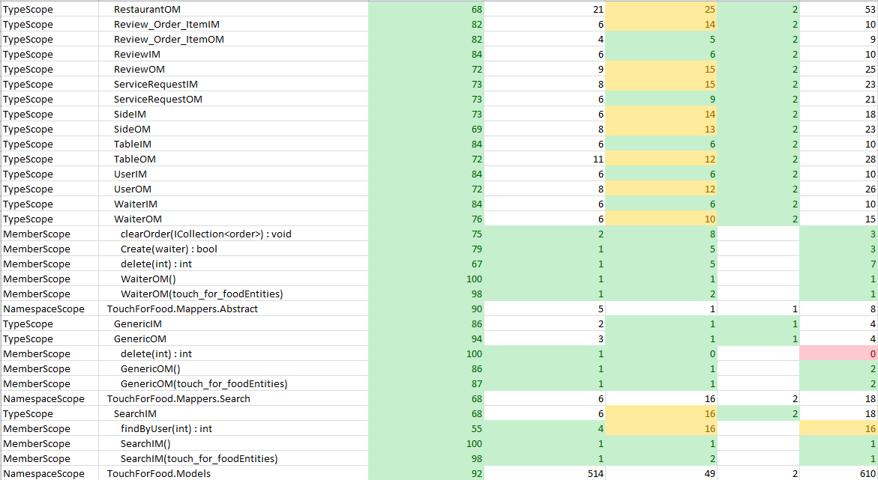

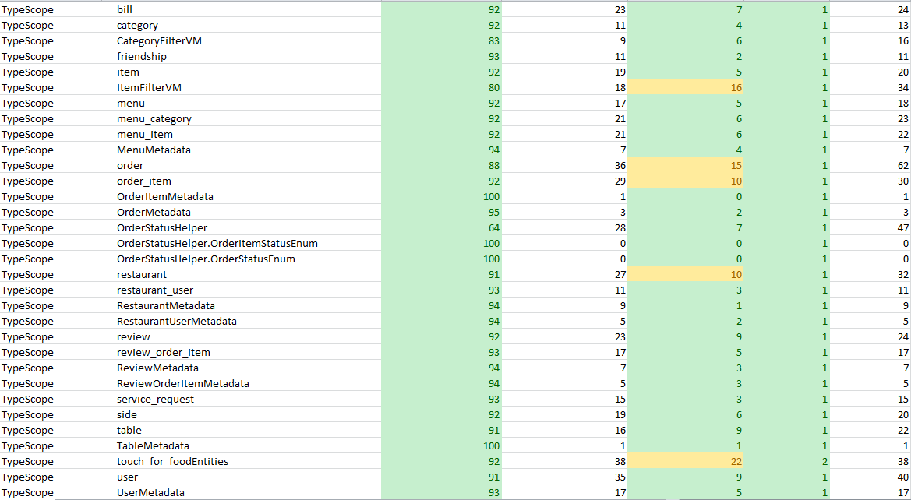

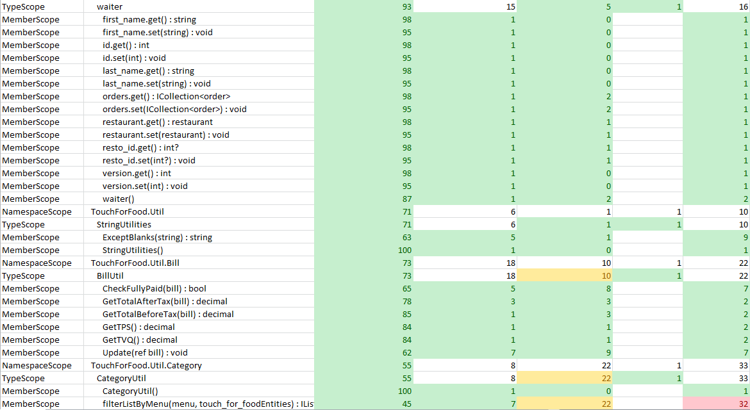

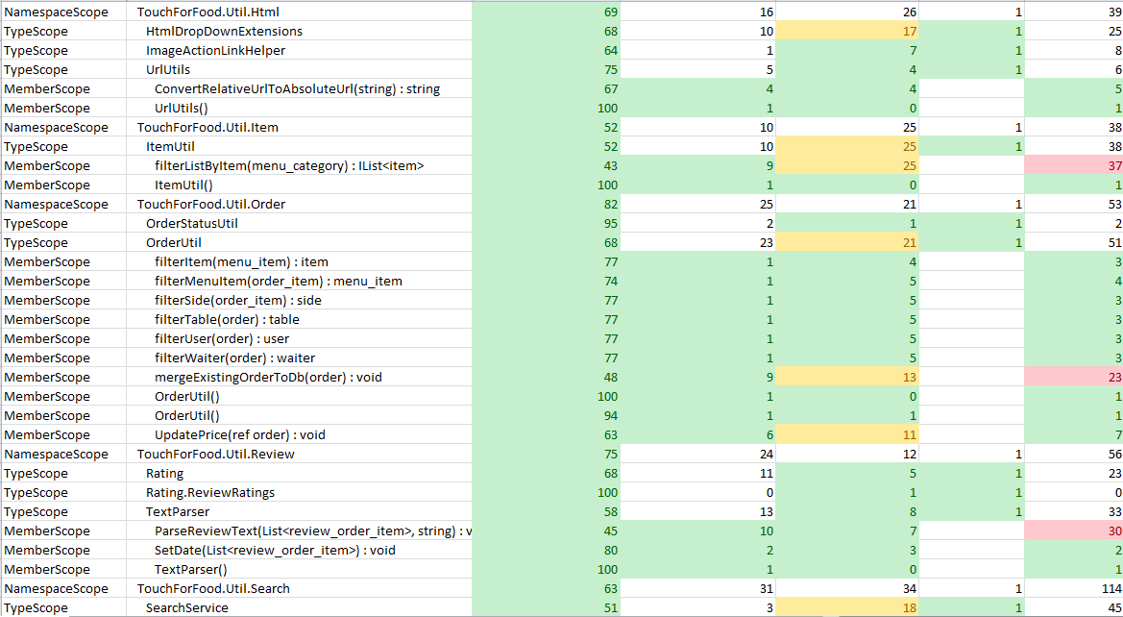

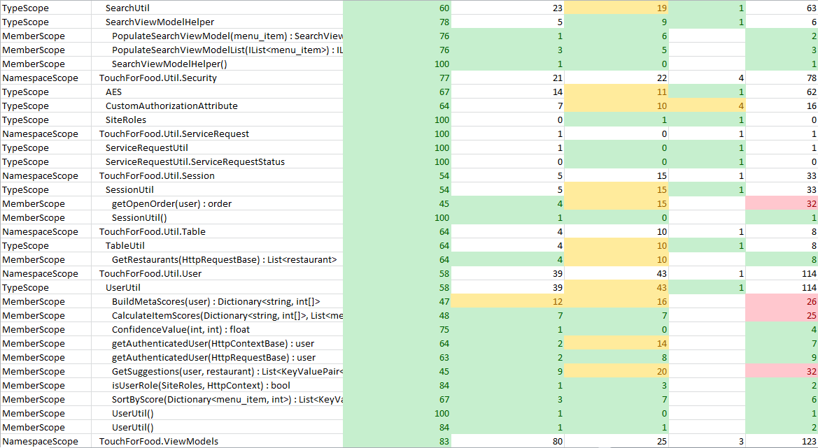

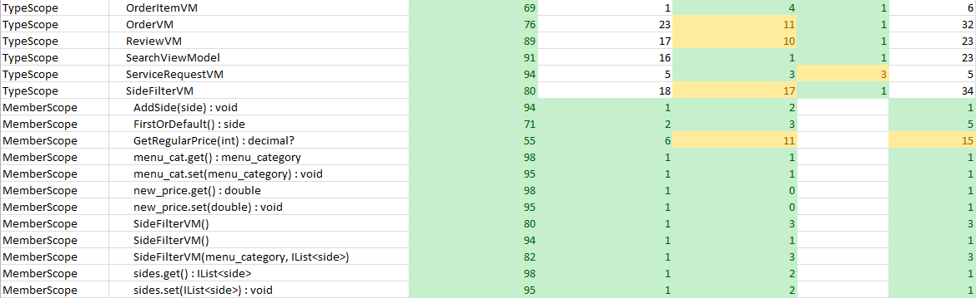

Figure 22‑5 Code Quality Report

## Retrospective

In Iteration 9, we closed out all remaining unit tests and stories. The goal of the sprint was to work on defects. Almost all reported bugs for the iteration were completed and closed. There are now no more stories to finish.

There were no major issues this sprint. Everything went smoothly. We no longer had a designated role for a bug basher as most people were assigned bugs as tasks. We continued to have a QA role and multiple team members reviewed code. We decided that if you are working on bugs, you can work in trunk instead of a branch since most bugs were small and needed to be completed quickly.

### Velocity

Sprint 9 velocity (story points): 37 story points

Cumulative velocity (story points): 128 story points

Average velocity (story points): 14.2 story points

Sprint 9 velocity (p-h): 254.13 person-hours

Cumulative velocity (p-h): 1,725.72 person-hours

Average velocity per sprint: 191.75 person-hours

Our average story point velocity finished at 14.2 story points per sprint. Since all stories are complete, this will not change anymore until the end of the project. Our average person-hour velocity went up again this sprint as we worked over 250 hours.

### Budget

Total person-hours budgeted to date: 4,554 person-hours

Total person-hours worked to date: 1,725.72 person-hours

Person-hours budgeted per sprint: 414 person-hours

Person-hours worked in Sprint 8: 254.13 person-hours

In Iteration 9, we continued to work over 200 hours per sprint as we worked 254 hours. We are satisfied with where we are in terms of hours worked as all team members continue to work hard.

### What was learned

The following positive and negative points were gathered from this sprint.

Positives:

* On schedule to finish the project in time
* Communication and meetings are going very well
* Everyone is doing their part and working as a team
* Met our goal in person-hours worked

Negatives:

* None

# Iteration 10 Plan

The goal of Iteration 10 is to close out all defect tasks. Defects relate mostly to code although there are a few documentation defects. Preparation for the project demos will also begin in iteration 10. There are a few planned improvements as well. Tasks will be completed in order of priority.

We are aware that some team members will have less time to commit during this sprint as many other classes are requiring time over the next two weeks. However, this should not be an issue since all stories have already been completed. The estimated number of hours for the planned activities should be less than 200.

## Planned Activities

Tables featured in this section of the document were created with JIRA [2].

Table 23‑1 Planned Activities

|  |  |  |  |  |
| --- | --- | --- | --- | --- |
| **Key** | **Issue Type** | **Priority** | **Assignee** | **Original Estimate (hours)** |
| CAP-547 | Sub-task | Trivial | Unassigned | 0.166666667 |
| CAP-559 | Sub-task | Trivial | Unassigned | 0.166666667 |
| CAP-560 | Sub-task | Trivial | Unassigned | 0.166666667 |
| CAP-562 | Sub-task | Trivial | Unassigned | 0.166666667 |
| CAP-563 | Sub-task | Trivial | Unassigned | 0.166666667 |
| CAP-565 | Sub-task | Trivial | Unassigned | 0.166666667 |
| CAP-570 | Sub-task | Trivial | Patrick Modafferi | 1 |
| CAP-572 | Sub-task | Trivial | Unassigned | 0.083333333 |
| CAP-582 | Bug | Trivial | Mikhail Levkovsky | 0.083333333 |
| CAP-584 | Bug | Trivial | Ryan Nasr | 0.083333333 |
| CAP-594 | Bug | Trivial | Unassigned | 1 |
| CAP-598 | Bug | Trivial | Unassigned | 2 |
| CAP-619 | Improvement | Trivial | Katrina Anderson | 0.25 |
| CAP-621 | Improvement | Trivial | Katrina Anderson | 0.5 |
| CAP-405 | Improvement | Minor | Matthew Tam | 4 |
| CAP-567 | Bug | Minor | Cynthia Donato | 1 |
| CAP-573 | Bug | Minor | Mikhail Levkovsky | 1 |
| CAP-610 | Bug | Minor | Unassigned | 0.166666667 |
| CAP-611 | Bug | Minor | Unassigned | 0.166666667 |
| CAP-613 | Bug | Minor | Josh Hum | 1 |
| CAP-614 | Bug | Minor | Ryan Nasr | 1 |
| CAP-616 | Bug | Minor | Cristian Asenjo | 0.5 |
| CAP-622 | Task | Minor | Josh Hum | 0 |
| CAP-623 | Sub-task | Minor | Josh Hum | 8 |
| CAP-624 | Sub-task | Minor | Josh Hum | 2 |
| CAP-625 | Sub-task | Minor | Mikhail Levkovsky | 0.5 |
| CAP-626 | Sub-task | Minor | Josh Hum | 1.5 |
| CAP-627 | Sub-task | Minor | Josh Hum | 1.5 |
| CAP-628 | Sub-task | Minor | Josh Hum | 0.5 |
| CAP-629 | Sub-task | Minor | Josh Hum | 2 |
| CAP-630 | Sub-task | Minor | Josh Hum | 2 |
| CAP-636 | Bug | Minor | Christian Daher | 0.5 |
| CAP-645 | Bug | Minor | Cristian Asenjo | 0.083333333 |
| CAP-112 | Story | Major | Matthew Tam | 0 |
| CAP-162 | Task | Major | Josh Hum | 0 |
| CAP-206 | Sub-task | Major | Katrina Anderson | 9 |
| CAP-433 | Sub-task | Major | Matthew Tam | 32 |
| CAP-482 | Sub-task | Major | Unassigned | 0 |
| CAP-545 | Bug | Major | Patrick Modafferi | 1 |
| CAP-555 | Bug | Major | Cynthia Donato | 0.25 |
| CAP-574 | Sub-task | Major | Cristian Asenjo | 6 |
| CAP-576 | Bug | Major | Unassigned | 1 |
| CAP-577 | Bug | Major | Unassigned | 1 |
| CAP-578 | Sub-task | Major | Unassigned | 0.083333333 |
| CAP-588 | Bug | Major | Mikhail Levkovsky | 0.25 |
| CAP-589 | Bug | Major | Mikhail Levkovsky | 0.166666667 |
| CAP-590 | Bug | Major | Unassigned | 1 |
| CAP-591 | Bug | Major | Cynthia Donato | 0.5 |
| CAP-592 | Bug | Major | Unassigned | 0.083333333 |
| CAP-595 | Bug | Major | Unassigned | 1 |
| CAP-602 | Bug | Major | Josh Hum | 1 |
| CAP-603 | Sub-task | Major | Ryan Nasr | 1 |
| CAP-605 | Bug | Major | Matthew Tam | 0.5 |
| CAP-606 | Sub-task | Major | Ryan Nasr | 0.5 |
| CAP-608 | Bug | Major | Josh Hum | 0.5 |
| CAP-609 | Bug | Major | Christian Daher | 1 |
| CAP-617 | Bug | Major | Patrick Modafferi | 4 |
| CAP-618 | Bug | Major | Josh Hum | 4 |
| CAP-620 | Sub-task | Major | Josh Hum | 0.5 |
| CAP-631 | Bug | Major | Unassigned | 1 |
| CAP-632 | Sub-task | Major | Patrick Modafferi | 0 |
| CAP-633 | Sub-task | Major | Patrick Modafferi | 0 |
| CAP-634 | Sub-task | Major | Patrick Modafferi | 0 |
| CAP-635 | Sub-task | Major | Patrick Modafferi | 0 |
| CAP-637 | Bug | Major | Christian Daher | 1 |
| CAP-639 | Bug | Major | Josh Hum | 2 |
| CAP-640 | Bug | Major | Mikhail Levkovsky | 2 |
| CAP-641 | Sub-task | Major | Mikhail Levkovsky | 0.5 |
| CAP-643 | Bug | Major | Christian Daher | 0 |
| CAP-644 | Sub-task | Major | Patrick Modafferi | 1 |
| CAP-646 | Sub-task | Major | Unassigned | 0 |
| CAP-647 | Bug | Major | Cynthia Donato | 0 |
| CAP-648 | Sub-task | Major | Josh Hum | 0.5 |
| CAP-552 | Bug | Critical | Cynthia Donato | 15 |
| CAP-568 | Bug | Critical | Cristian Asenjo | 2 |
| CAP-579 | Bug | Critical | Josh Hum | 4 |
| CAP-599 | Bug | Critical | Unassigned | 0.166666667 |
| CAP-607 | Bug | Critical | Christian Daher | 1 |
| CAP-615 | Bug | Critical | Unassigned | 2 |
| CAP-642 | Bug | Critical | Mikhail Levkovsky | 0 |
| CAP-651 | Bug | Critical | Christian Daher | 0 |
|  |  |  | **TOTAL** | **131.92** |

## Person-Hour Estimation

The Expert Judgement Method was used to calculate person-hour estimations.

Table 23‑2 Person-Hour Estimation

|  |  |  |  |  |
| --- | --- | --- | --- | --- |
| **Description** | **Worst Case** | **Most Likely Case** | **Best Case** | **Expected Case** |
| **Activities** | 171.50 | 131.92 | 92.34 | 131.92 |
| **Total(ph)** | 171.50 | 131.92 | 92.34 | 131.92 |
| **Velocity(ph/day)** | 12.25 | 9.42 | 6.60 | 9.42 |
| **Velocity (ph/team member/day)** | 1.36 | 1.05 | 0.73 | 1.05 |

## Activity-on-Node Planning

The following graph reflects the progress of the planned user stories. The numbers represent the Early Start, Duration, Early Finish, Late Start, Slack, and Late Finish in days. All remaining stories are currently in progress.

All stories were completed in Sprint 9. The activity on node diagram now reflects that all stories are complete.



Figure 23‑1 Activity on Node Diagram

# Iteration 10 Report

## Person-Hour Work Log

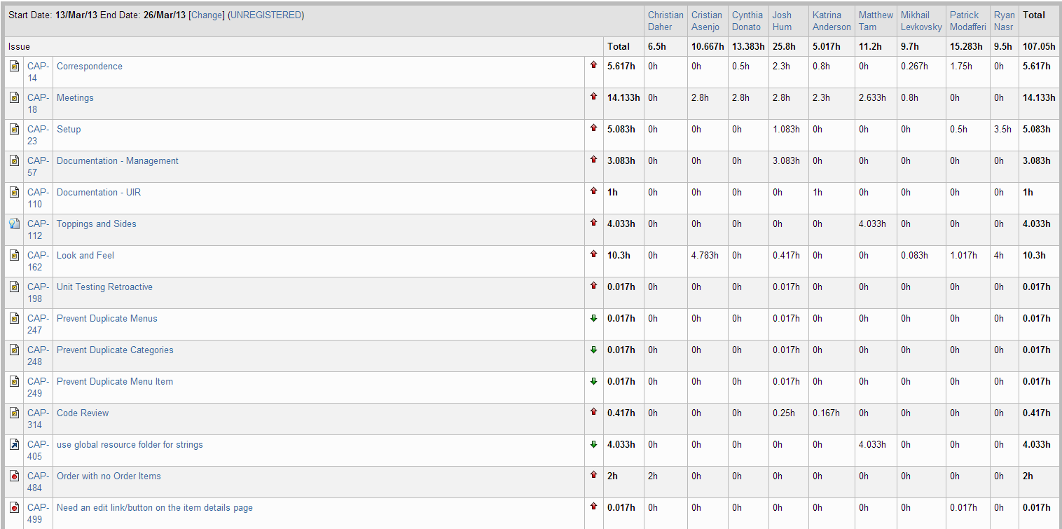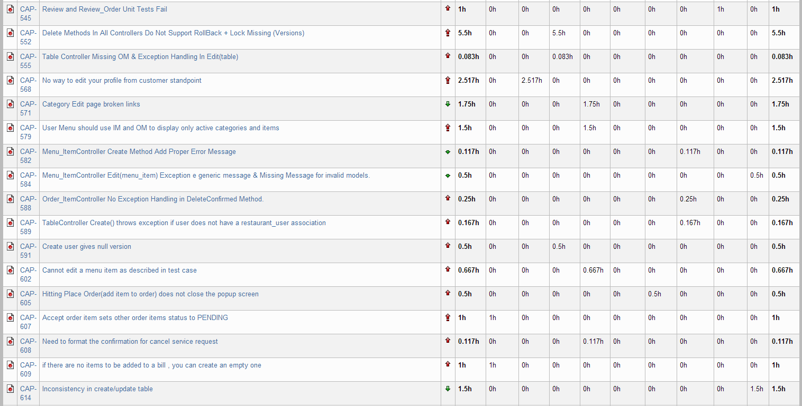

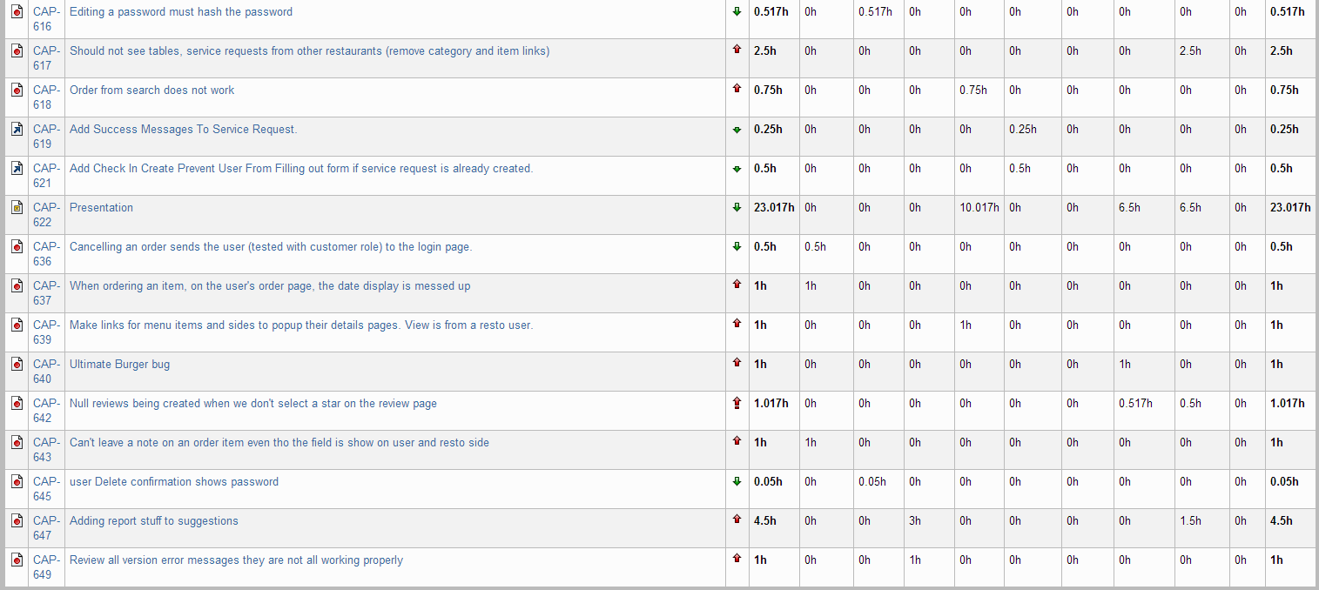

Figure 24‑1 Person-Hour Work Log

With 107 hours worked in Iteration 10, we came close to the original estimate for the planned activities. Although the number of hours is around half of what the team has been working per sprint over the past few sprints, this was expected and we are satisfied with the team effort.

## Hour Burndown Chart

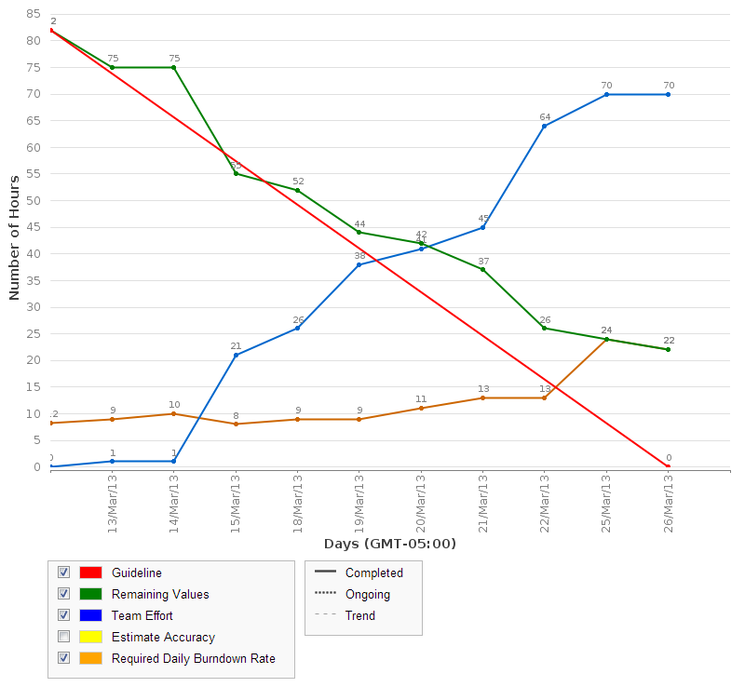

Figure 24‑2 Hour Burndown Chart

The above chart shows the consistent work by team members throughout the sprint. There were 22 hours that were originally estimated that were not burned down. We attribute this mostly to faulty time logging. Some tasks that were completed did not get estimated down to 0 on completion. There were also a few incomplete tasks at the end of this sprint.

## Issue Burndown Chart

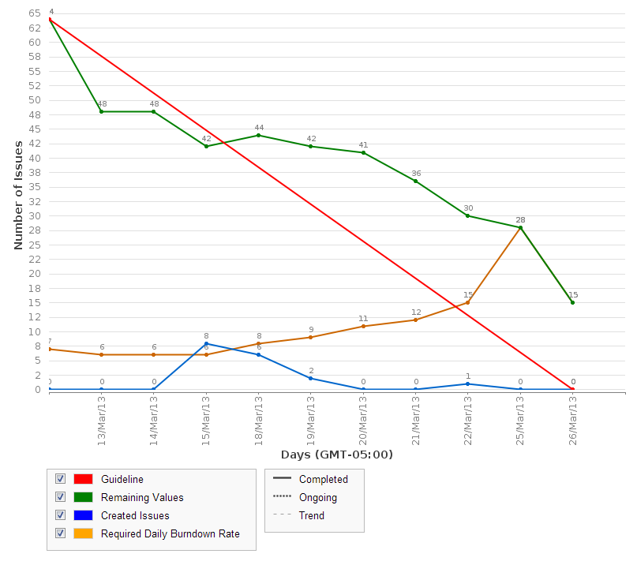

Figure 24‑3 Issue Burndown Chart

15 issues were not completed at the end of the sprint. These are mostly documentation tasks and will be taken care of next sprint. There should be a little bit more time next sprint to work on these tasks.

## Cumulative Flow Diagram

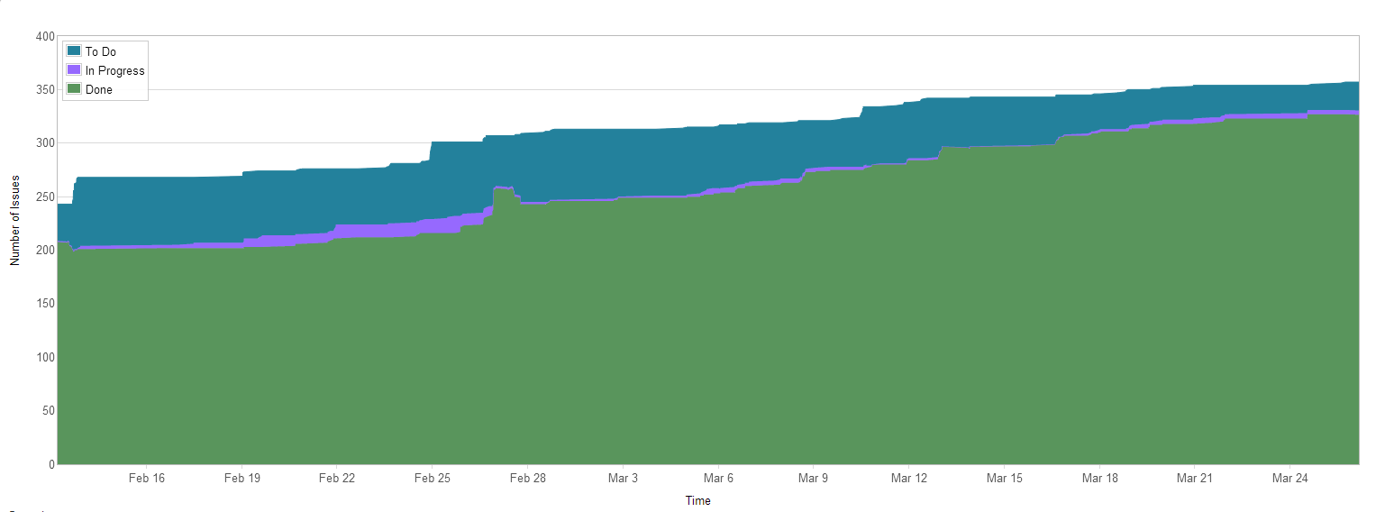

Figure 24‑4 Cumulative Flow Diagram

For the first time, the above figure shows how the project is coming to an end. The number of to do tasks are significantly less and we can see how significant progress has been made this sprint.

## Measurement Report

### Code Quality Analysis

The following report was generated after analyzing the code. Thirteen methods did not meet code quality goals by exceeding the expected number of lines of code or having none. They have been entered as bugs and will be fixed in a future iteration. Since it is a minor bug, the priority is not high for it which is why they occur repeatedly in the code quality analysis report.

We are NOT planning on fixing this bug as there are many other tasks with higher priorities. The lines of code is a very minor defect and we must focus as a team on completing higher priority issues.

Since our only issues have been with lines of code, we took note for the future that the following scale defines lines of code quality:

0: red

1 – 10: green

11 – 10: yellow

21+: red

Analysis tool used: Code Metrics Viewer

Found at: <http://visualstudiogallery.msdn.microsoft.com/9f35524b-a784-4dbc-bd7b-6babd7a5a3b3>

Version: 1.5.3

Last updated: 2/5/2012

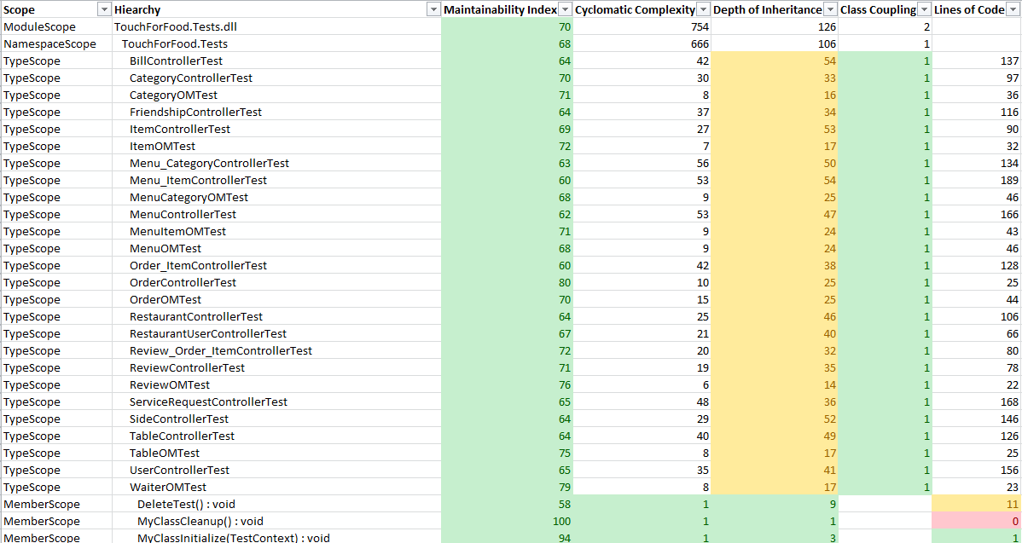

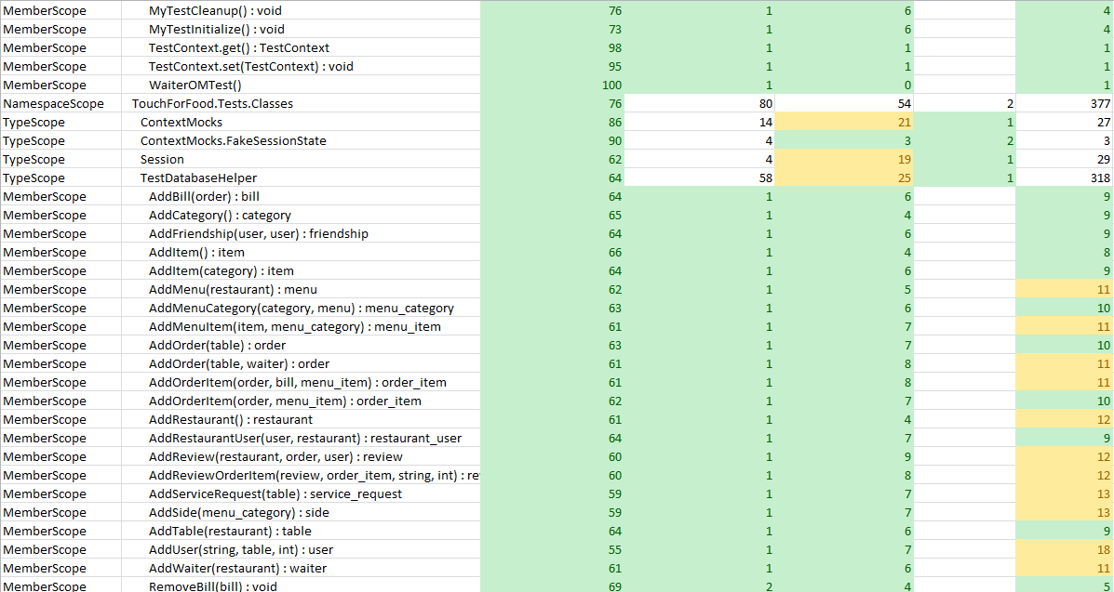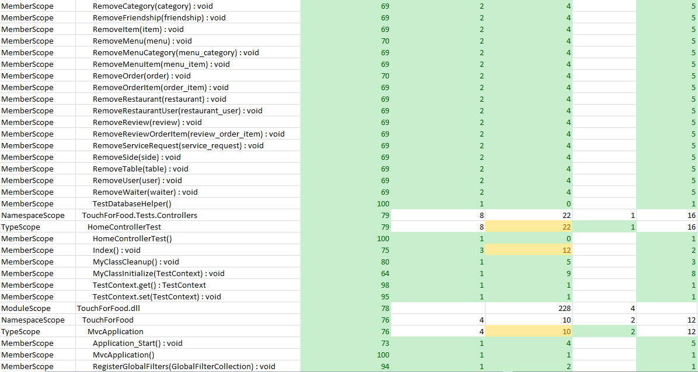

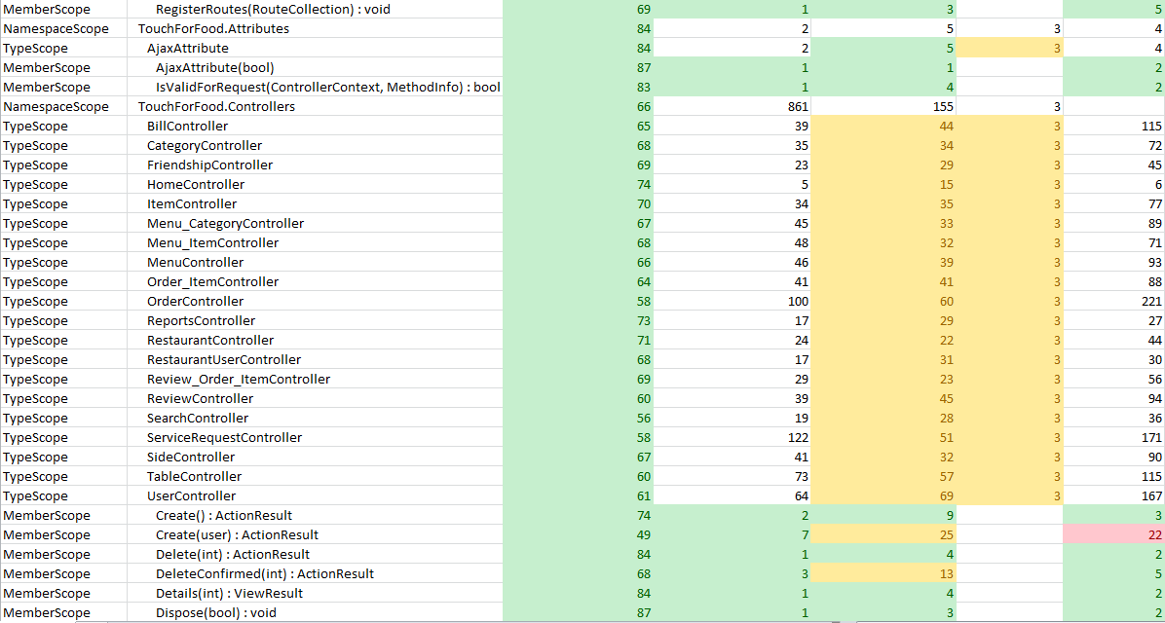

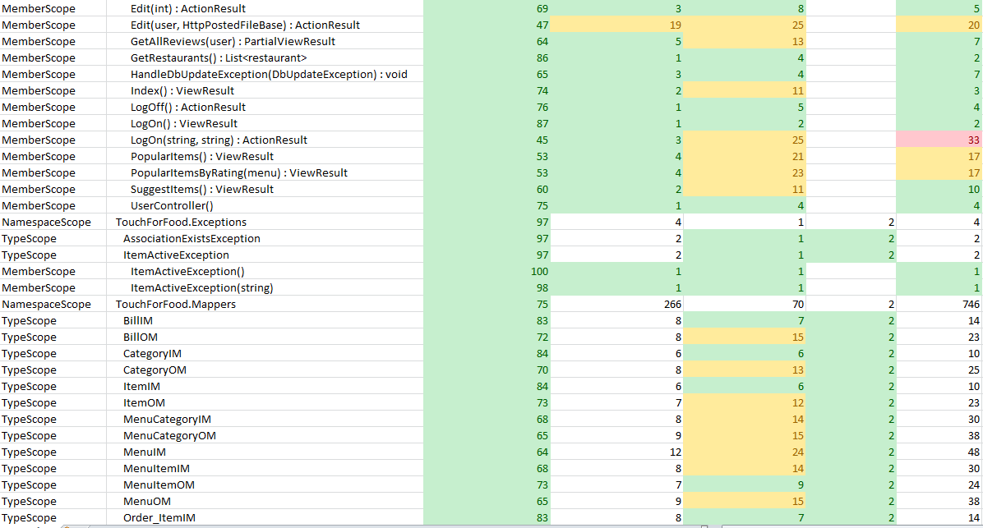

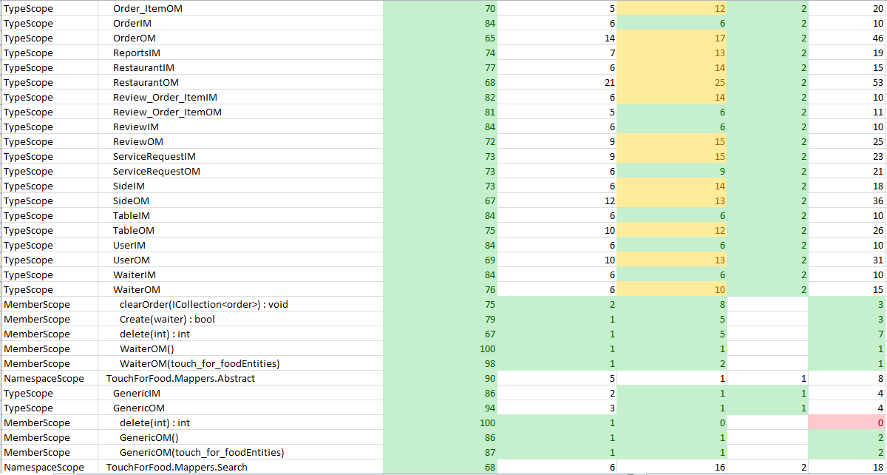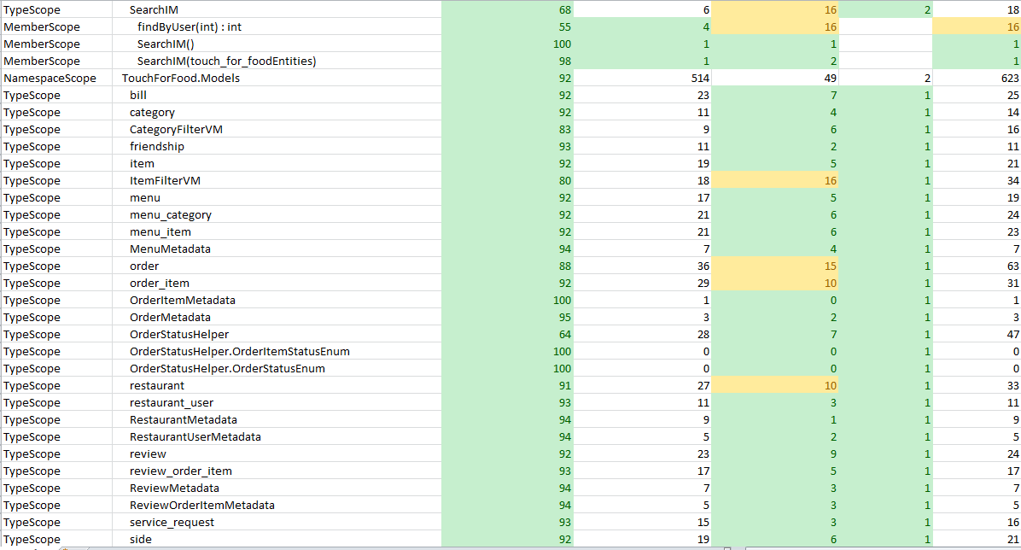

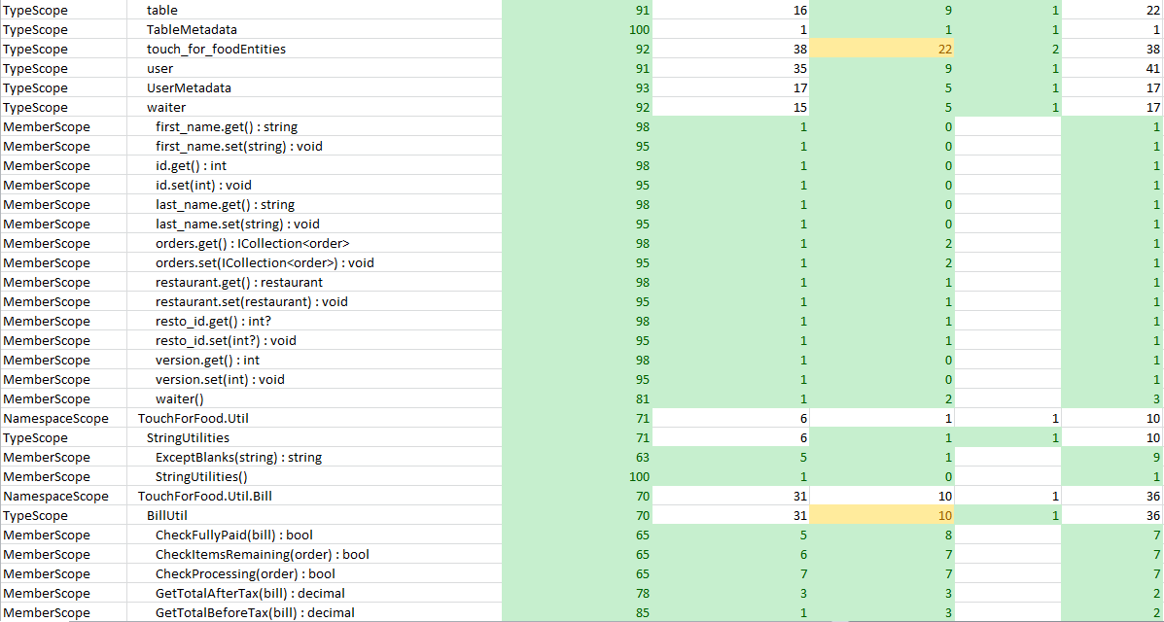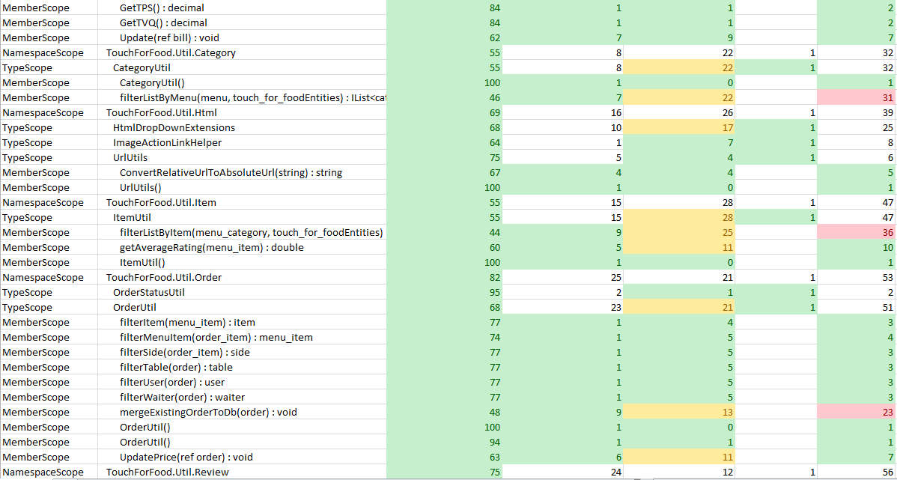

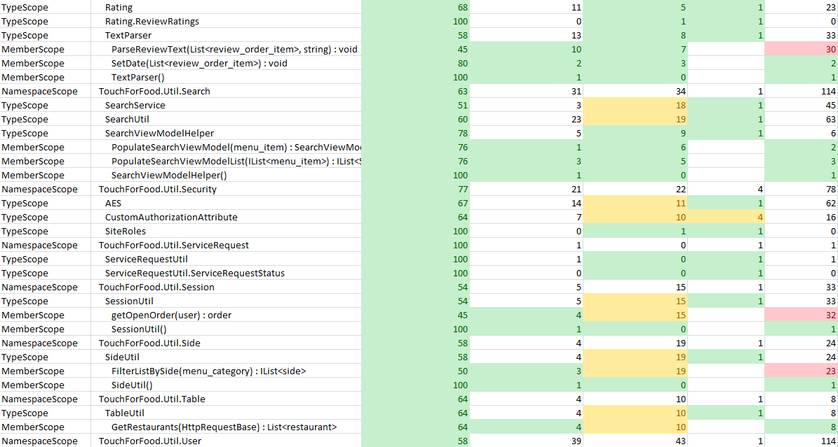

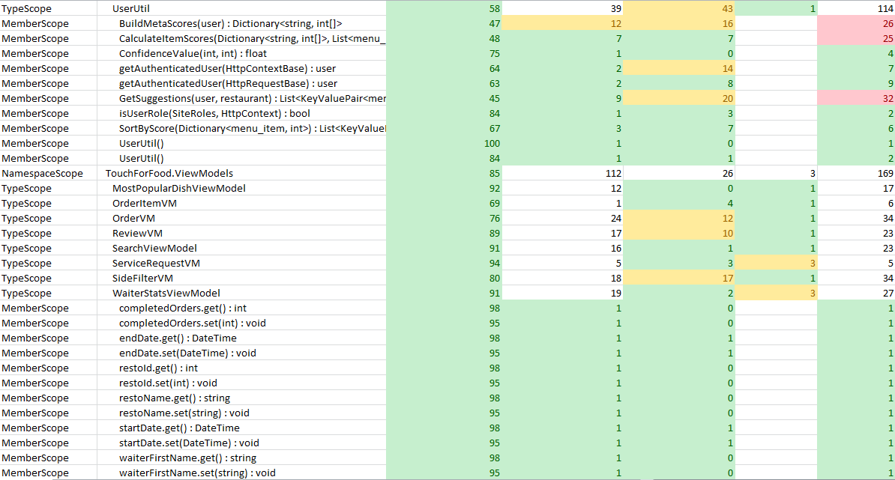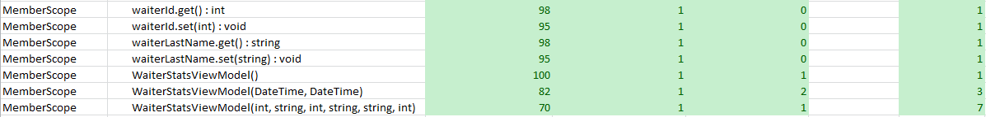

Figure 24‑5 Code Quality Report

## Retrospective

In Iteration 10, we finished all the planned defect fixes. We had a few documentation and improvement tasks leftover that we will carry over into Iteration 11.

There were no time consuming defects. There were a lot of little defects and all the changes made a significant difference in the project. Some team members were very busy with other classes and responsibilities but that didn’t slow our progress down. We are right on track with almost all coding tasks complete.

### Velocity

Story point velocity will not be changed this sprint as there were no more stories planned. All tasks are bugs, tasks, or improvements.

Cumulative velocity (story points): 128 story points

Average velocity (story points): 14.2 story points

Sprint 10 velocity (p-h): 107.92 person-hours

Cumulative velocity (p-h): 1,833.64 person-hours

Average velocity per sprint: 183.36 person-hours

Our average person-hour velocity went down as we did not work many hours this sprint. We expect it to go slightly back up in Iteration 11.

### Budget

Total person-hours budgeted to date: 4,968 person-hours

Total person-hours worked to date: 1,833.64 person-hours

Person-hours budgeted per sprint: 414 person-hours

Person-hours worked in Sprint 10:107.92 person-hours

In Iteration 10, we dropped even more under budget. However, this was expected this iteration.

### What was learned

The following positive and negative points were gathered from this sprint.

Positives:

* On schedule to finish the project in time
* Communication and meetings are going very well
* Everyone is doing their part and working as a team

Negatives:

* None

# Iteration 11 Plan

The goal of Iteration 11 is to prepare for the Capstone demos and finish up any few remaining bugs. Most of the work will occur in the first week of the sprint as the demo day for the project is scheduled for the day after the halfway point of the sprint.

## Planned Activities

There were not many planned activities this sprint. The main tasks were:

* Prepare for the demo (buy supplies, get posters ready, etc.)
* Review docs
* Finish up a handful of improvements/bugs
* Prepare for presentation

## Sprint Schedule

Because this is the last sprint and this document must be handed in before our last day, we will explain what the schedule will be over the course of the sprint.

Table 25‑1 Sprint Tasklist

|  |  |
| --- | --- |
| **Task** | **Due Date** |
| Complete Documents | March 30, Midnight |
| Complete Review of Documents | March 31, Midnight |
| Complete Coding Tasks (Code Freeze) | March 31, Midnight |
| Complete Testing for Demo | April 2, Midnight |
| Capstone Demo | April 4, 13:30 – 16:30 |
| Hand in Documents | April 5, Midnight |
| Capstone Presentation | April 9, 11:30 – 13:00 |

# Iteration 11 Report

## Person-Hour Work Log

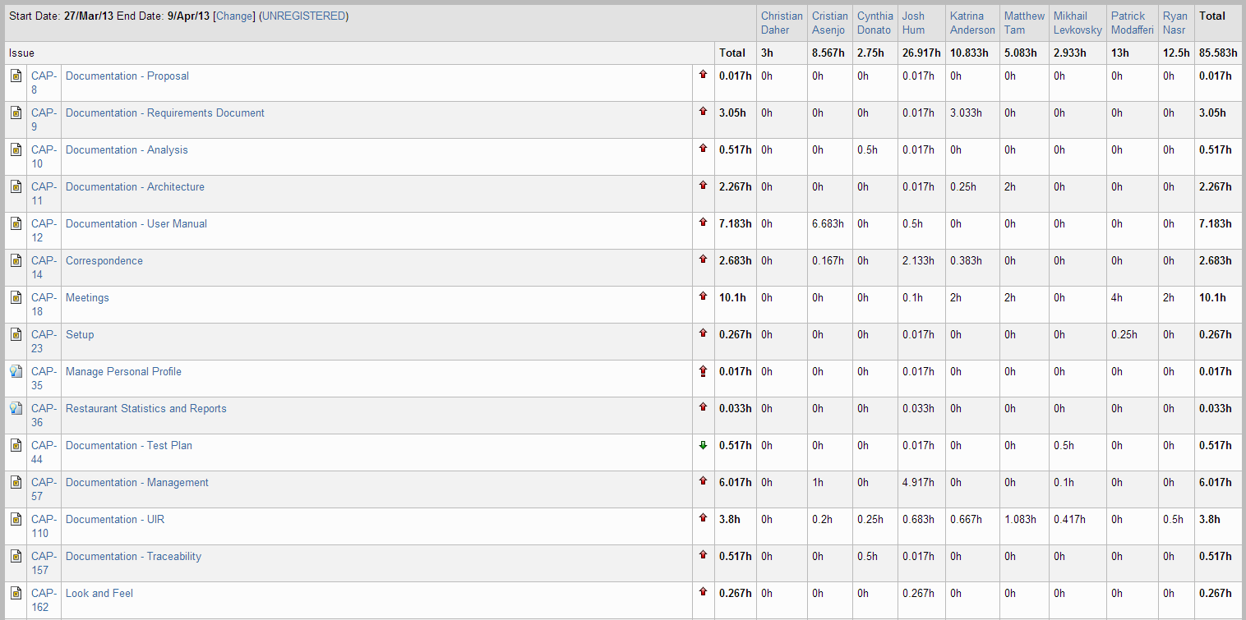

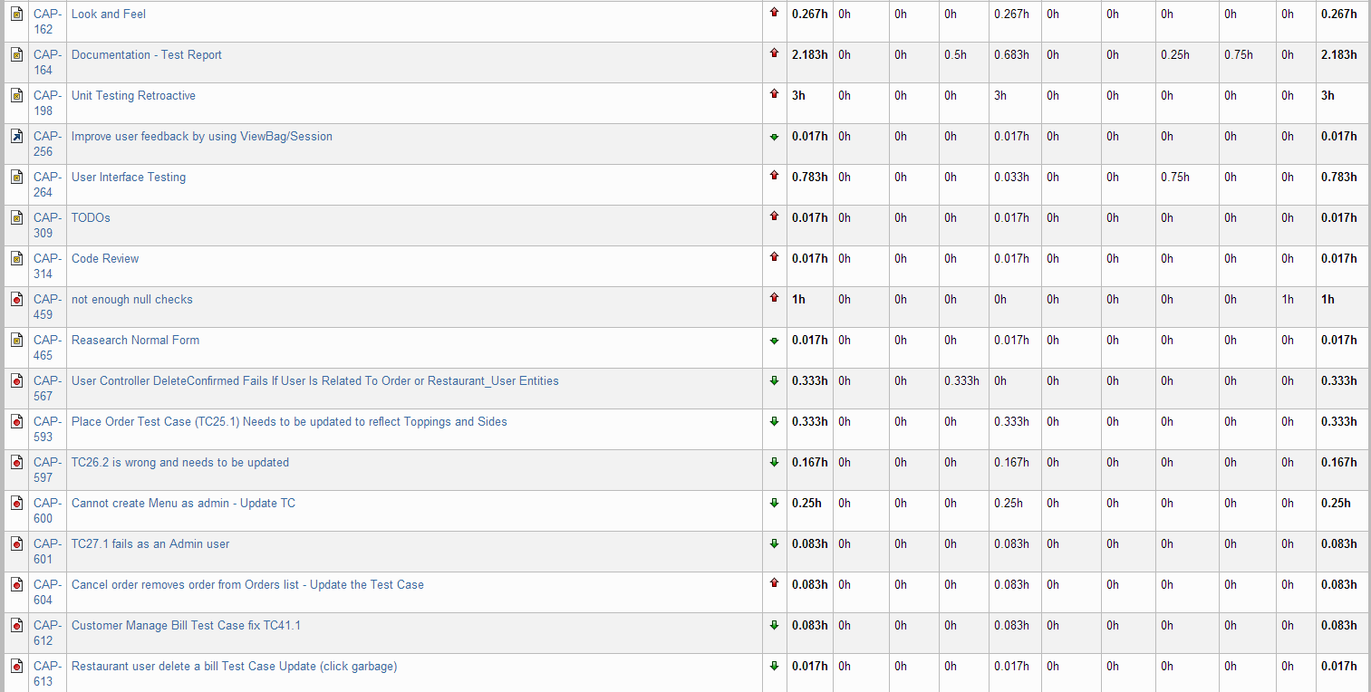

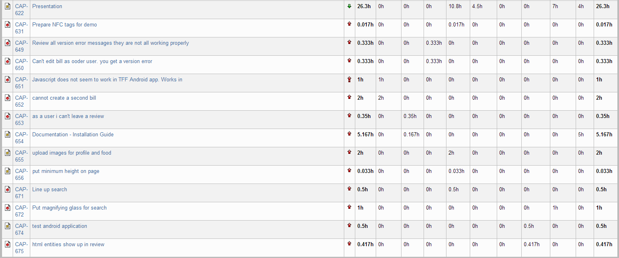

Figure 26‑1 Person-Hour Work Log

With just 85 hours worked, the person-hour effort was the lowest it has been in the last few sprints. However, since there was really not much work left to do on the project, that was just fine. The project was completed successfully.

## Hour Burndown Chart

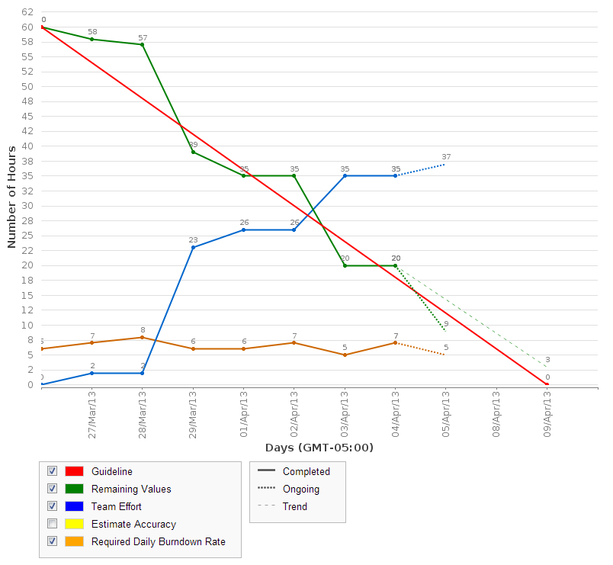

Figure 26‑2 Hour Burndown Chart

The above chart is slightly incomplete as the sprint is not yet over. However, as can be seen, we are on track to burn down the rest of the estimated hours in the next few days.

## Issue Burndown Chart

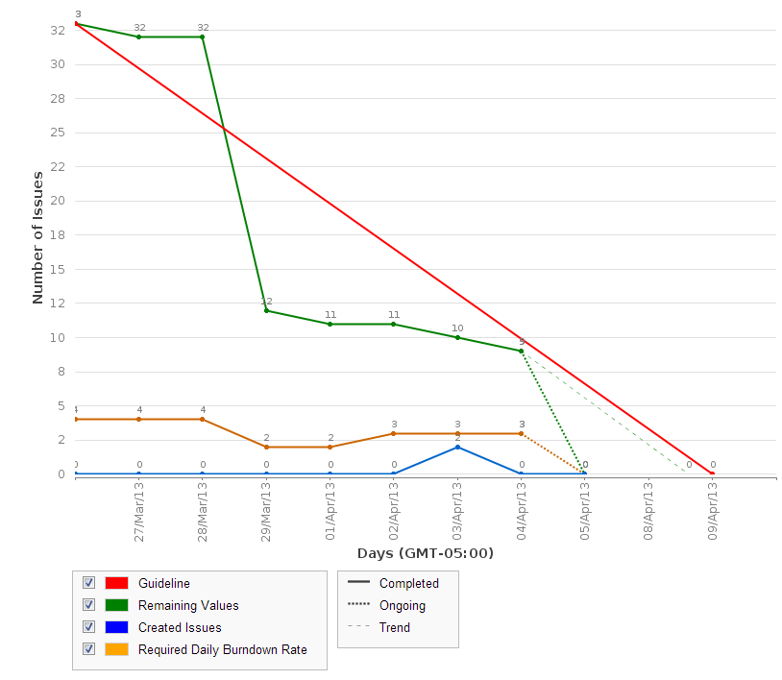

Figure 26‑3 Issue Burndown Chart

All issues are completed. There are only 5 remaining to be closed out on Jira.

## Cumulative Flow Diagram

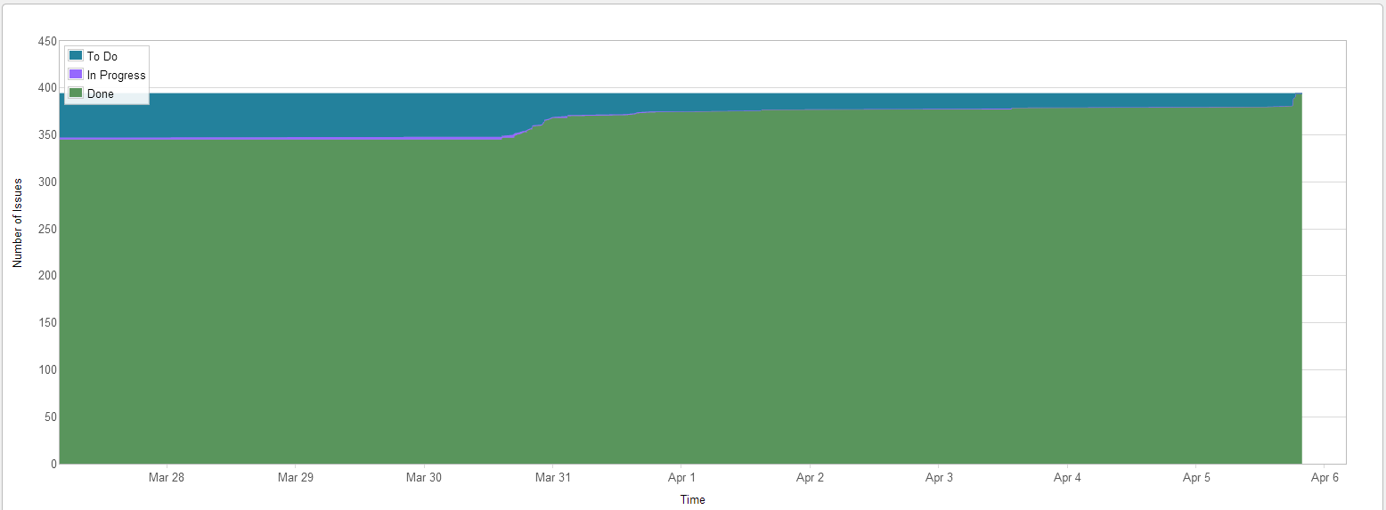

Figure 26‑4 Cumulative Flow Diagram

As can be seen in the above diagram, we resolved all the issues in the project. Some issues were not completed as planned (scoped out, duplicated, ignored, etc.). Whatever the reason, all issues were closed at the end of the project.

## Measurement Report

### Code Quality Analysis

There were no major code changes during sprint 11. Thus, we did not run a new code quality report. The issue to resolve too many or too little lines of code was ignored because there was no time to complete it as other issues had higher priority.

## Retrospective

In sprint 11, the team prepared for the demo and finished up outstanding documentation tasks. Unfortunately, we were not able to complete all the suggested tasks from previous submission feedback for the documents because we ran out of time and team members had to commit time to other classes. However, we completed all the doc tasks that we planned.

As for the demo, everything went smoothly and the demo was a great success. We were well prepared and did not have to scramble for anything last minute. Our posters were printed a couple weeks in advance and we arrived early to setup. We received a lot of positive feedback as well as a few suggestions from the users who came around and tried out our app. We simulated a real restaurant scenario where we allowed users to try TFF on our phones. We had a screen showing them what was going on from the restaurant point of view as they accepted orders. After ordering, the food was brought to them and their bill was closed out (this was a technicality because the food was free).

Some users had never or hardly used smartphones before. We got good feedback from them and a few suggestions on how to make the interface more intuitive.

### Velocity

Story point velocity was not changed this sprint as there were no more stories planned. Our person-hour velocity was not very high due to team commitments to other classes. There were also less tasks to be completed this sprint.

Cumulative velocity (story points): 128 story points

Average velocity (story points): 14.2 story points

Sprint 11 velocity (p-h): 85.58 person-hours

Cumulative velocity (p-h): 2,134.89 person-hours

Average velocity per sprint: 177.91 person-hours

Our average person-hour velocity went down again. The total average velocity over the project including sprint 0 (setup and preparation) is 177.91 person-hours.

### Budget

Total person-hours budgeted to date: 4,968 person-hours

Total person-hours worked to date: 2,134.89 person-hours

Person-hours budgeted per sprint: 414 person-hours

Person-hours worked in Sprint 11: 85.58 person-hours

Overall, we finished at around 50% of the budgeted person-hours. We hoped to be much closer to the estimated budget. However, we overestimated how long it would take to complete the project as well as how much time each team member would be able to commit to the project.

### What was learned

The following positive and negative points were gathered from this sprint.

Positives:

* On schedule to finish the project in time
* Communication and meetings are going very well
* Everyone is doing their part and working as a team
* Very organized for the demo

Negatives:

None

# Final Project Report

## Summary

Overall this Capstone project was a great learning experience for all of us. We learned a lot. There was something new for all of us to learn whether it was working with a new coding language, framework, development method, management system, or documentation. The team worked really well together and we all pulled together to complete the project. Each team member had their strengths and they used them to the best of their abilities to help the team.

As the team became more organized, we created developer roles for each sprint. Team members would rotate to assume these roles. Some of the roles that were used throughout development included QA, Bug Basher, and Flow Fixer. Everyone took a turn to assume at least one of these three mentioned roles.

The project took a considerable effort in terms of time commitment and determination but we are very satisfied with how the project turned out.

## Stakeholder

In the Fall, we had approached Dr. Ormandjieva to be our stakeholder. She accepted and I met with her a couple times. We discussed finding a restaurant stakeholder which she attempted to help us with. Unfortunately, we were unable to find a restaurant stakeholder. Since it was difficult to arrange meetings with Dr. Ormandjieva and we could not find a restaurant stakeholder, we built our needs and features ourselves from both the restaurant and customer point of view.

In the Winter semester, Dr. Ormandjieva informed us that she would not have the time to commit to being our stakeholder. Instead, Dr. Grogono accepted our request to be our stakeholder. We met once informally to talk about the project and then again with the whole group to present and demo the current progress. He did not have much feedback and seemed satisfied with the project. We wanted to meet once more before the end of the semester but did not have a chance. He attended our project demo and will come to our presentation as well.

## Risk Management

Throughout the course of the project, we had to manage risk to make sure we finished the project in time. We realized at the end of December that we would probably not be able to implement the social networking aspect of the project as was originally planned. Thus, after speaking with Dr. Constantinides, we scoped out the social networking aspect of the project.

Sometimes people went on vacation, got sick, or had time commitments in other classes. These were all factors in planning each sprint and managing risk. We used an activity-on-node diagram to ensure that we were on track to finish in time. One of the things we did to manage our time was to aim to complete all the stories of the project by the end of February which would give us time to eliminate defects in the code and give us a buffer zone in case we didn’t meet that deadline. We ended finishing the stories by the second week of March which we were satisfied with.

Although not always shown in this document, rough outlines for the next few sprints till the end of the project were set prioritizing tasks in the order that they should be worked on. These were discussed in sprint planning meetings. You can see the meeting slides in /trunk/docs/Management/meeting presentations/ folder. These outlines began in the January 29.pptx slide set as we needed to manage how close we were to finishing as we were already halfway through the project.

## Budget

The budget is part of risk management and has been reported on in this document in each sprint. We were very far behind in working the hours budgeted. However, the problem was that our original estimate was way too high. We couldn’t change that estimate but we continued to monitor our working hours. We set a goal to work around 200 person-hours per sprint and the timing worked out very well for us.

## Conclusion

I am very proud of my team and all the hard work they put into this Capstone project. Everyone worked together to make the project a success. Although there were occasional disagreements, there were no major problems and we made it through each issue very professionally. Personally, as the leader, I can say that there were times that were stressful and taxing but it was great to work with each person in the team and it was a great overall experience.

# Appendix A References

x

|  |  |
| --- | --- |
| [1] | Microsoft. (2012, December) Code Metrics Viewer. [Online]. <http://visualstudiogallery.msdn.microsoft.com/9f35524b-a784-4dbc-bd7b-6babd7a5a3b3> |
| [2] | Atlassian. (2013, January) JIRA; Issue & Project Tracking Software. [Online]. <http://www.atlassian.com/software/jira/overview> |

x

# Appendix B Glossary

|  |  |
| --- | --- |
| Term | Definition |
| Bug Basher | A developer role. At the beginning of each sprint, all defects in the backlog are assigned to the bug basher. It is their responsibility to fix as many defects as possible according to priority. Defects can relate to any aspect of the project but are usually code defects. |
| QA | A developer role. The QA person writes new UI tests for the sprint. They execute the tests during the last two days of the sprint. They are also in charge of running unit tests and writing the test report. Once usability tests start, they will also be in charge of executing each usability test. |
| Flow Fixer | A developer role. There are often issues where the flow between two parts of the system is not correct or multiple parts work in singularity do not work together. The flow fixer’s job is to ensure that all parts of the TFF system work together as designed. Flow fixing is always a coding task. |

For all other terms and definitions, please refer to the SRS document - Appendix B Glossary and Appendix C Acronyms.